Deploy Three-Tier Architecture in AWS Using Terraform

Github Link: https://github.com/NiteeshManne?tab=repositories

1)Login to the AWS Console.

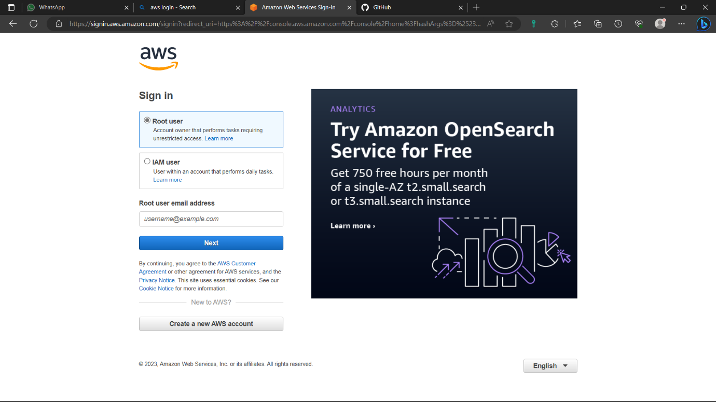

2)Now type “EC2” in search bar and select the ”EC2” option below.

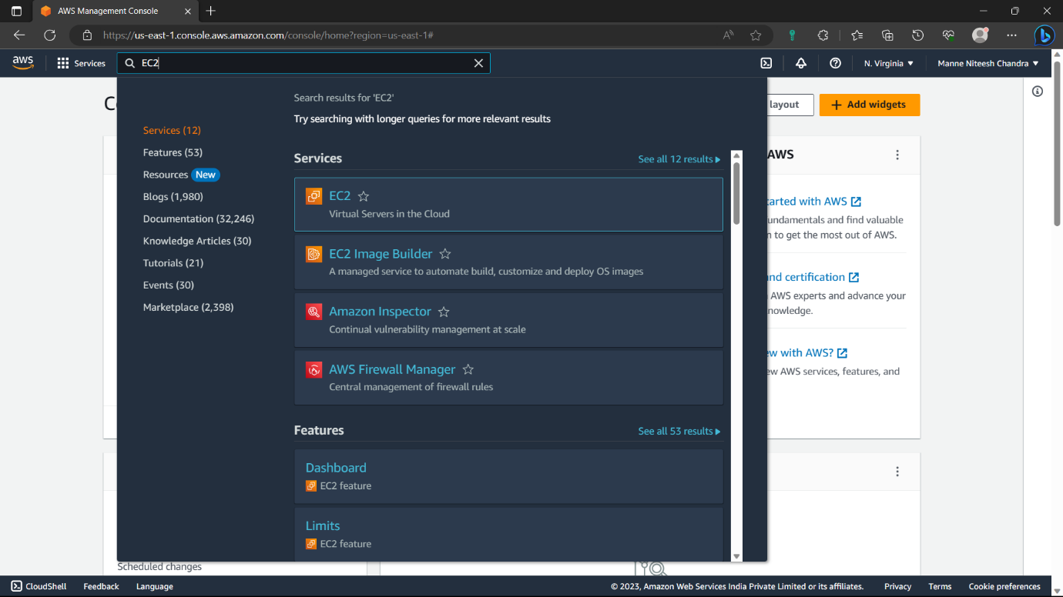

3)Click on “Launch instance” option to create a new instance.

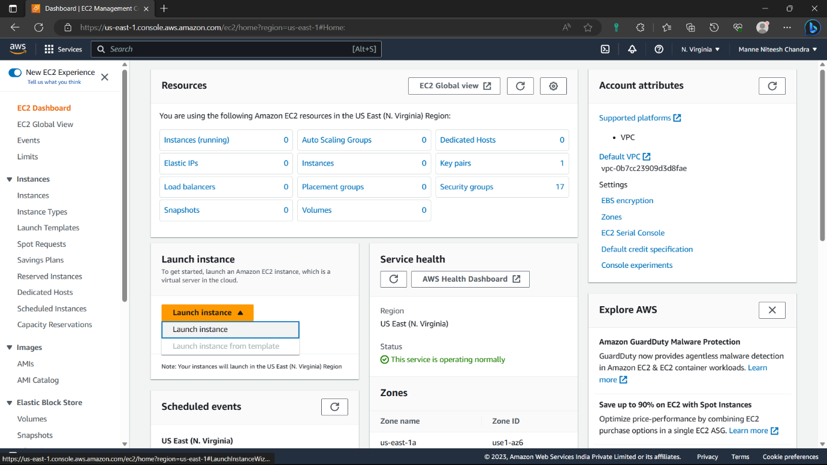

4)Give a name of you’re choice to the instance.

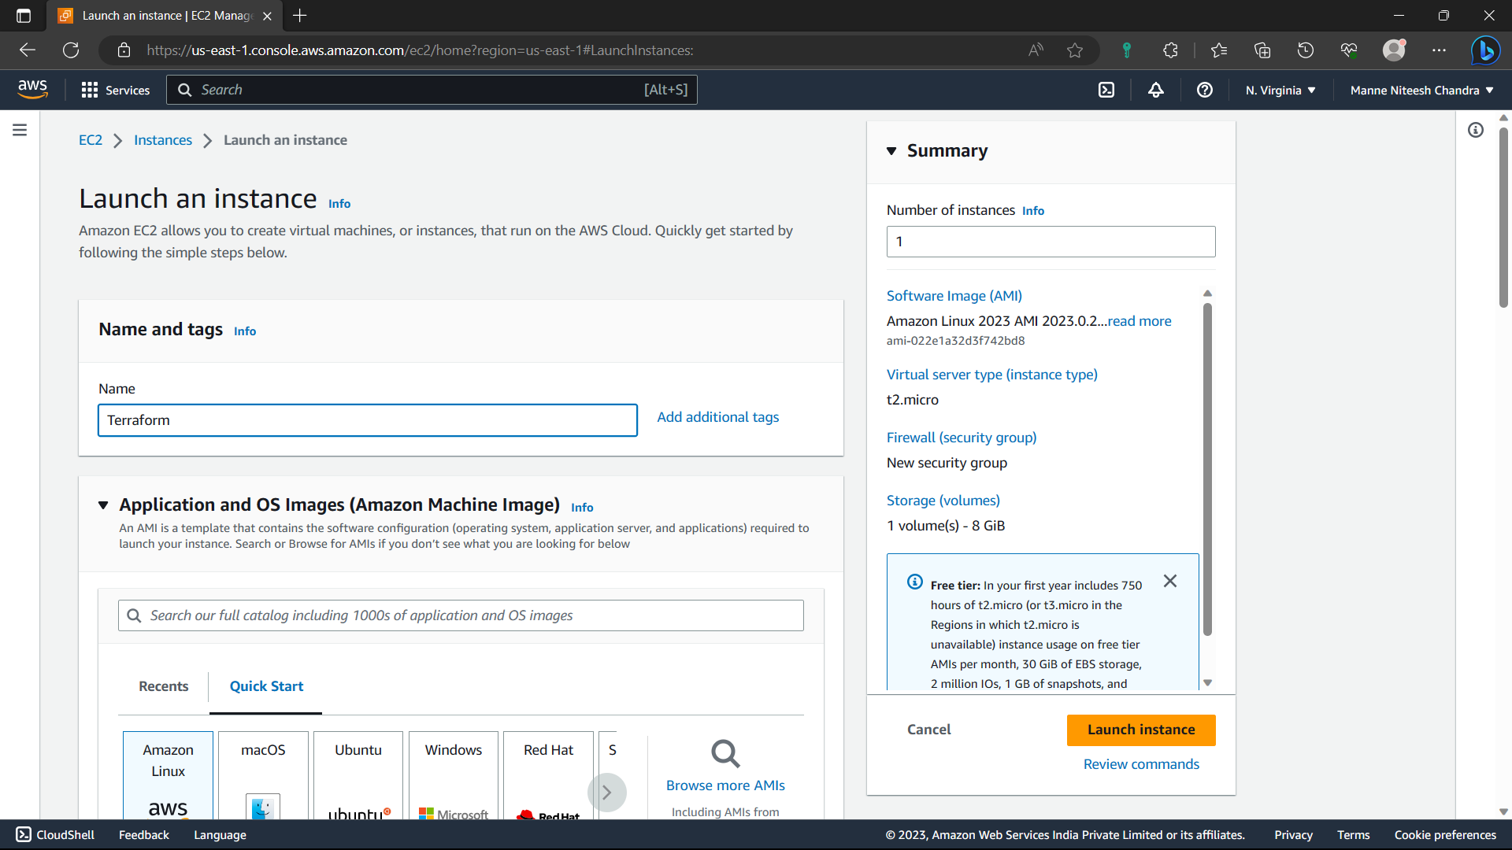

5)AMI-Linux, Description(default), Architetcture-64bit(default), AMI ID (default).

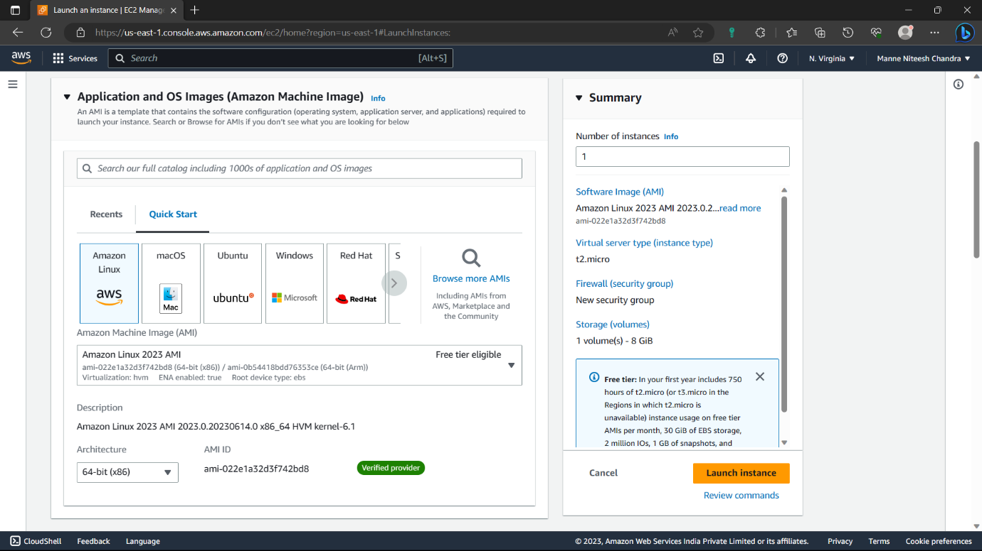

6)Instance type-t2.micro, Select the key pair if you have or else click on “create new key pair”.

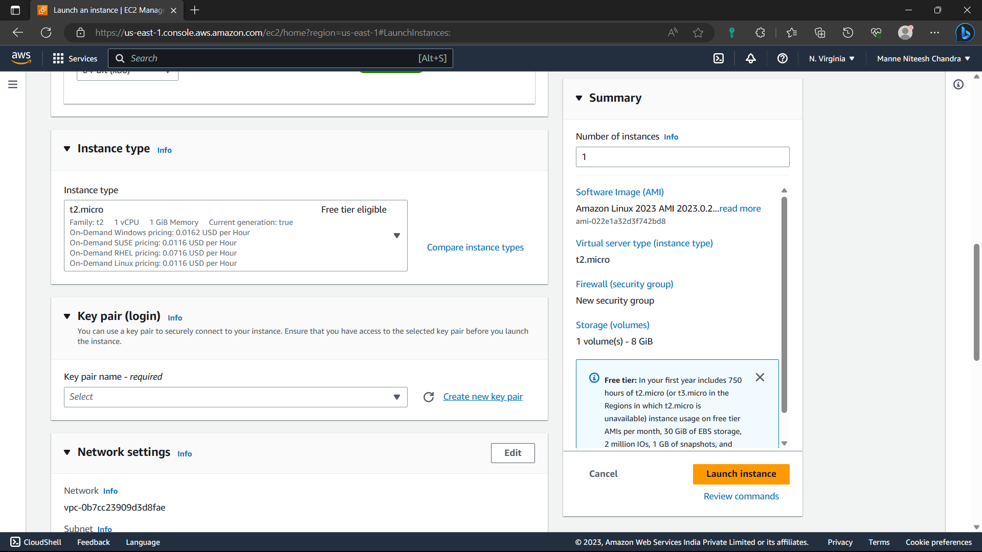

7)If you have key pair you can skip this step, give a name to the key pair and click on “create key pair”.

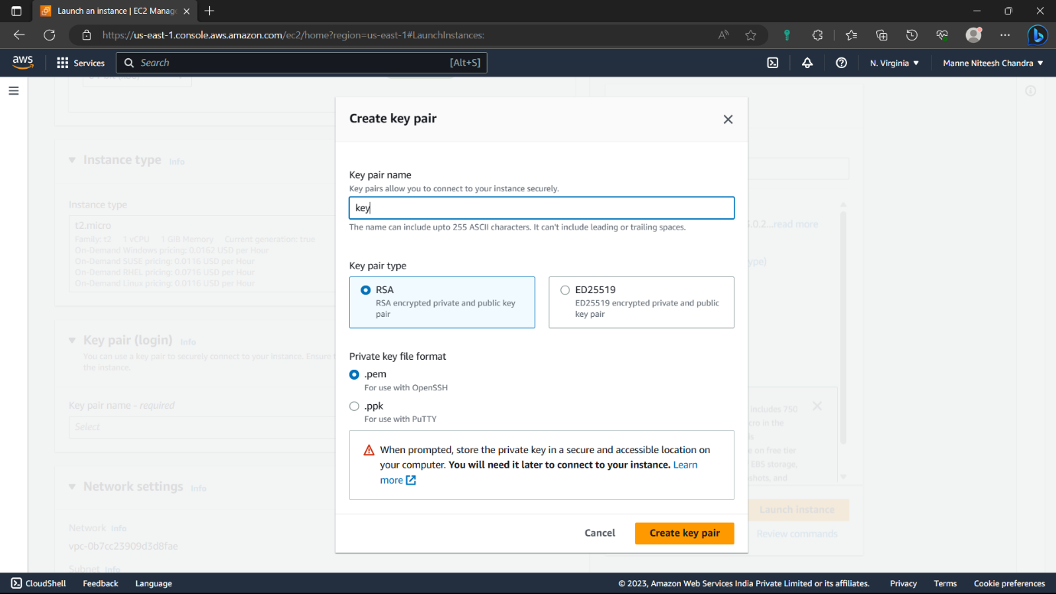

8)Now a copy of the key pair is downloaded to our local system, Select the key pair you created.

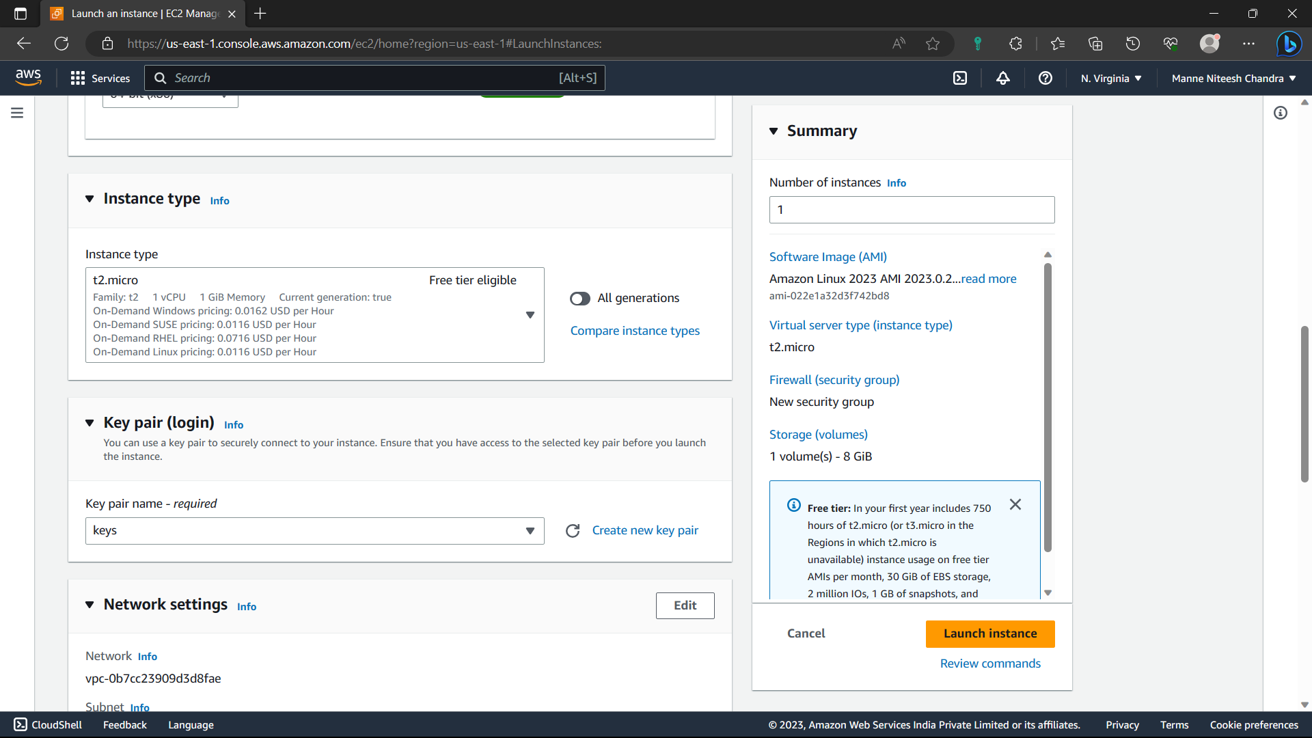

9)Enable “Allow HTTPS traffic from the internet” option in the network settings.

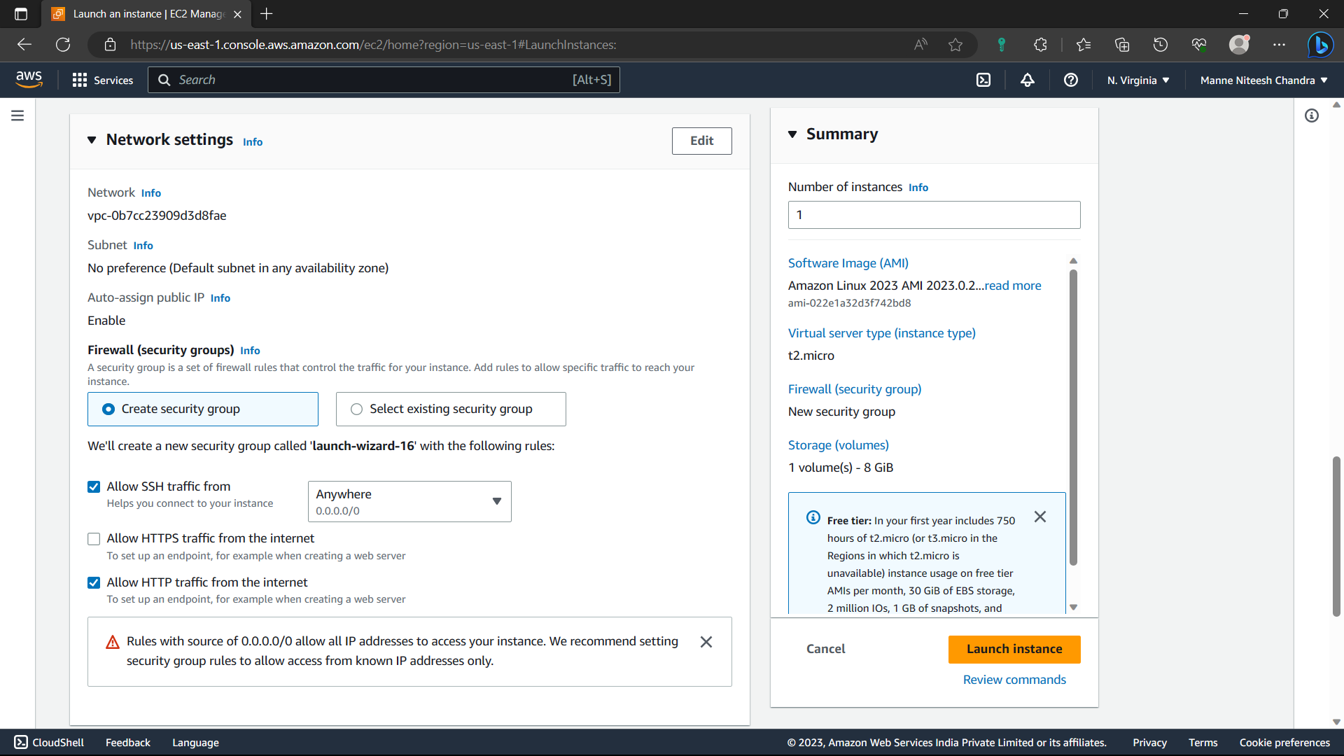

10)Review everything in the “summary” and click on “Launch instance” option.

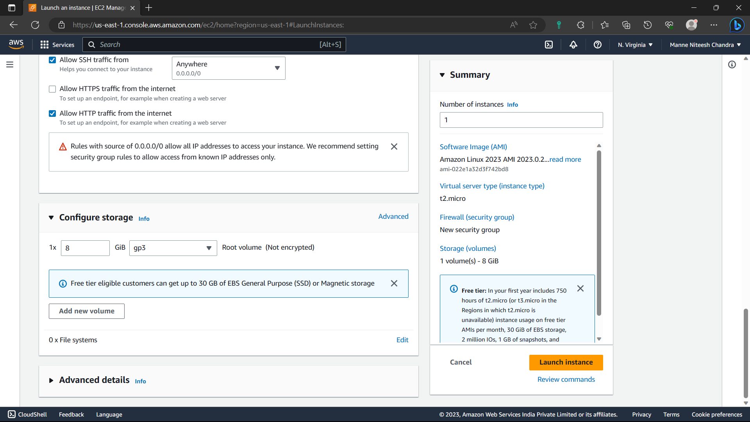

11)Now the instance is created. Click on “Instances” option which is between “EC2” and “Launch an instance” option.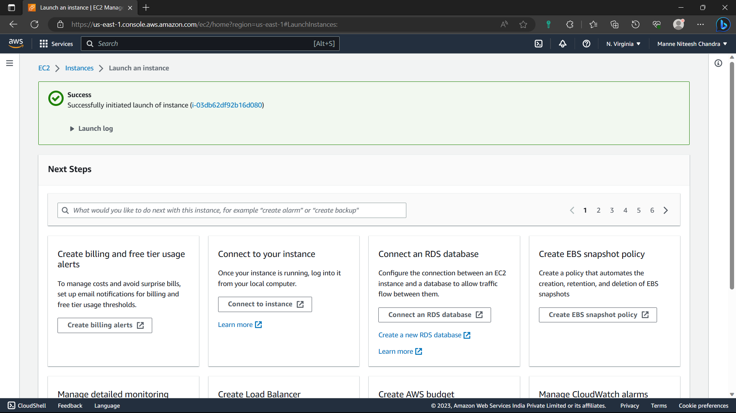

12)Wait till the created instance shows instance state- Available.

Status check- 2/2 checks passed.

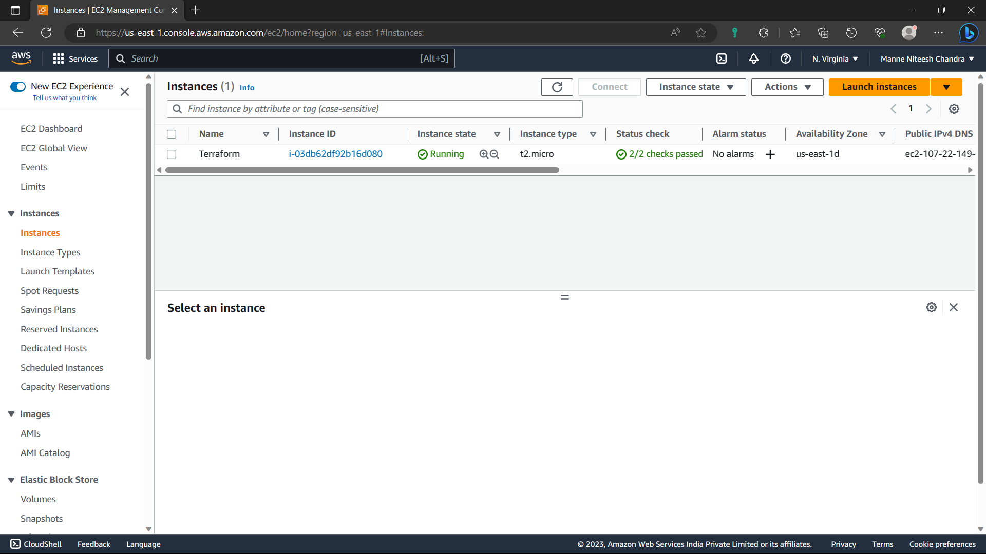

13)Select the instance you created and click on “connect” option.

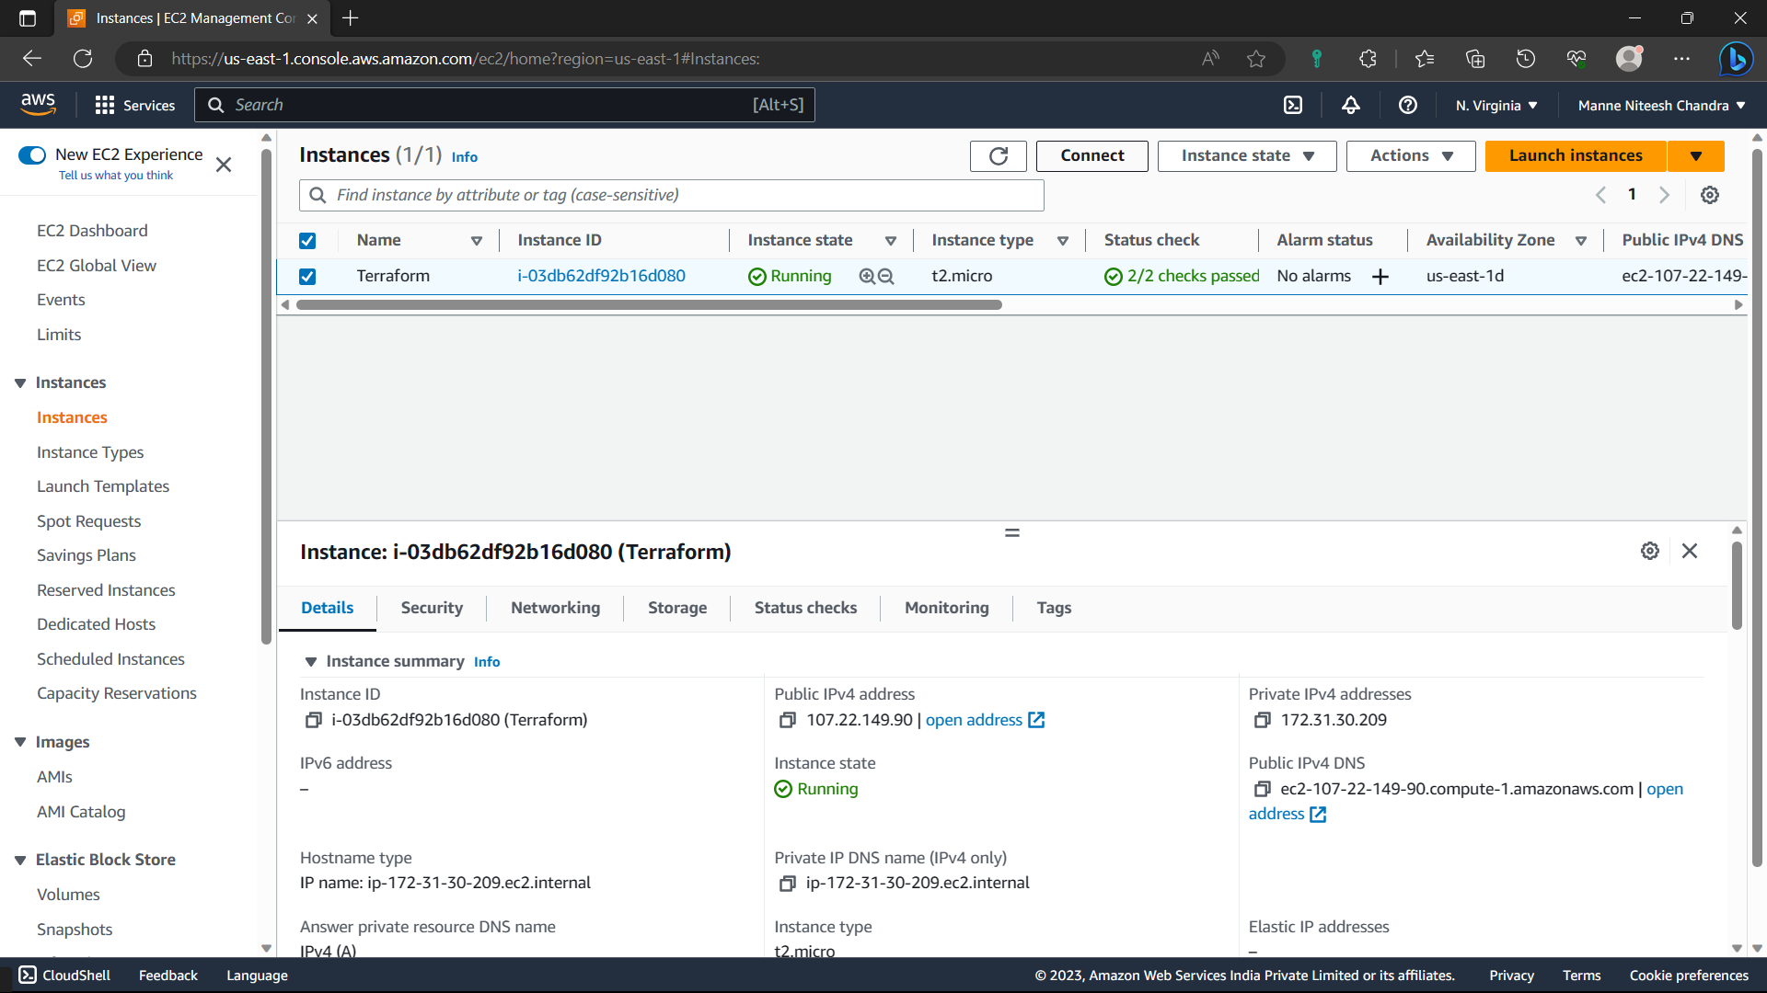

14)Navigate to “SSH client” option and copy the command below the “Example”.

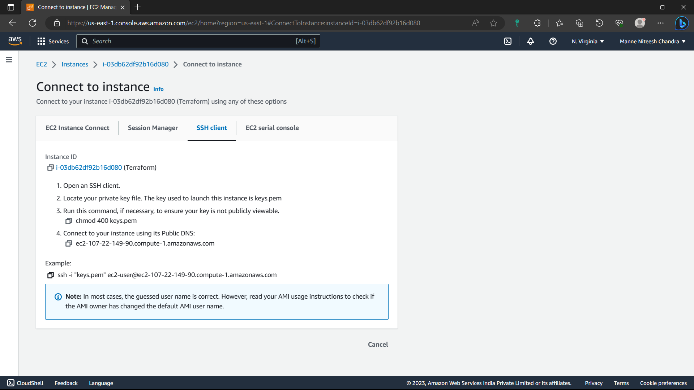

15)Now open the command prompt in you’re local machine.

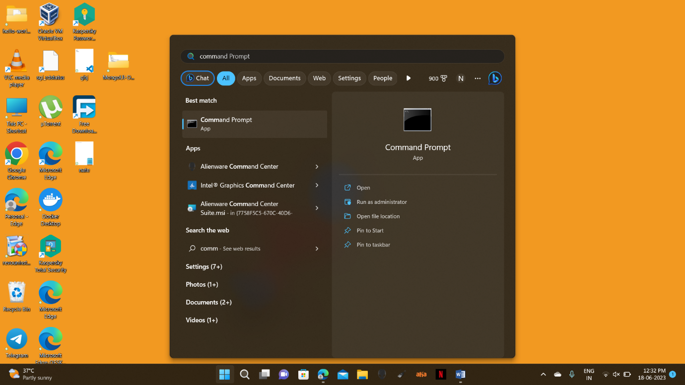

16)Type the command “cd path” [-- path: where copy of key pair is located] in my system the key pair is in downloads, “cd downloads”.

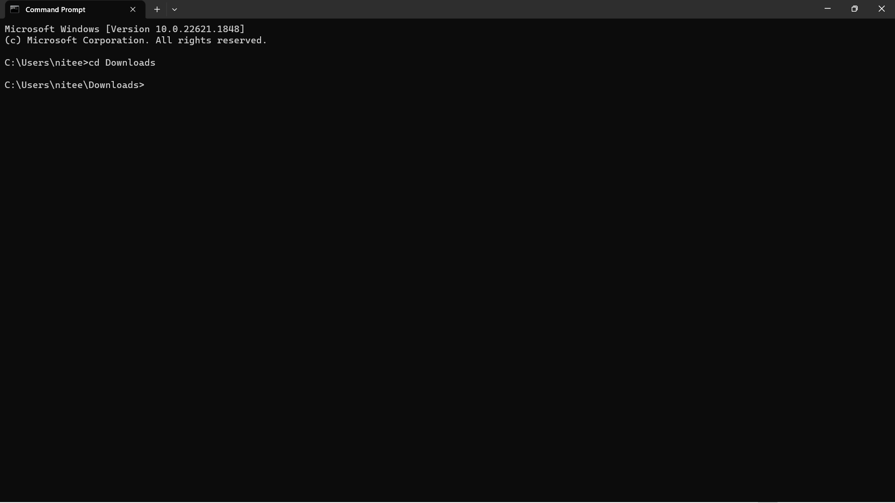

17)Paste the command i.e., copied in “SSH client” option. Click enter.

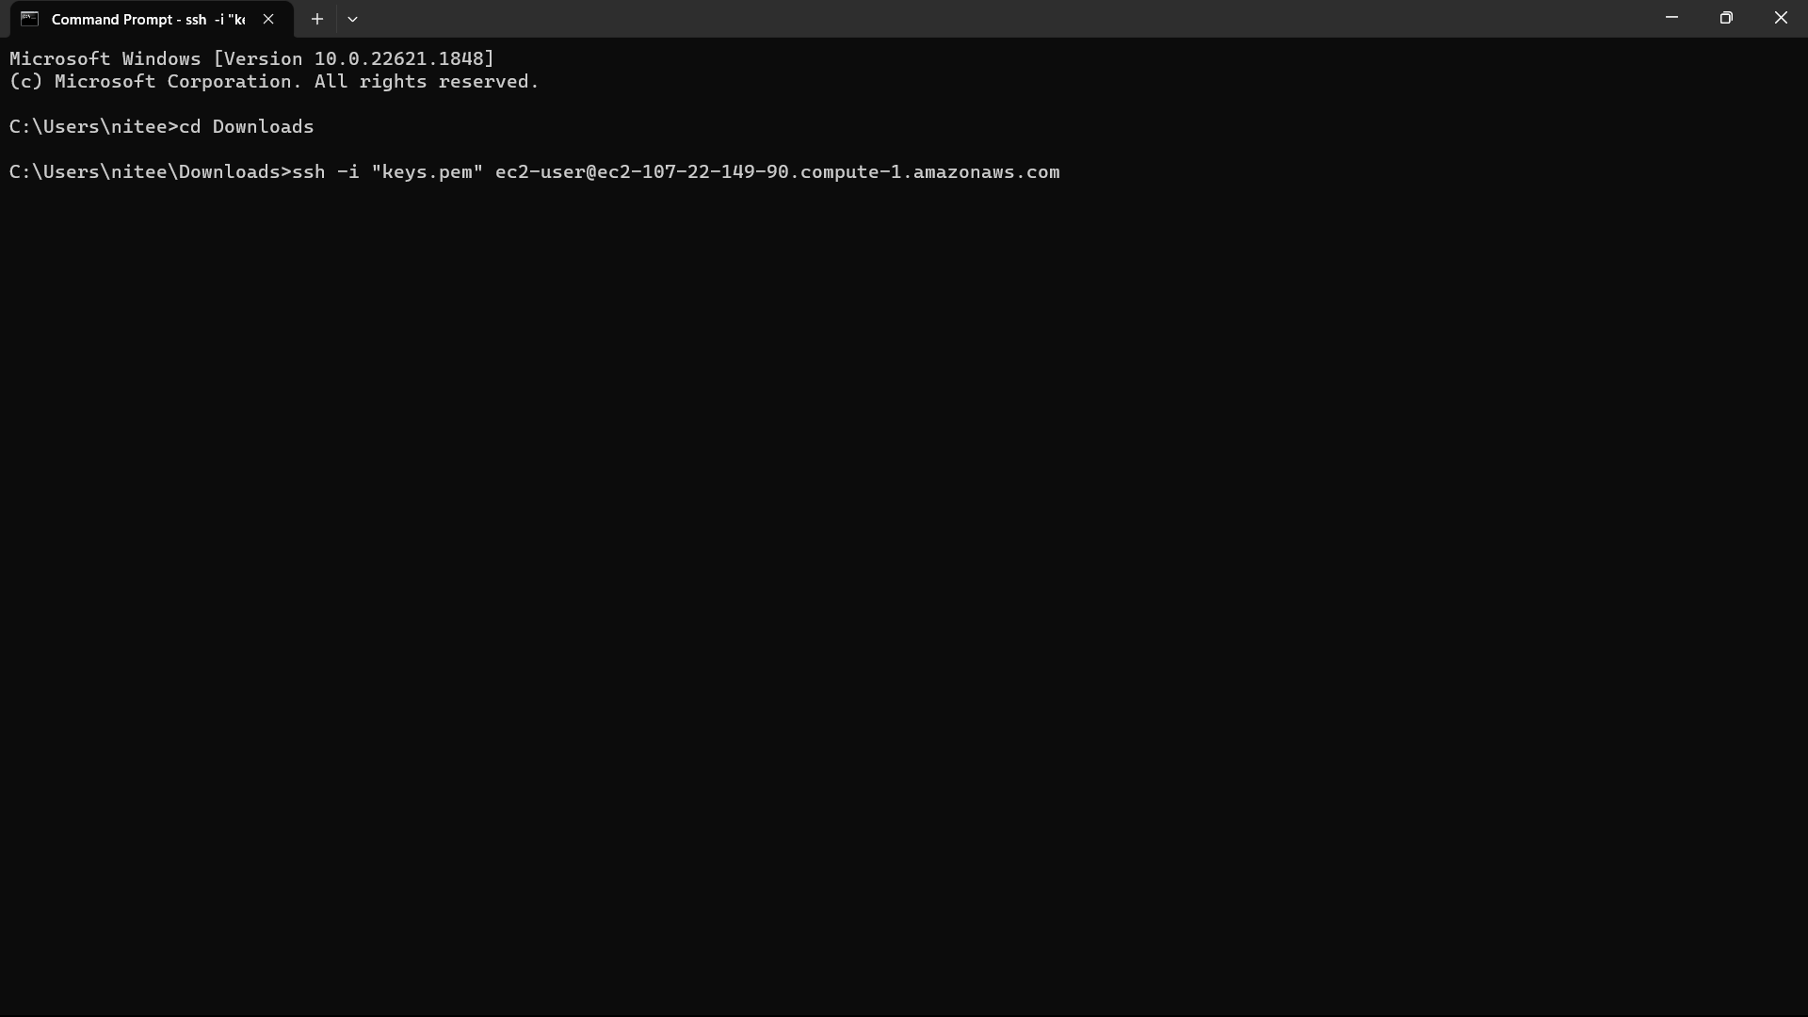

18)Type “yes” and click enter.

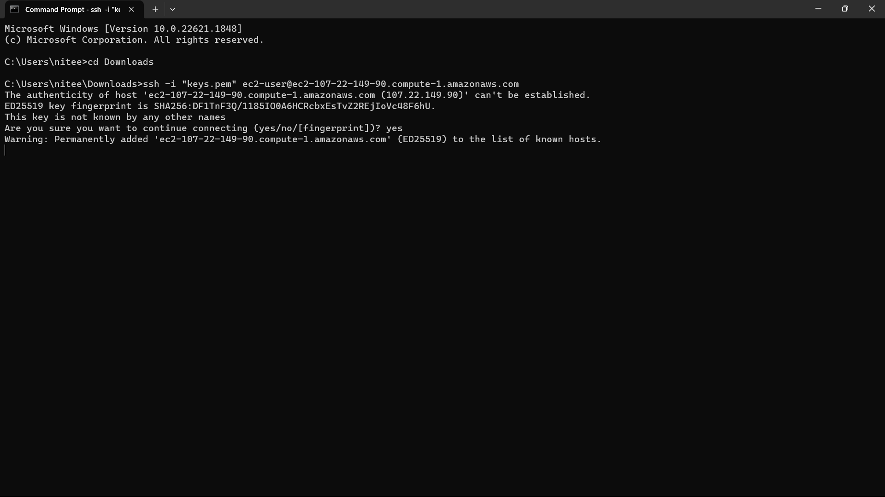

19)Now the instance server is opened in our local machine.

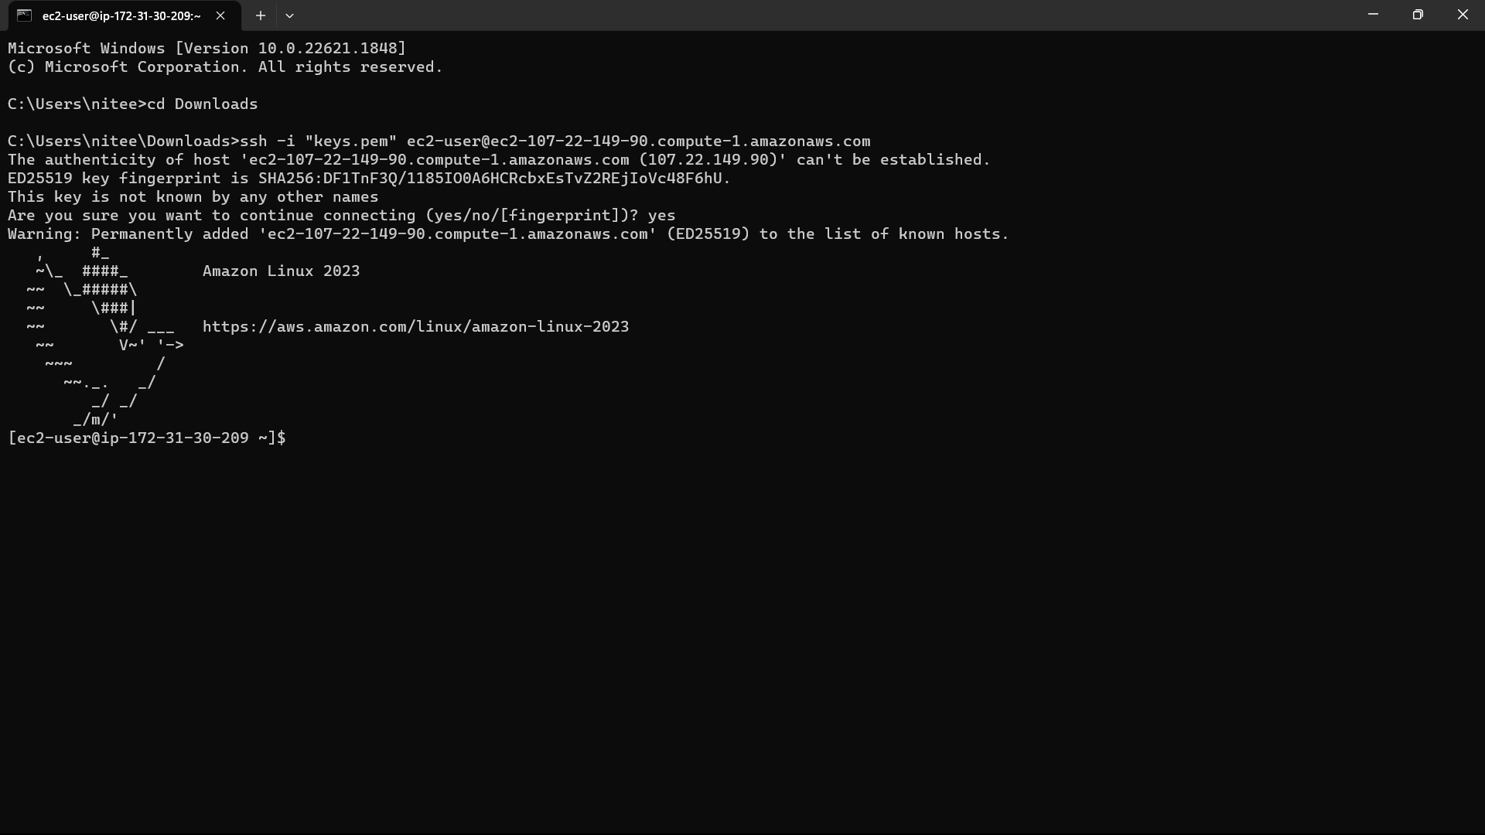

20)Update the system using the command “sudo yum update”.

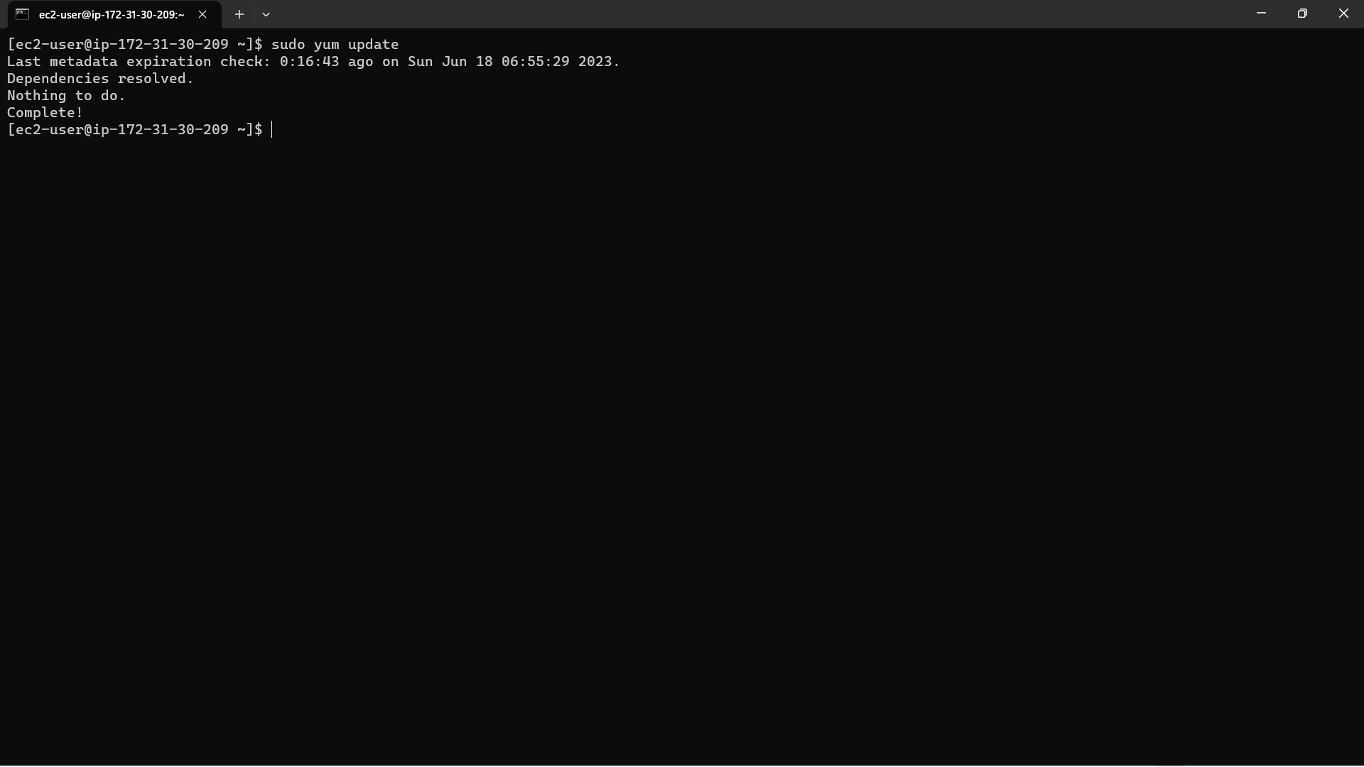

21)Open this link in your browser: <https://developer.hashicorp.com/terraform/downloads?product_intent=terraform>. Paste the below command in ec2 instance to install terraform.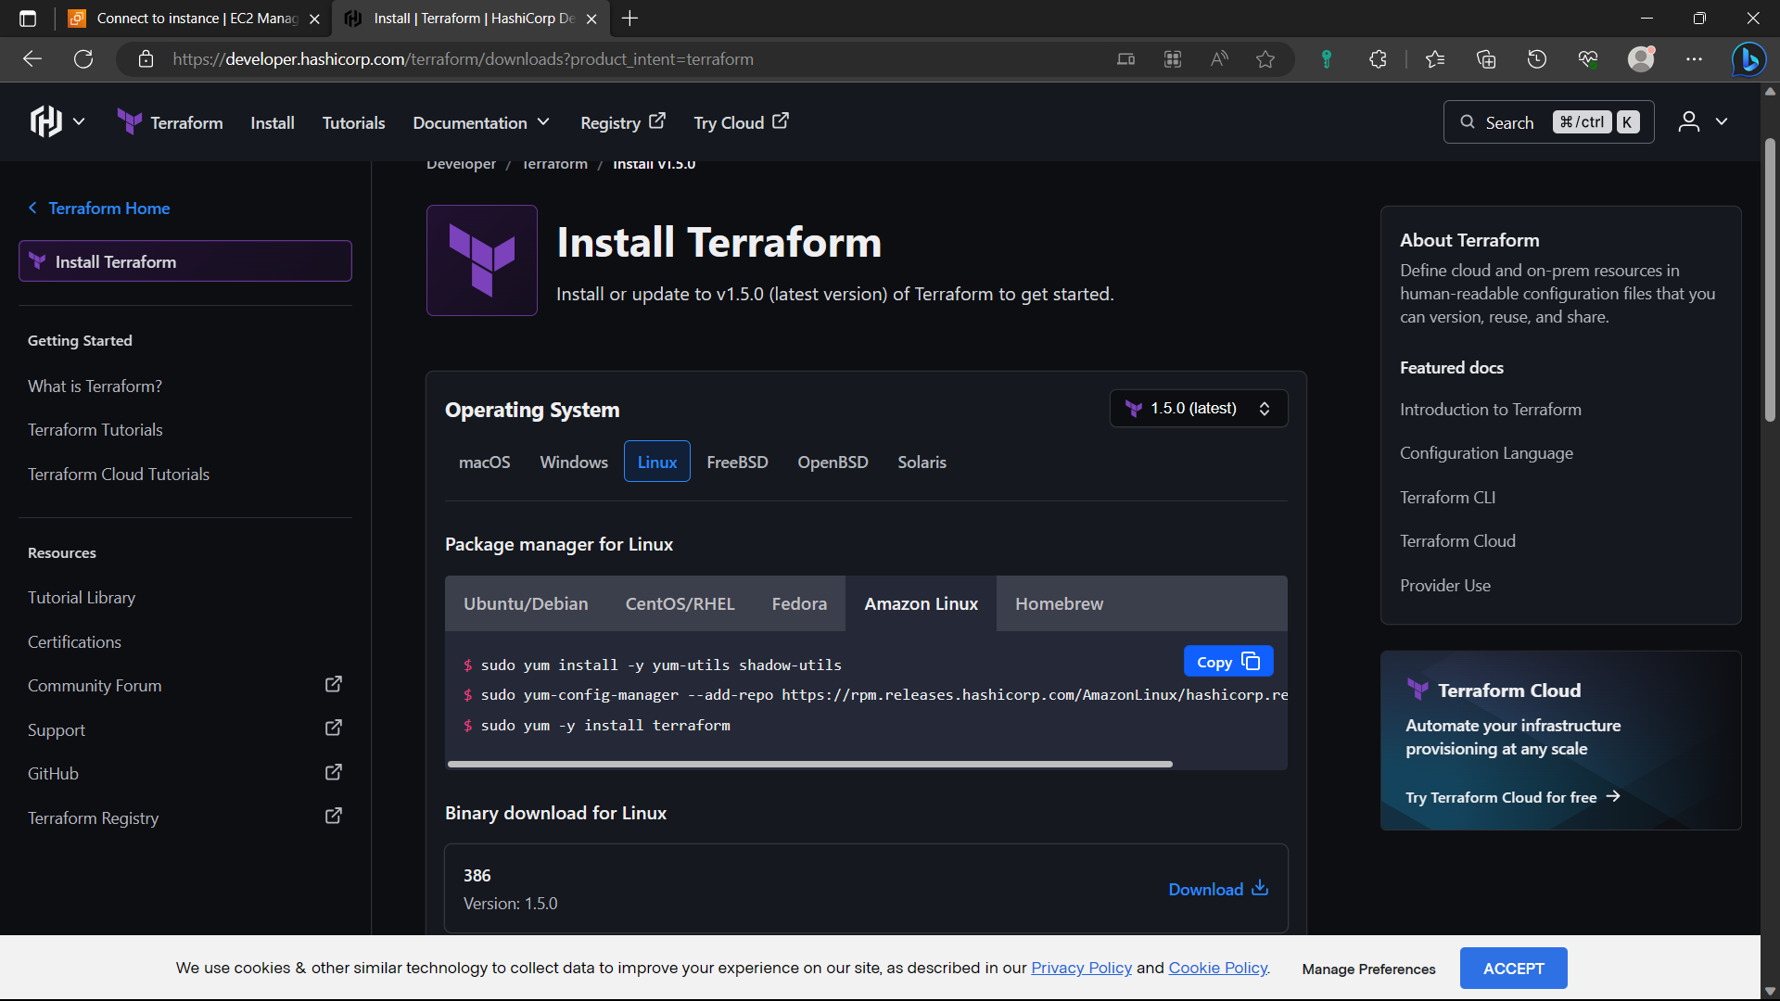

22)Now the Terraform is installed.

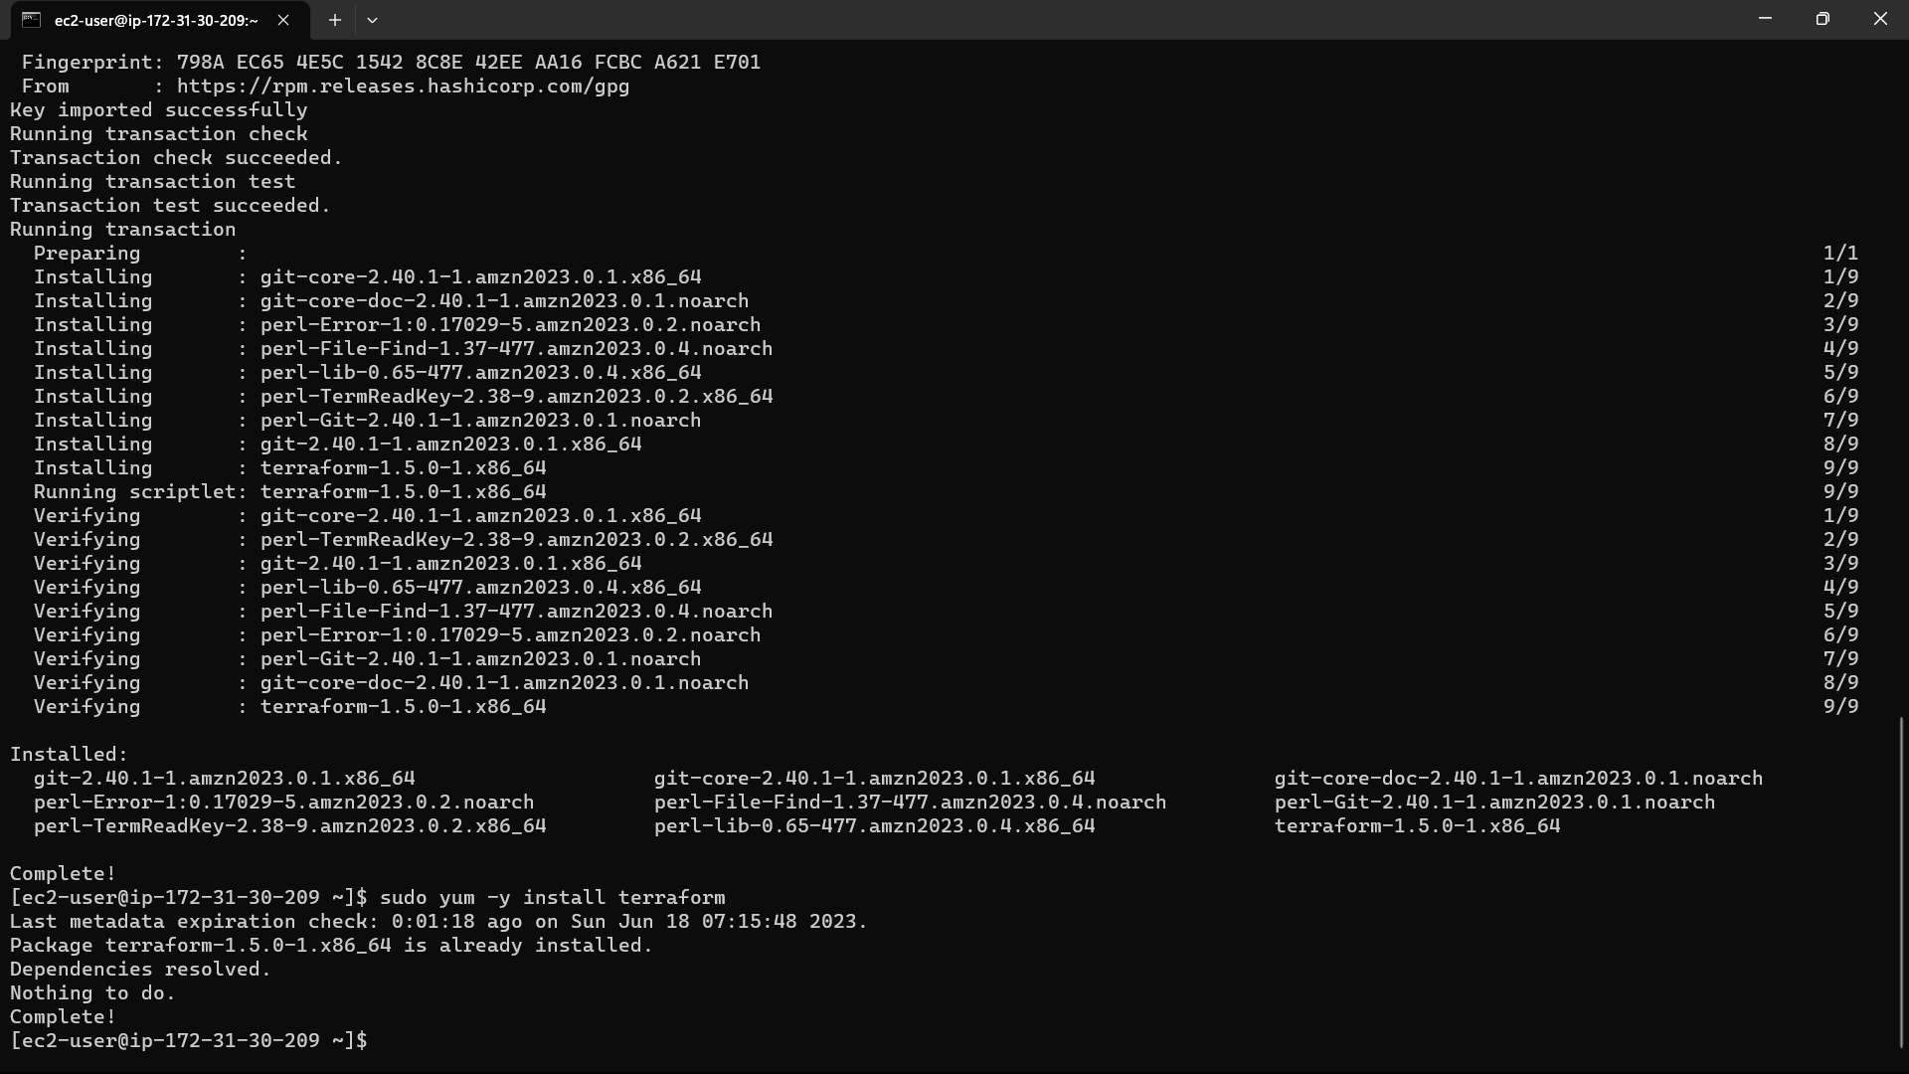

23)Create a folder(or)directory to store configuration files.

Command: “mkdir foldername”—“mkdir ter”.check if it is created or not using the command “ls”.

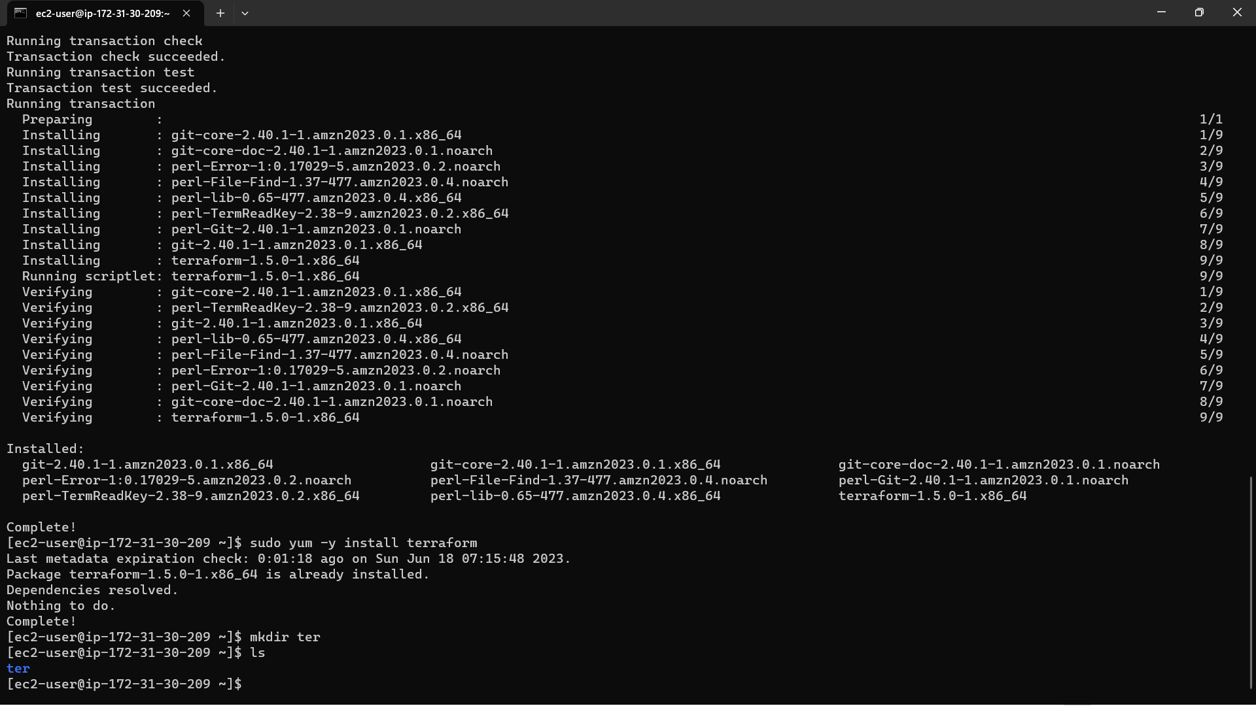

24)Click on profile and select the “security credentials” option.

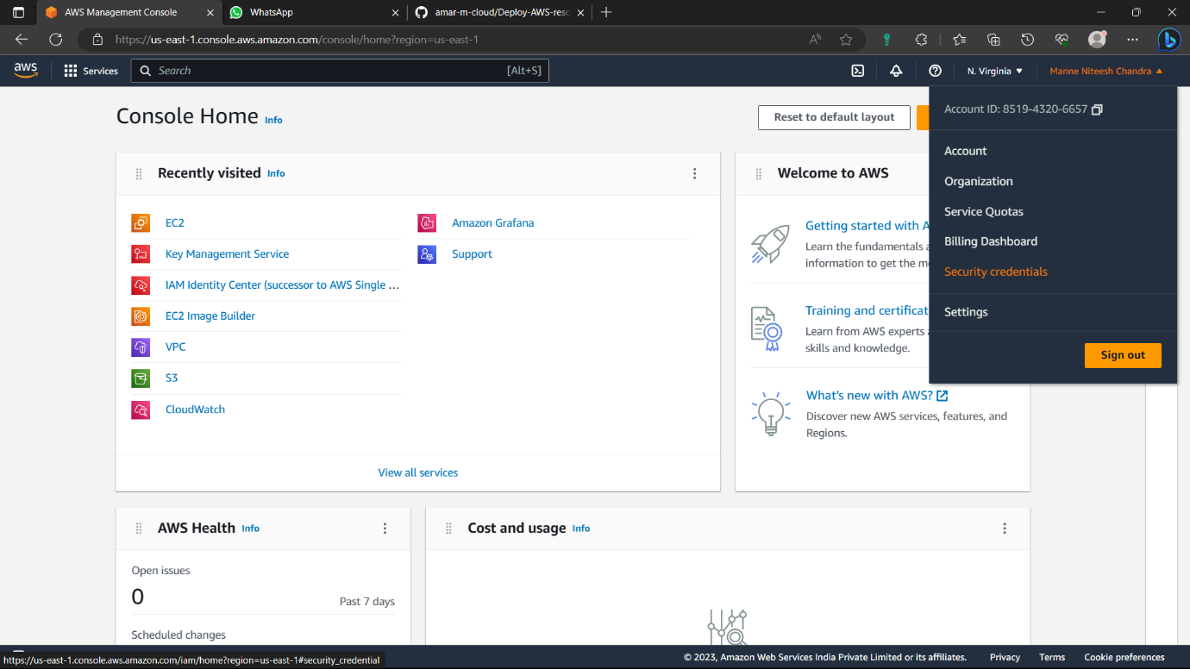

25)Come down and click on “create access key” from Access key.

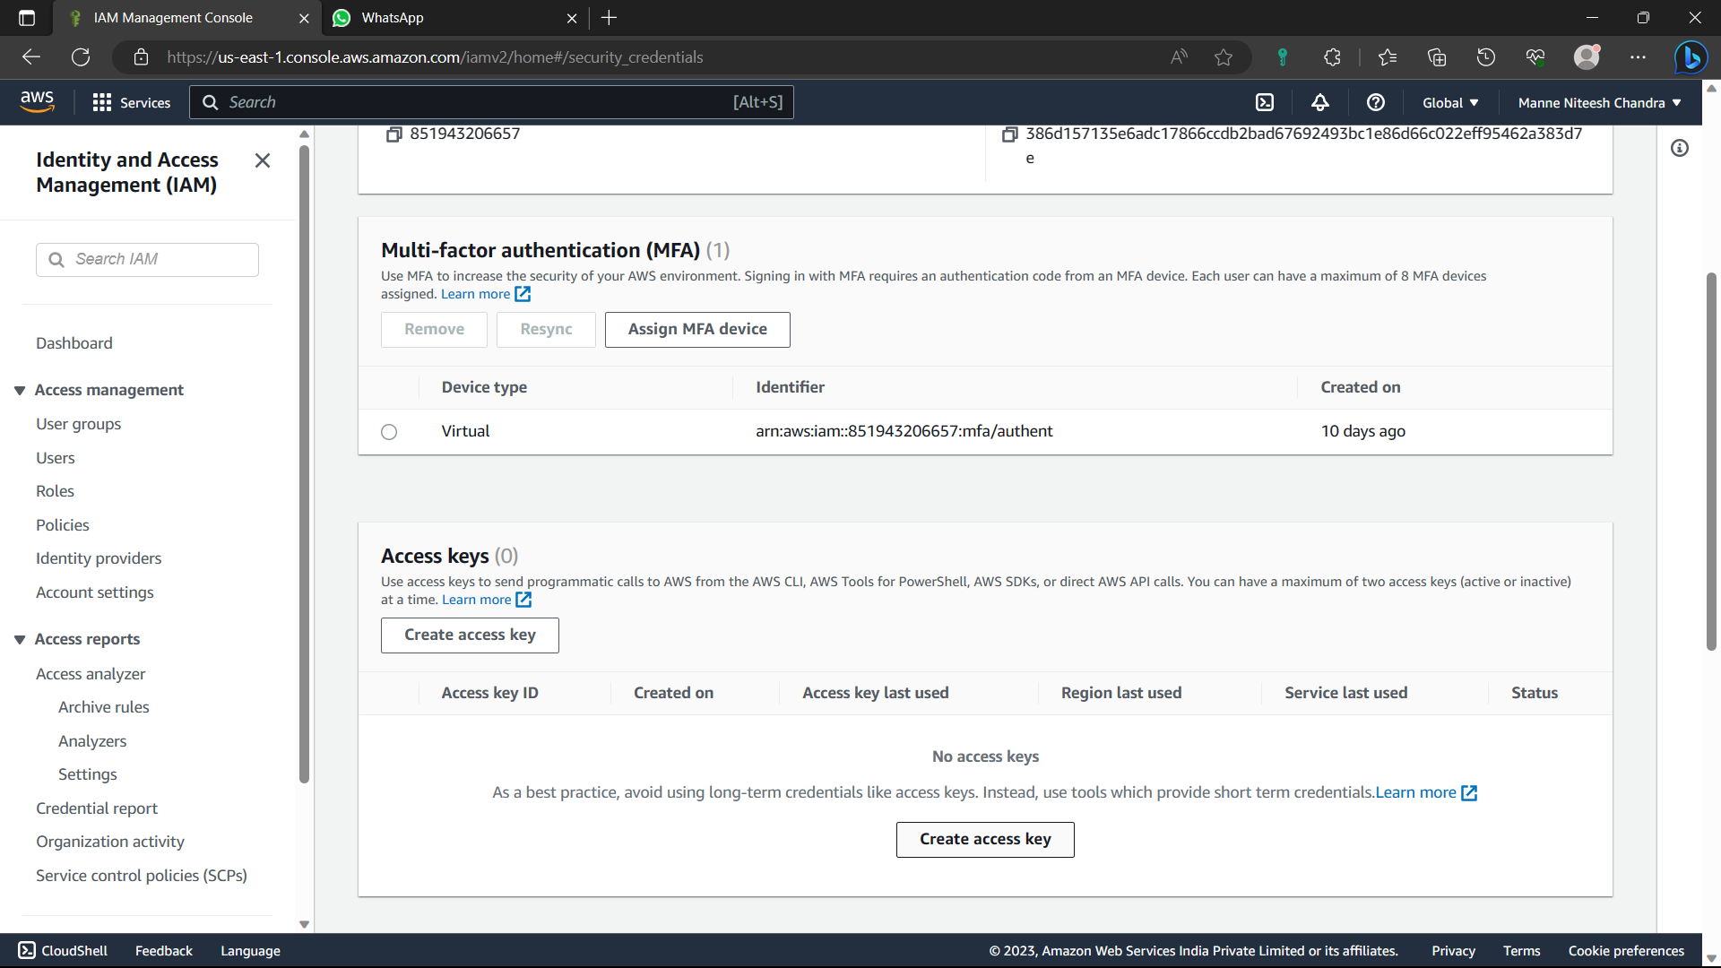

26)Enable “I understand” option and click on “Create access key”.

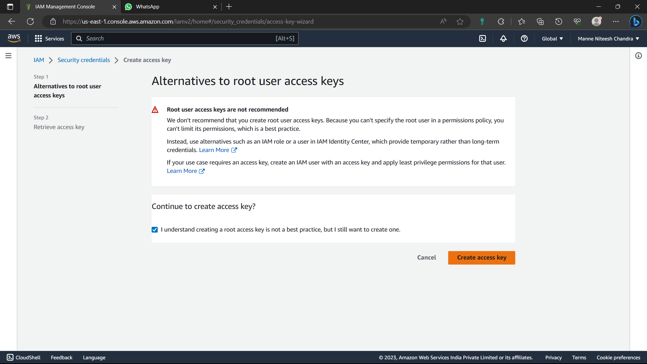

27)Now the key is created. Click on “Download.csv file” option to save a copy in local host. After that click on “Done”.

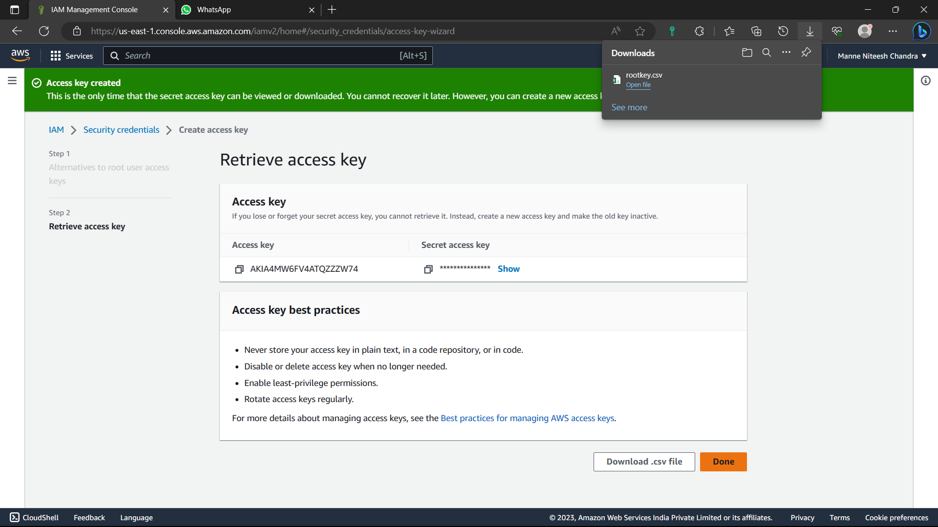

28)Now go to the repository you created by using the command -: “cd reponame” - “cd ter”.

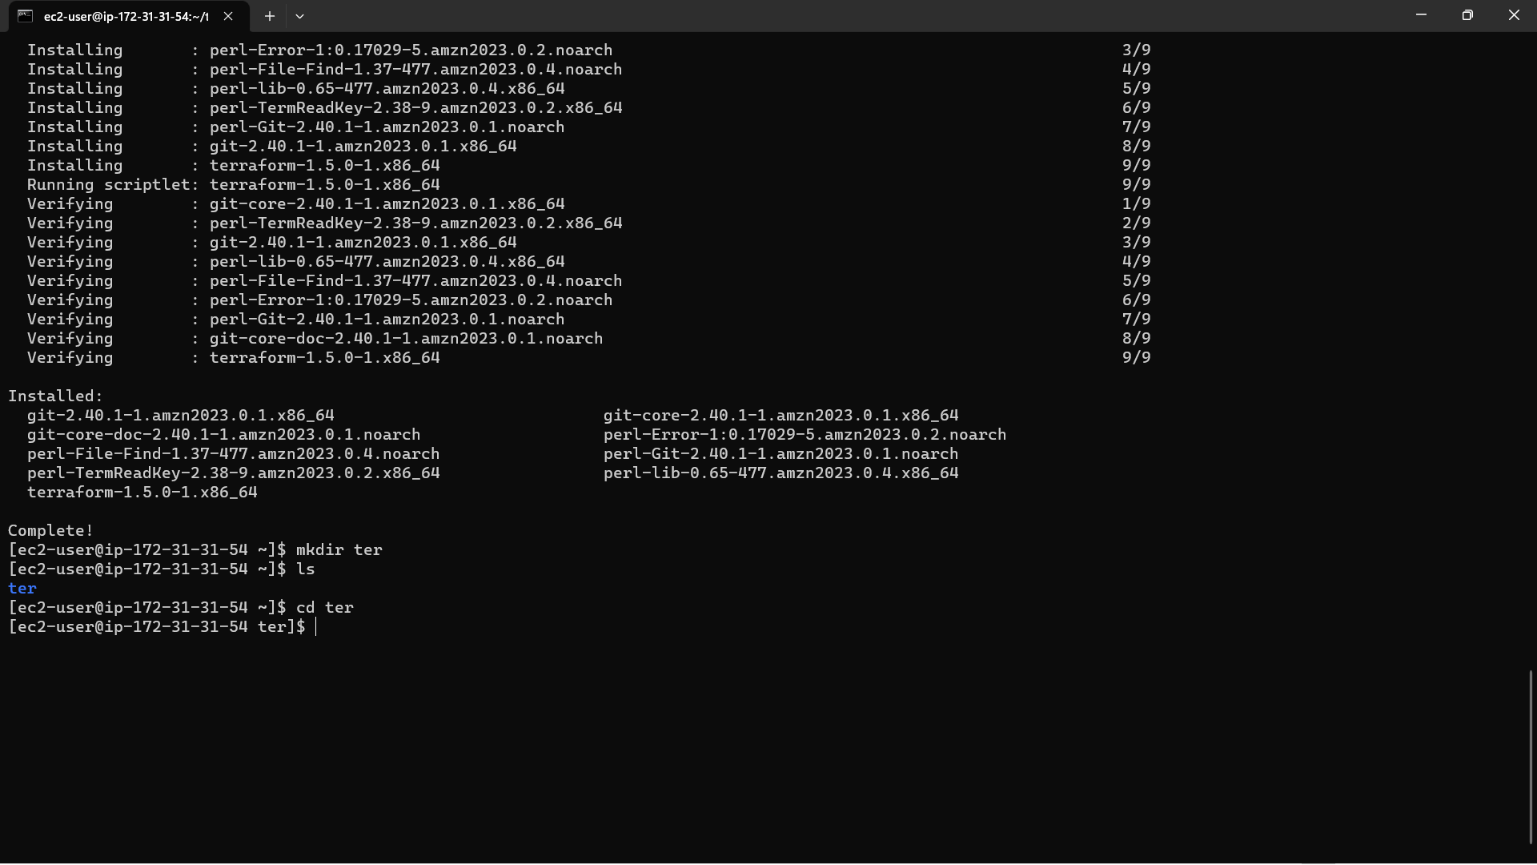

29)Now create a file (provider file) write the access key details in it. “vi filename” - “vi prov.tf”.

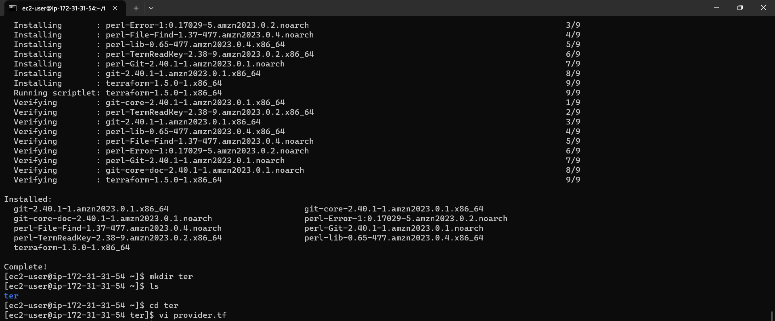

To insert data click on “insert” button in keyboard.

To save the data after writing the date click “esc” button the “shift+:wq”

30)After providing the access key use the below commands

terraform init : to initialize the repository for terraform commands

terraform validate: to validate the files.

terraform apply –auto-approve : to approve the infrastructure.

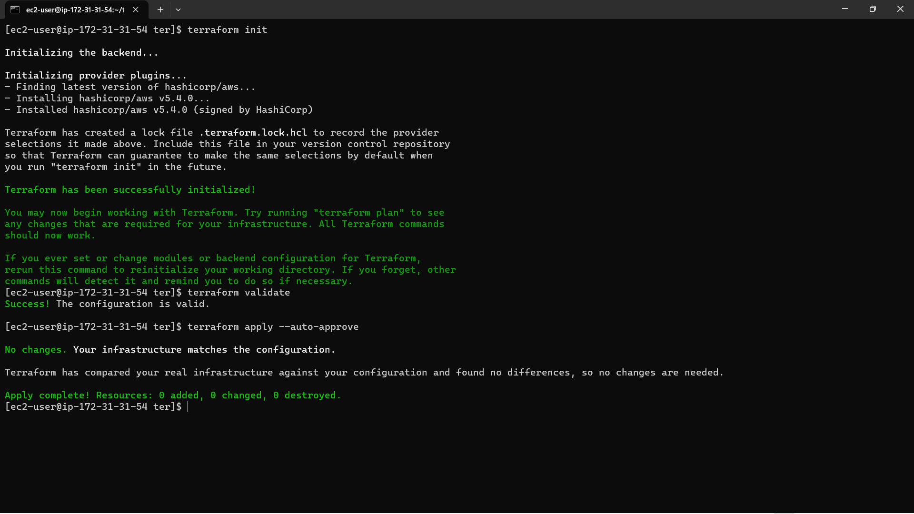

31)Now create a file for vpc: “vi vpc.tf”. Type the script required to create vpc in AWS. And save it, then type the command “terraform apply”.

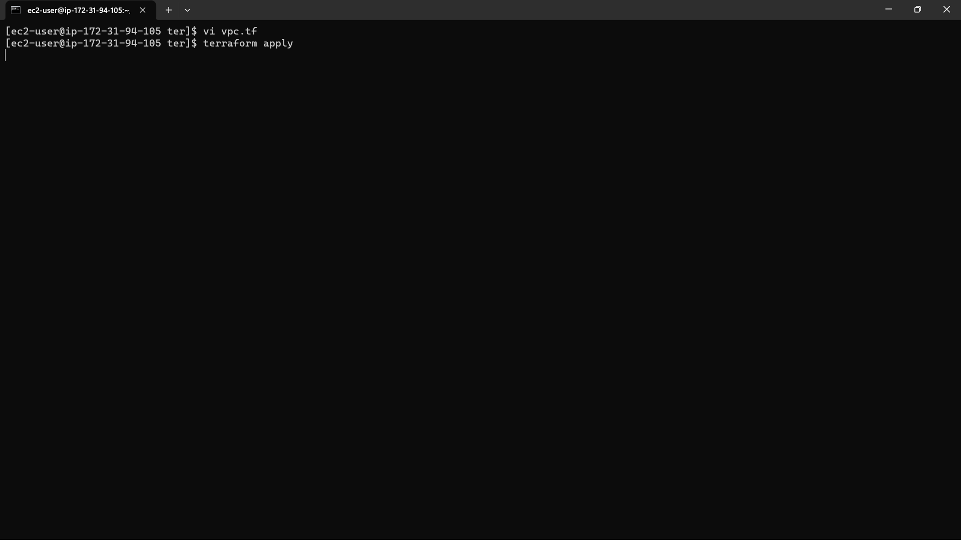

32)Now the VPC infrastructure is created.

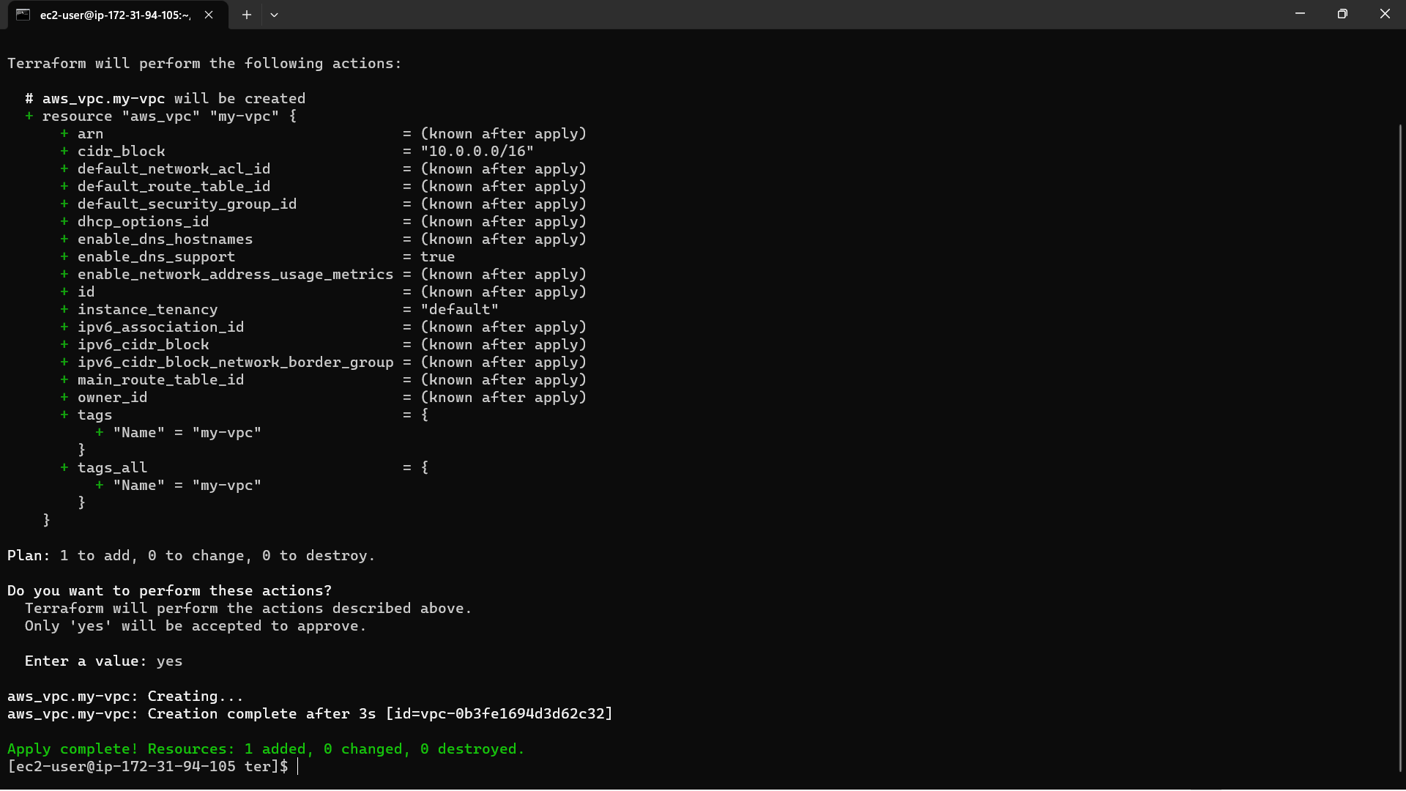

33)Check it in AWS Console whether it is created or not.

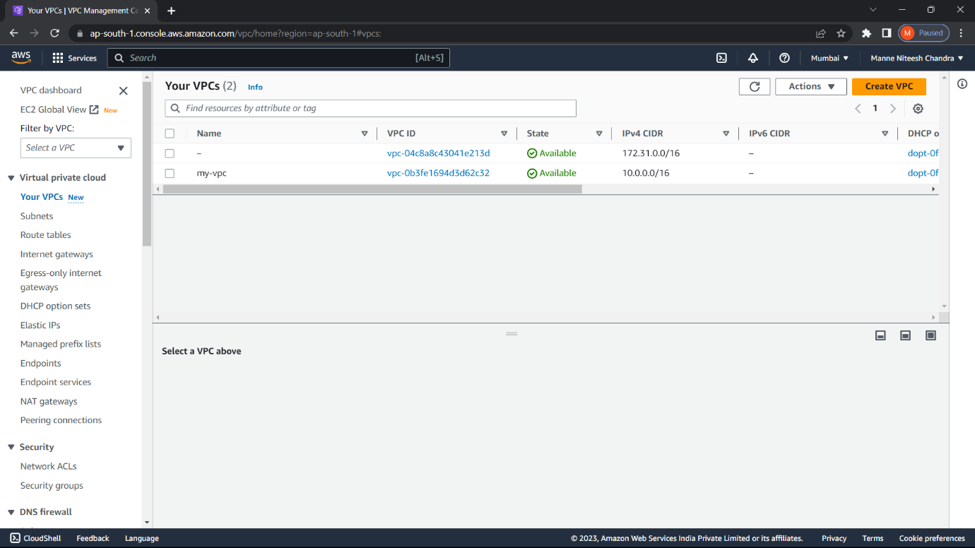

Now the VPC is created in AWS.

34)Create a file for public-subnet as “vi pub-sub.tf” and write the script required to create 2 public subnets. And type the command : “terraform apply”.

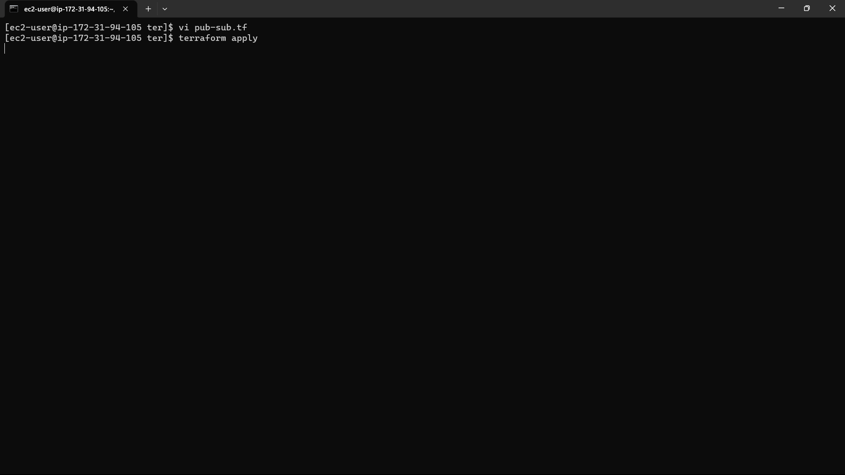

35)Now the infrastructure is created.

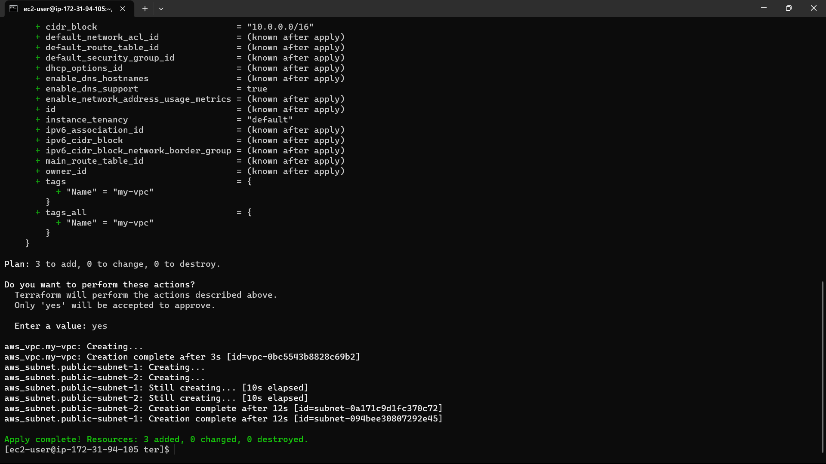

36)Check in console i.e., they are created or not.

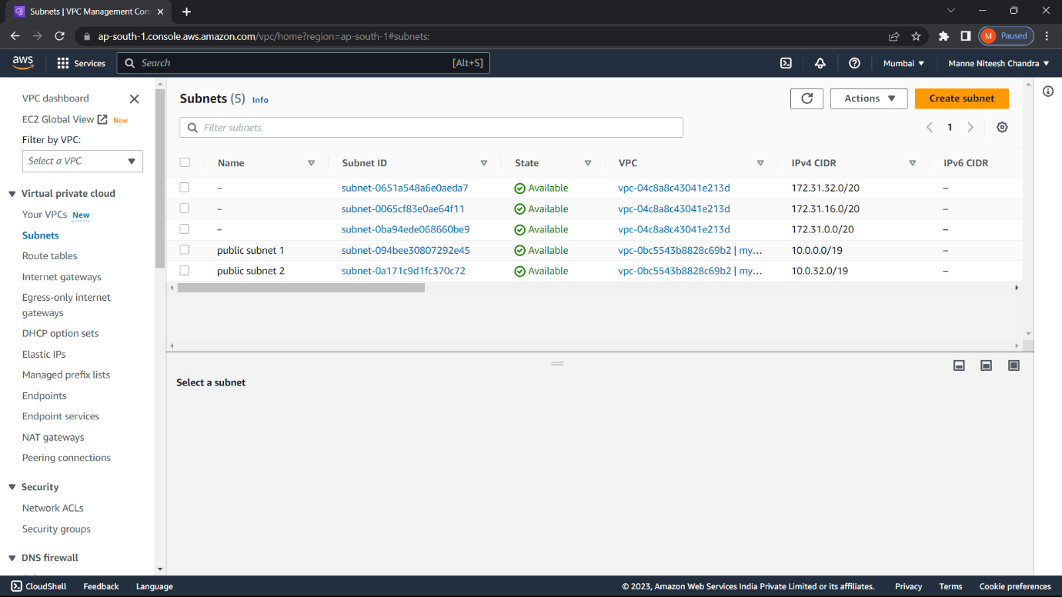

They are created in AWS.

37) Create a file for private-subnet as “vi pvt-sub.tf” and write the script required to create 2 private subnets. And type the command : “terraform apply”.

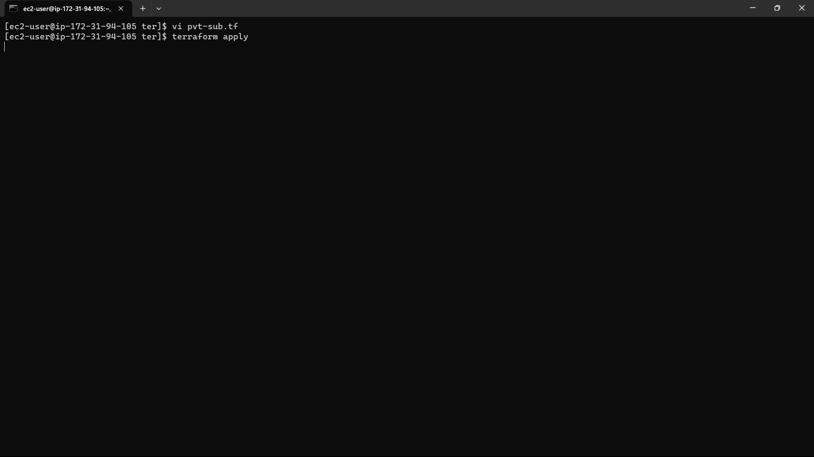

38)Now the infrastructure is created.

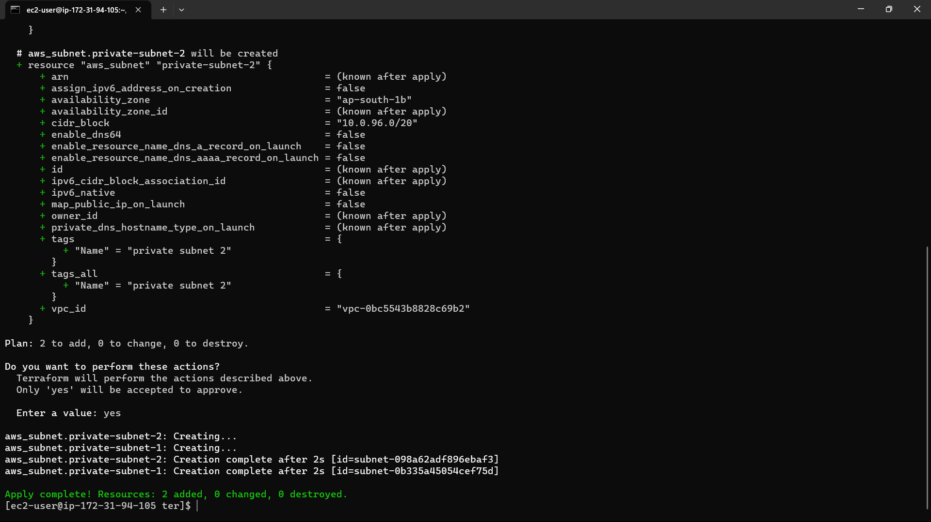

39) Check in console i.e., they are created or not.

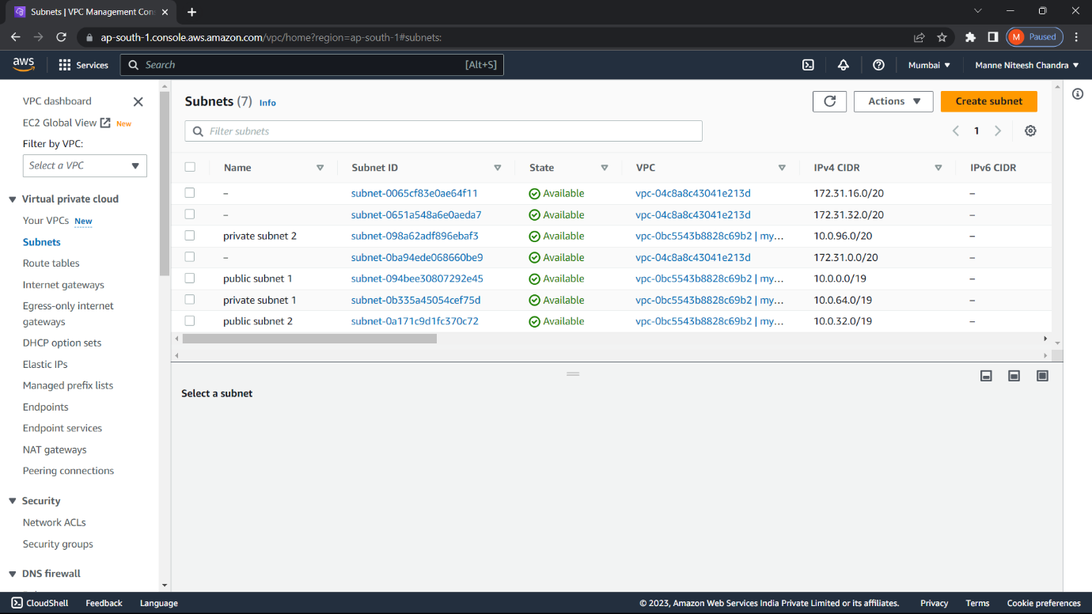

They are created in AWS.

40) Create a file for route tables as “vi routetbale.tf” and write the script for both public and private subnet route tables. And type the command : “terraform apply”.

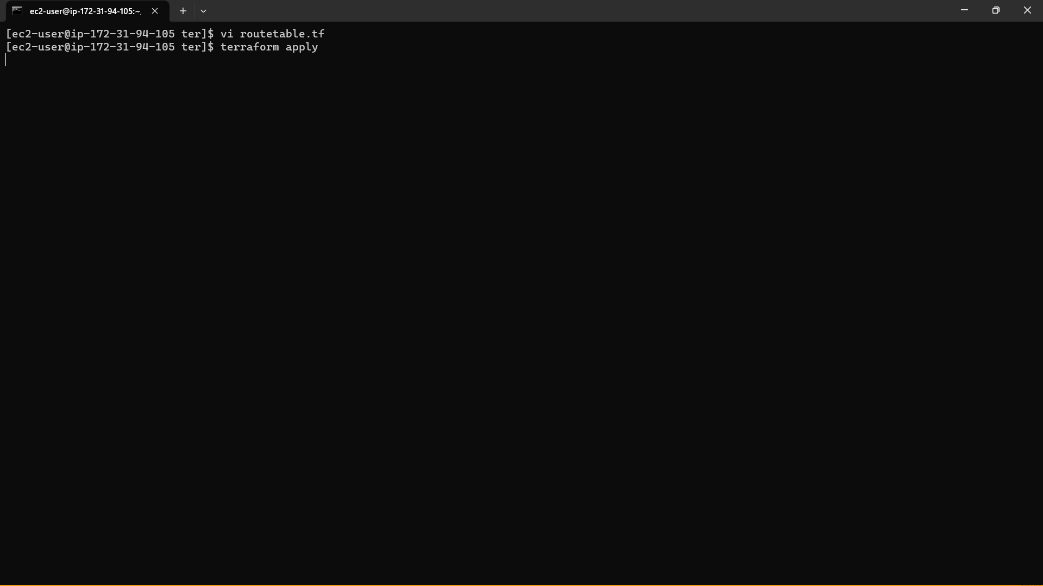

41)Now the infrastructure is created.

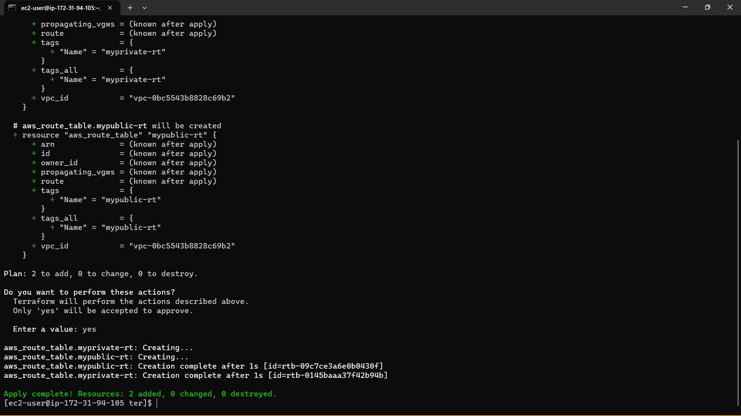

42) Check in console i.e., they are created or not.

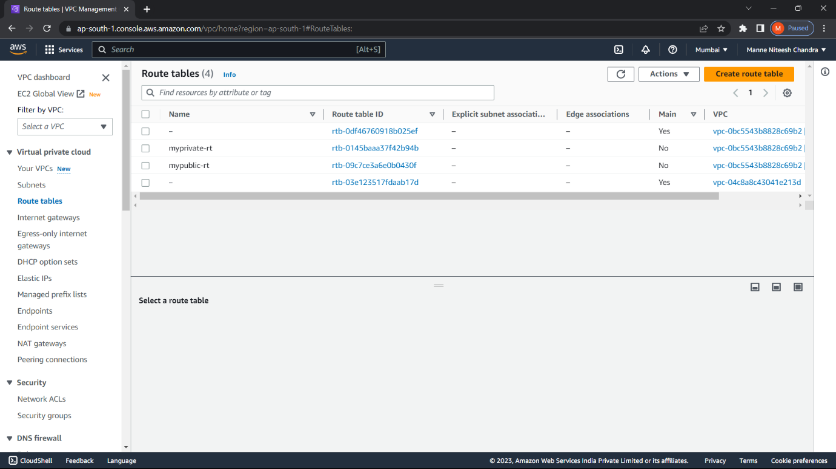

It is created in AWS.

43) Create a file for internet gateway as “vi igw.tf” and write the script required to create internet gateway. And type the command : “terraform apply”.

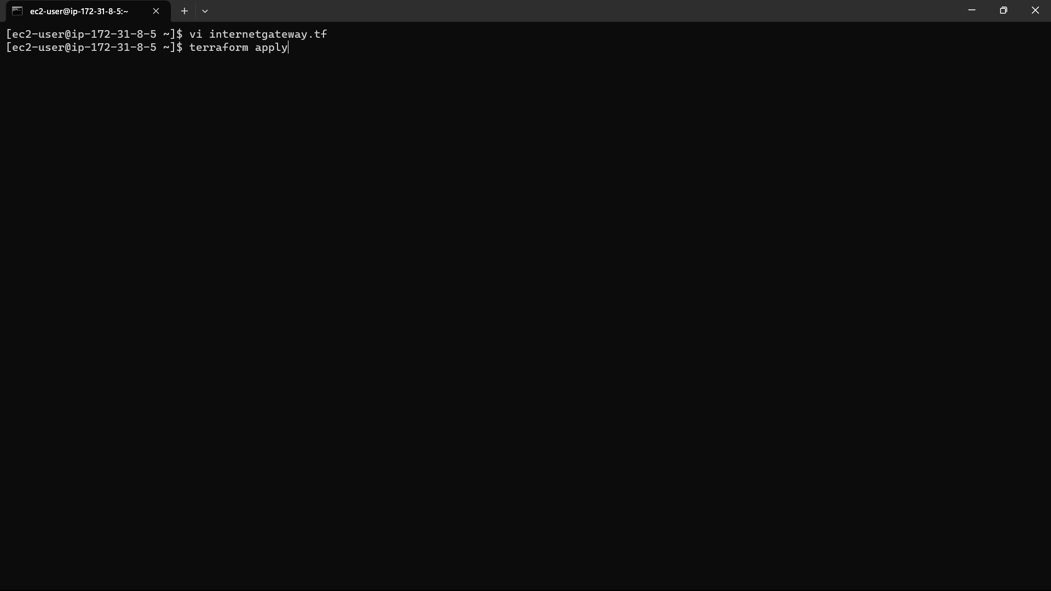

44)Now the infrastructure is created.

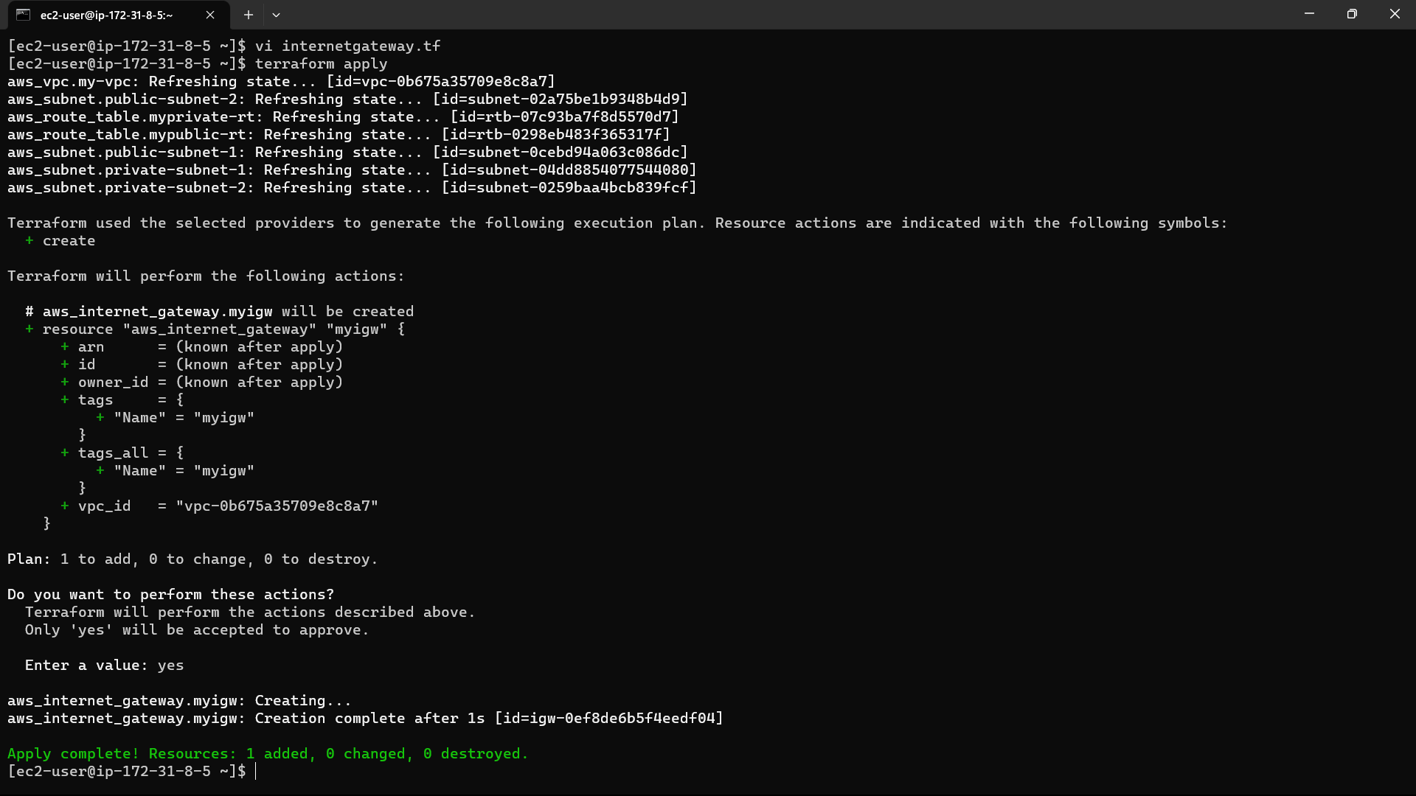

45) Check in console i.e., they are created or not.

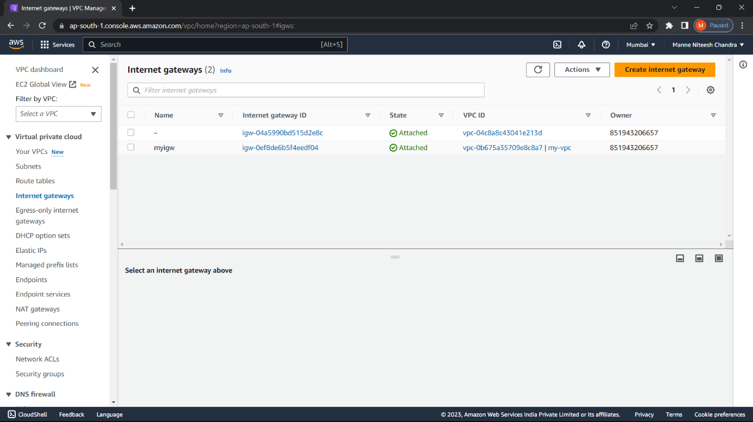

It is created in AWS.

46) Create a file for route table association as “vi rassociation.tf”, Here the route table is assigned with subnets and write the script required to create route table association. And type the command : “terraform apply”.

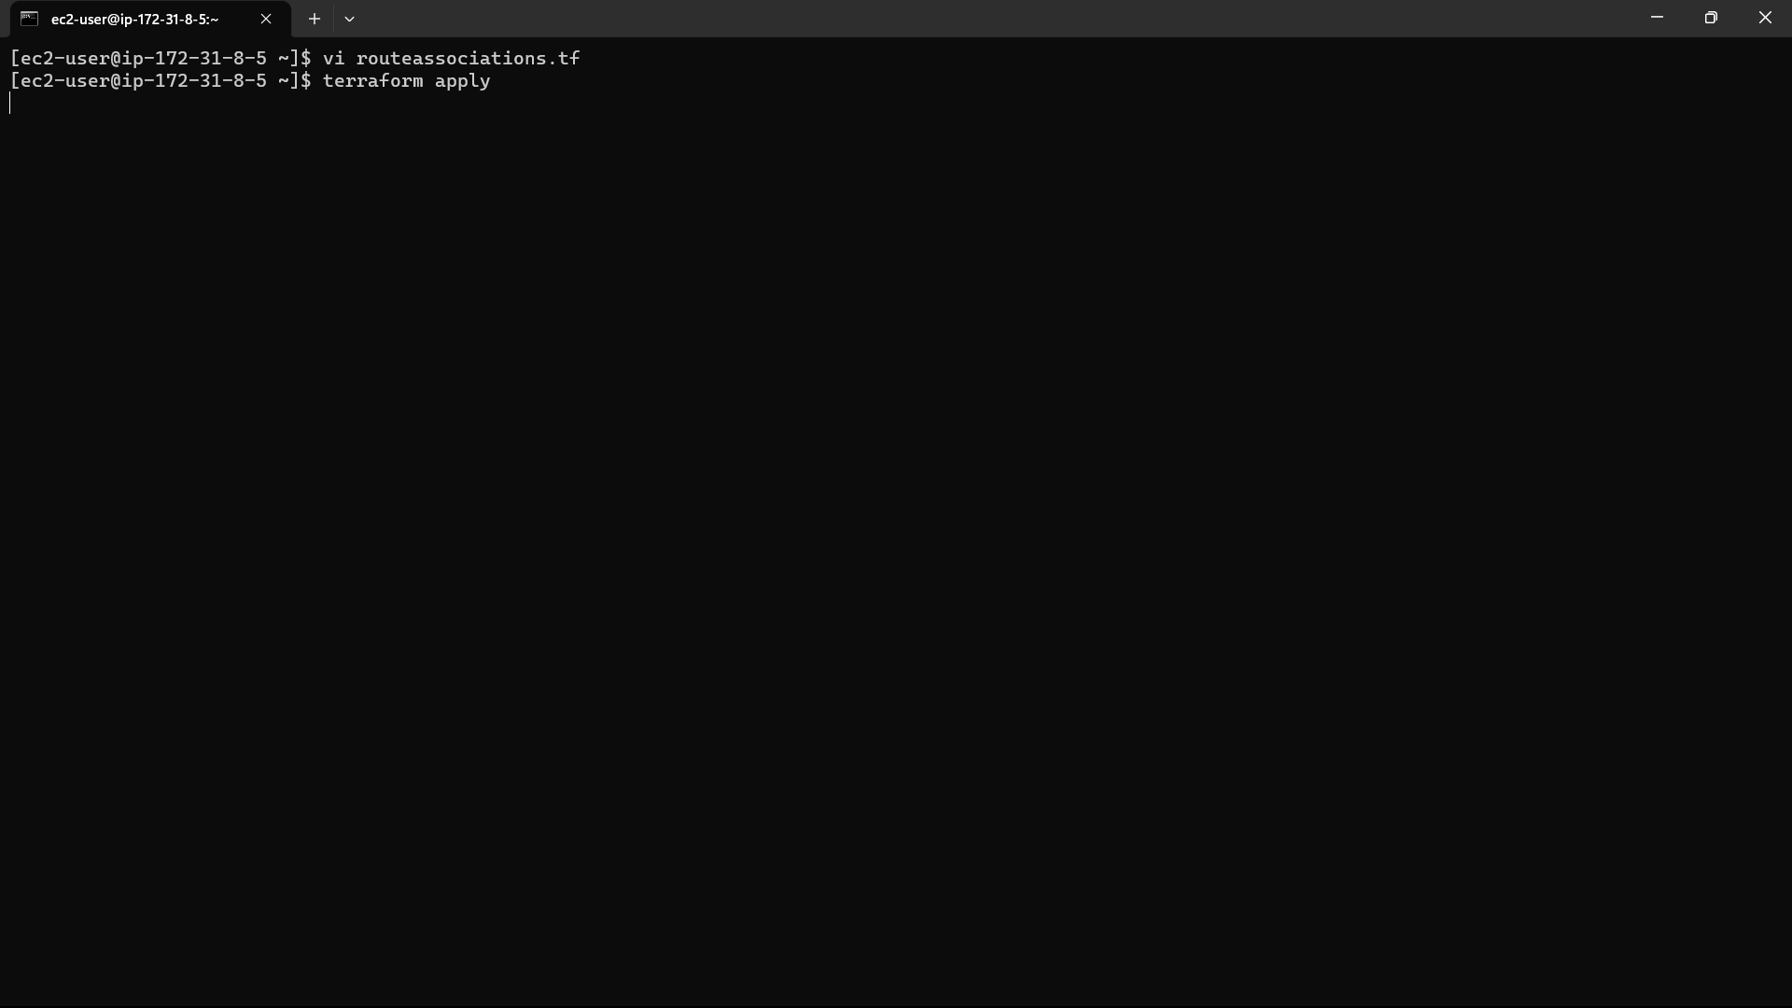

47)Now the infrastructure is created. Check in AWS console i.e., created or not.

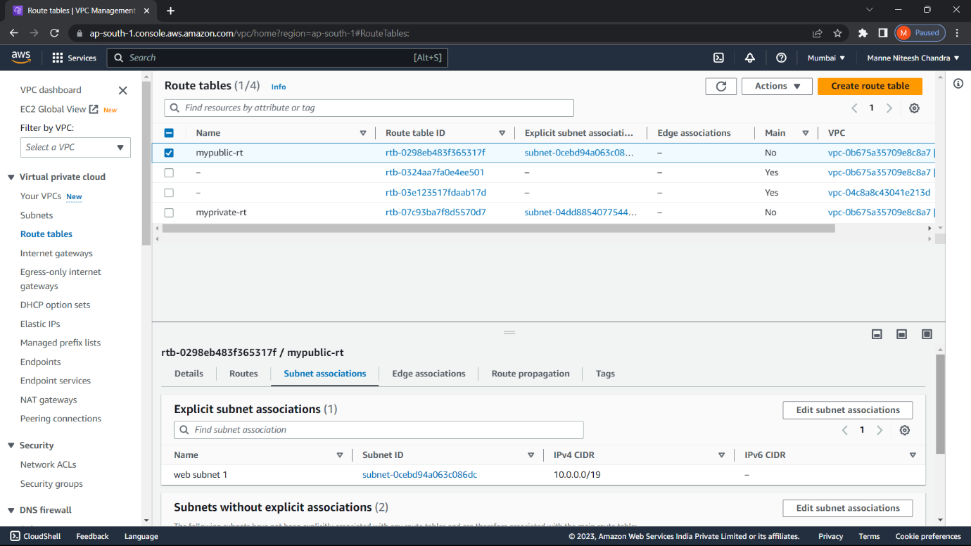

It is created in AWS.

48) Create a file for security group as “vi security.tf” and write the script required to create security group. And type the command : “terraform apply”.

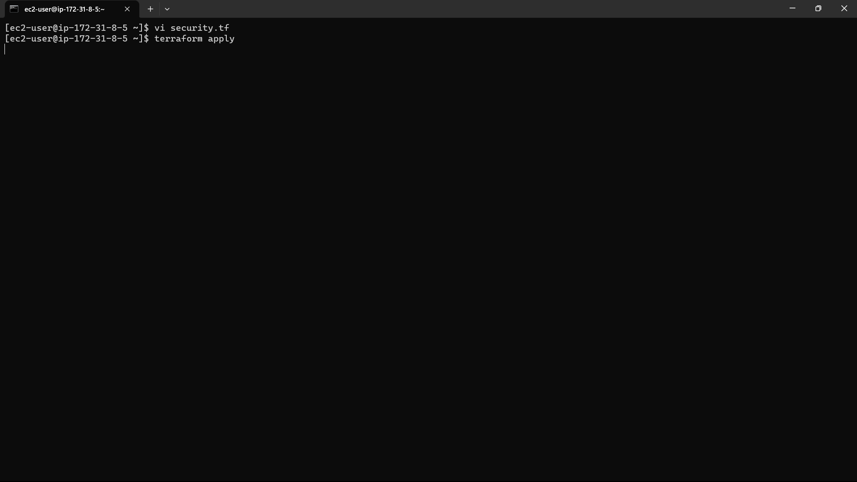

49)Now the infrastructure is created.

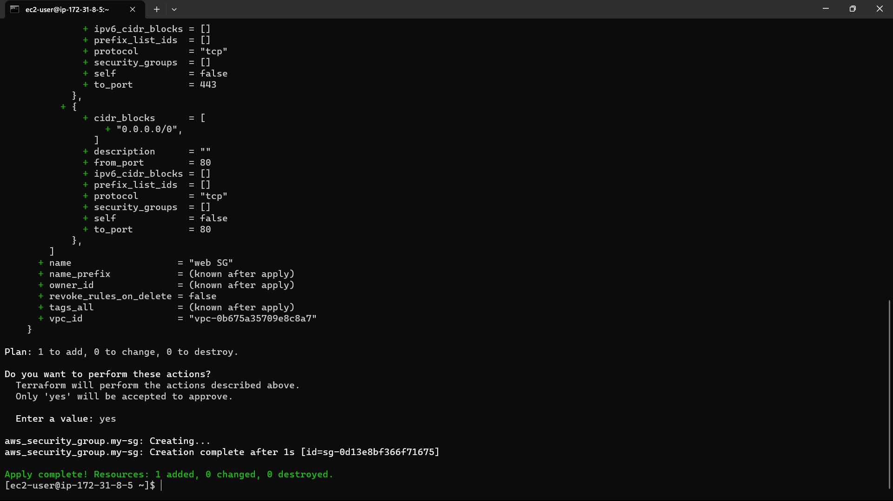

50)Check in AWS console i.e., created or not.

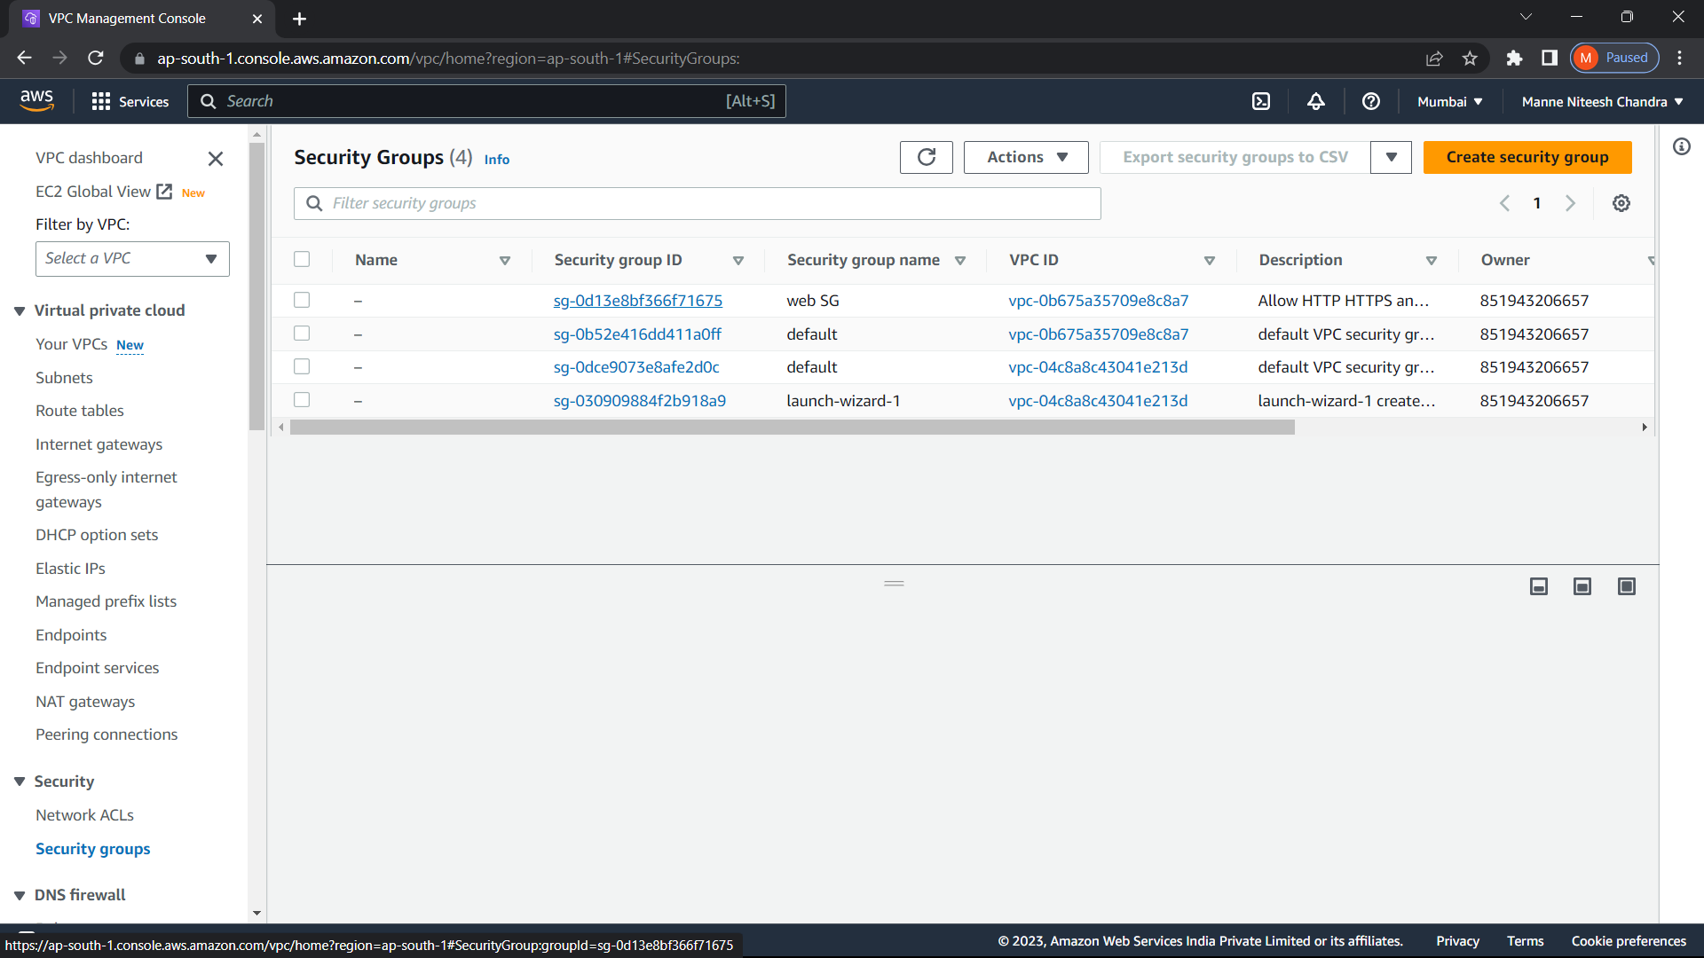

It is created in AWS.

51) Create a file for database as “vi database.tf” and write the script required to create database. And type the command : “terraform apply”.

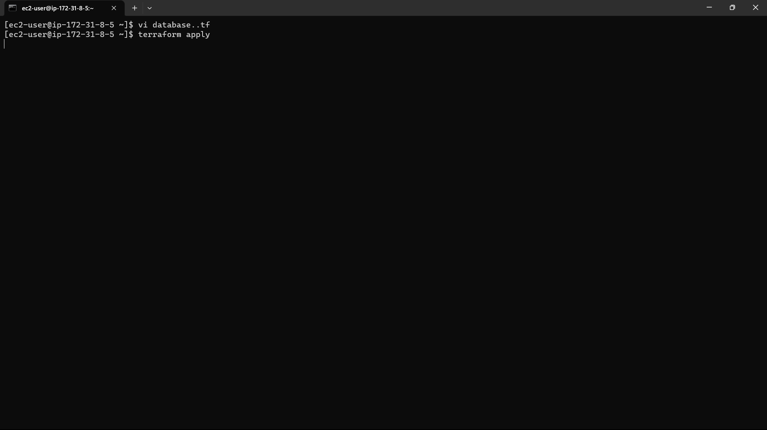

52)Now the infrastructure is created.

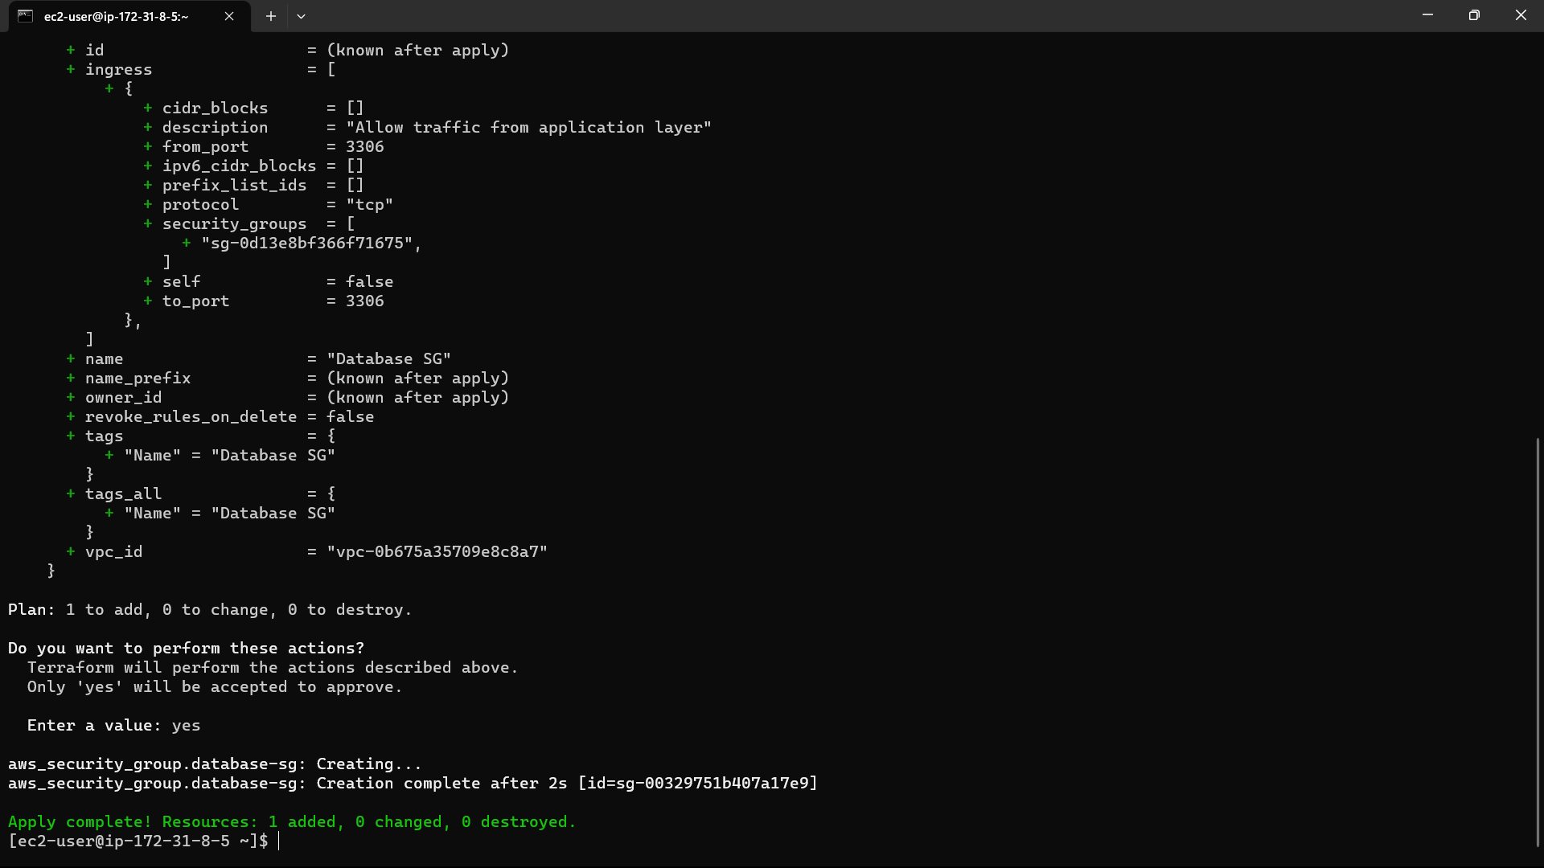

53)Create a file for user date as “vi file.sh”, the commands written in this file will automatically run after the instance is created and write the script required to create internet gateway. And type the command : “terraform apply”.

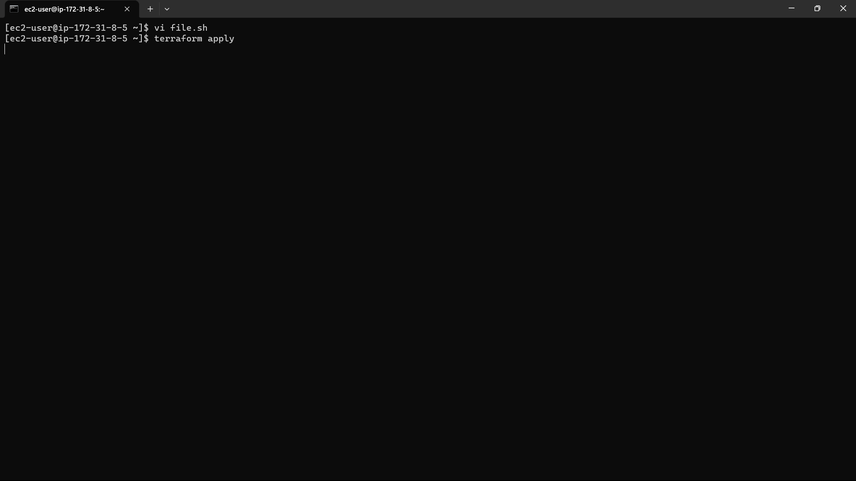

54)The file is approved by the terraform.

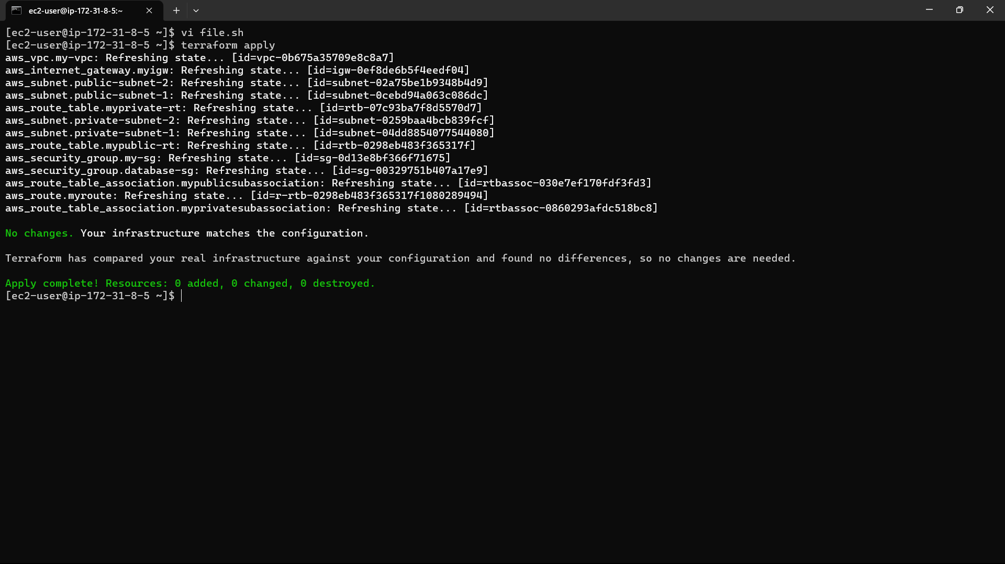

55)Create a file for EC2 Instance as “vi instance.tf” and write the script required to create EC2 Instance. And type the command : “terraform apply”.

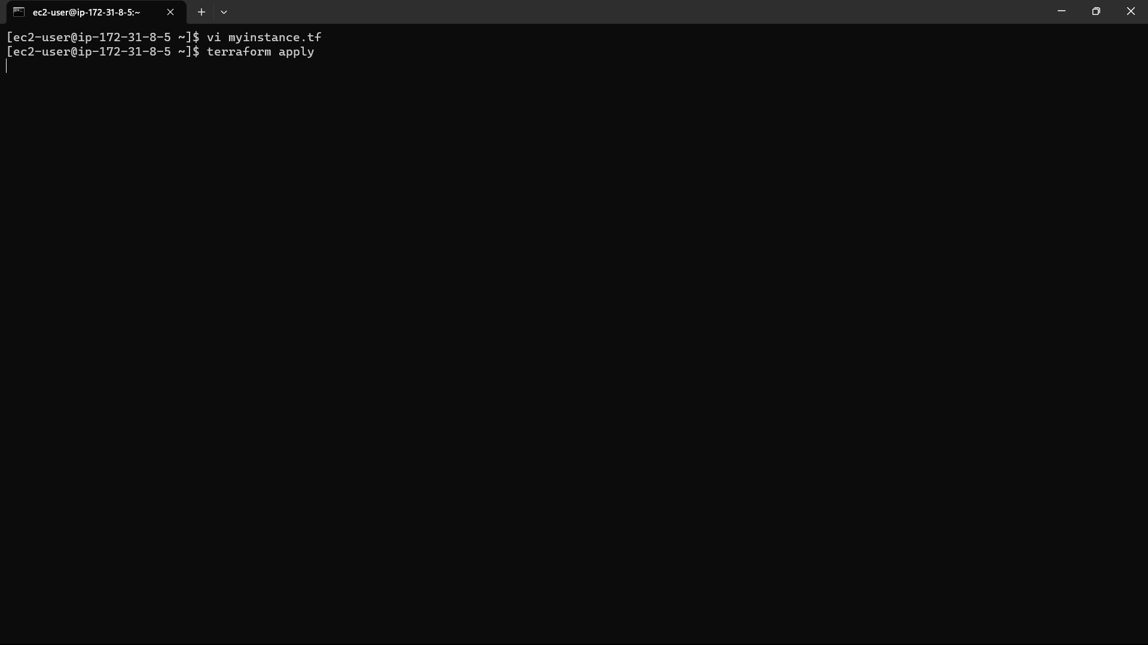

56)The infrastructure is created.

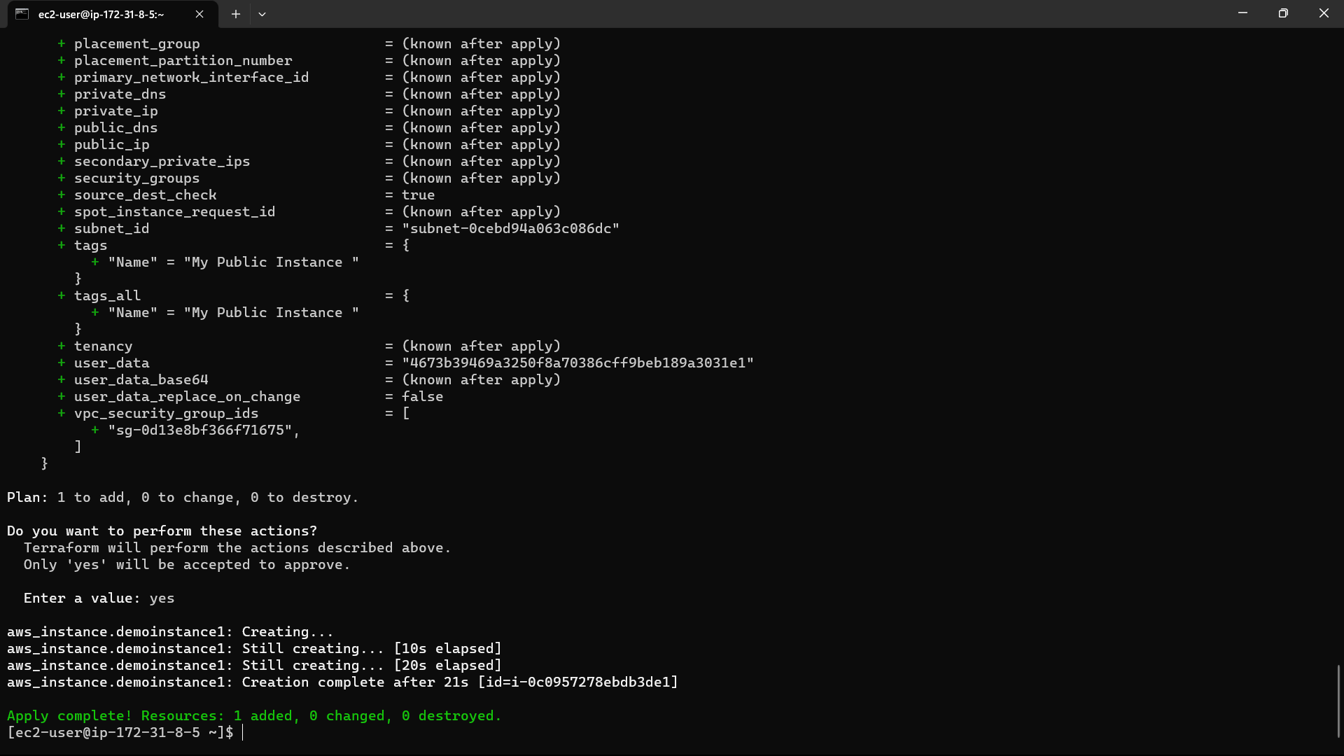

57)Check it is created or not in AWS.

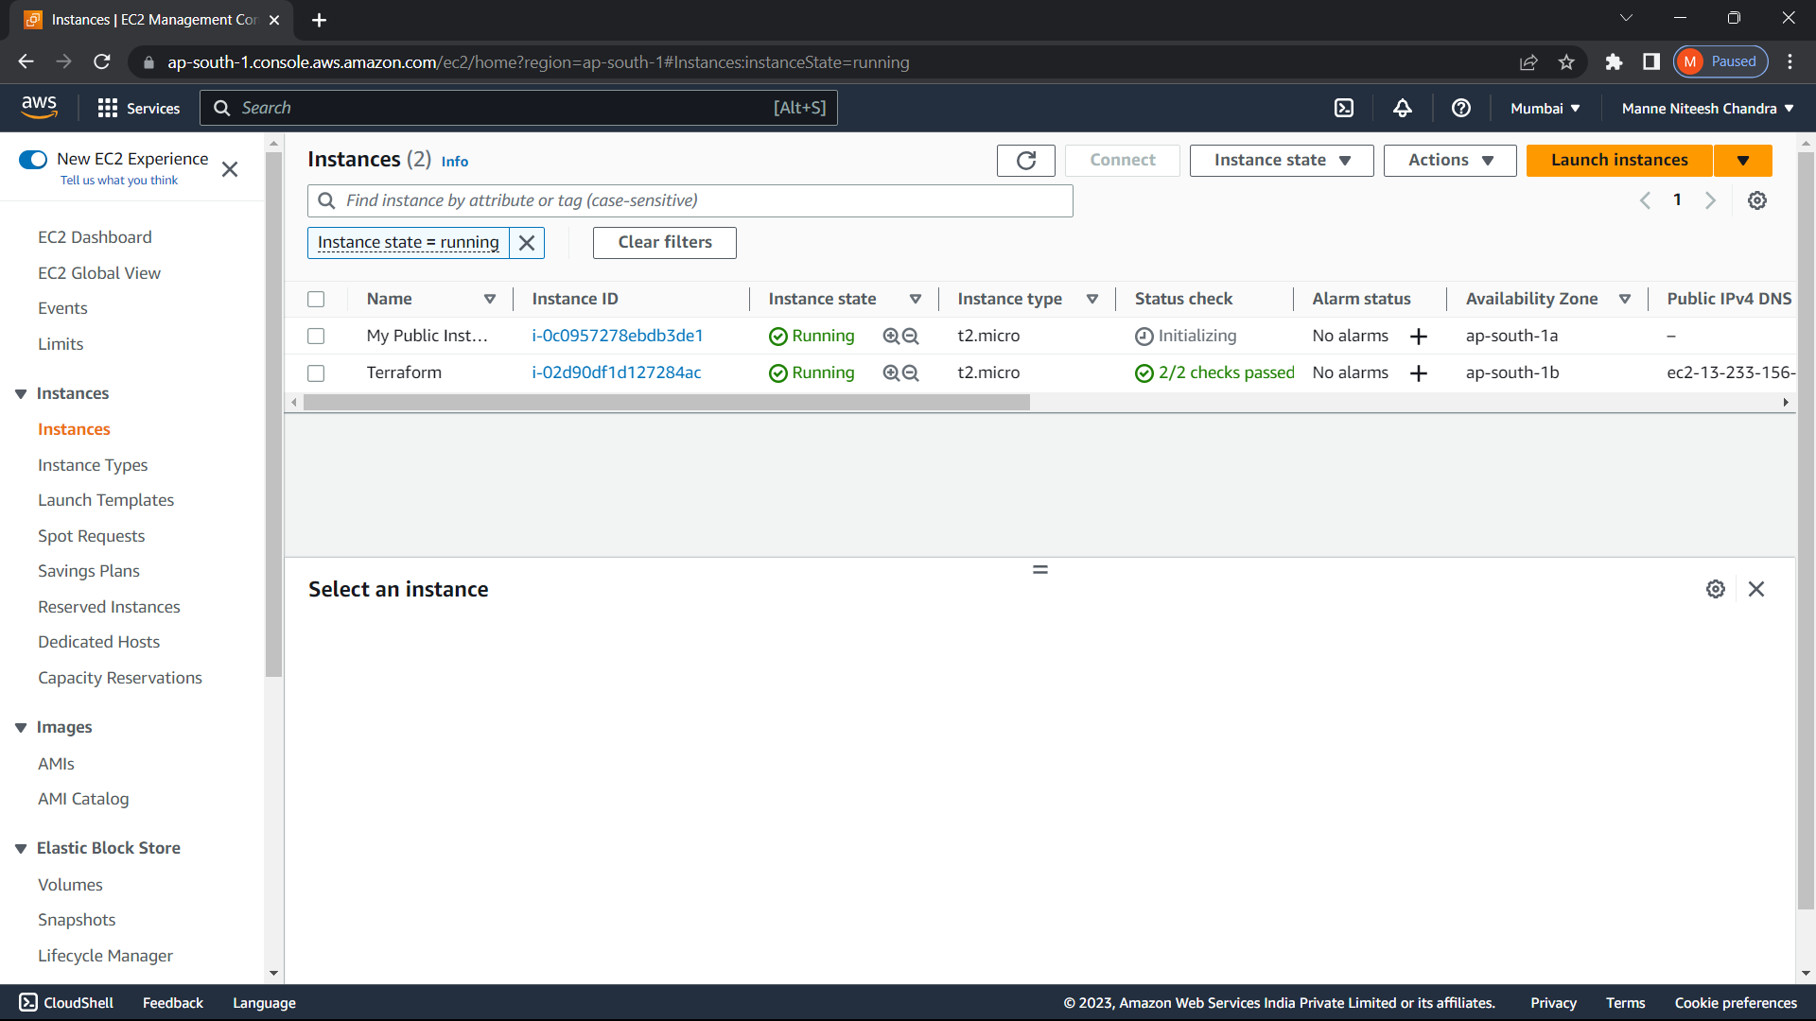

It is created in AWS.

58) Create a file for Load Balancer as “vi loadbalancer.tf” and write the script required to create load balancer. And type the command : “terraform apply”.

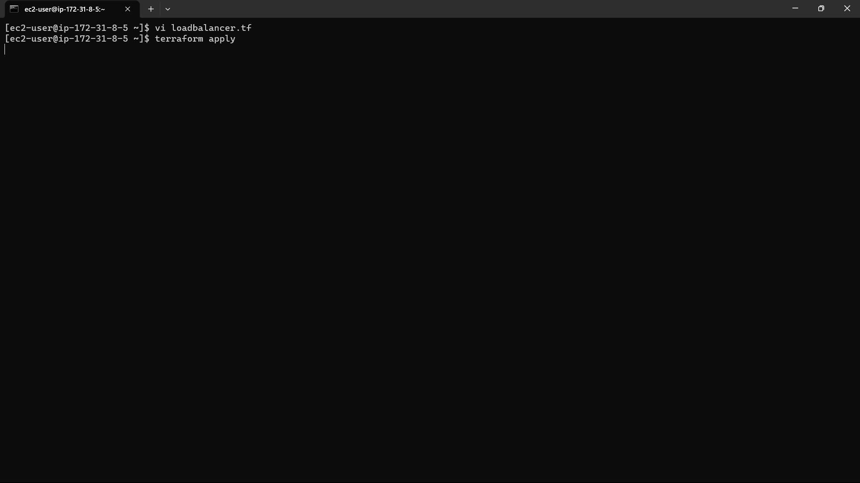

59)The infrastructure in created.

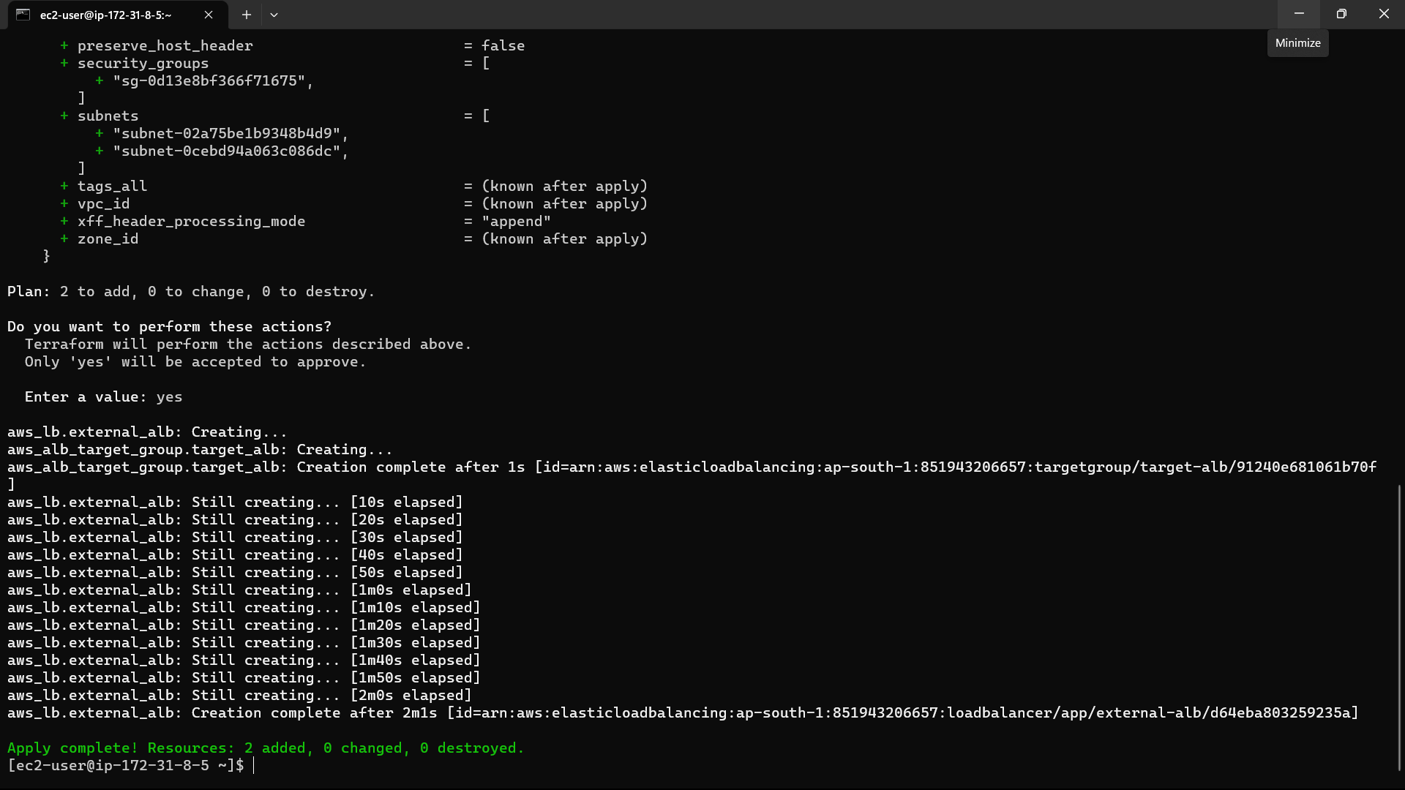

60)Check it is created or not in AWS.

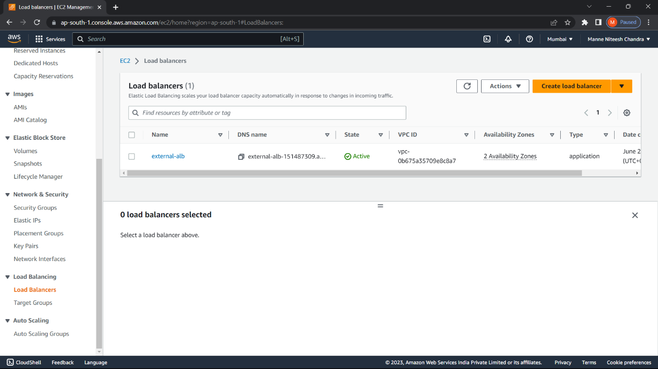

61) Create a file for Relational Database as “vi rds.tf” and write the script required to create the relational database. And type the command : “terraform apply”.

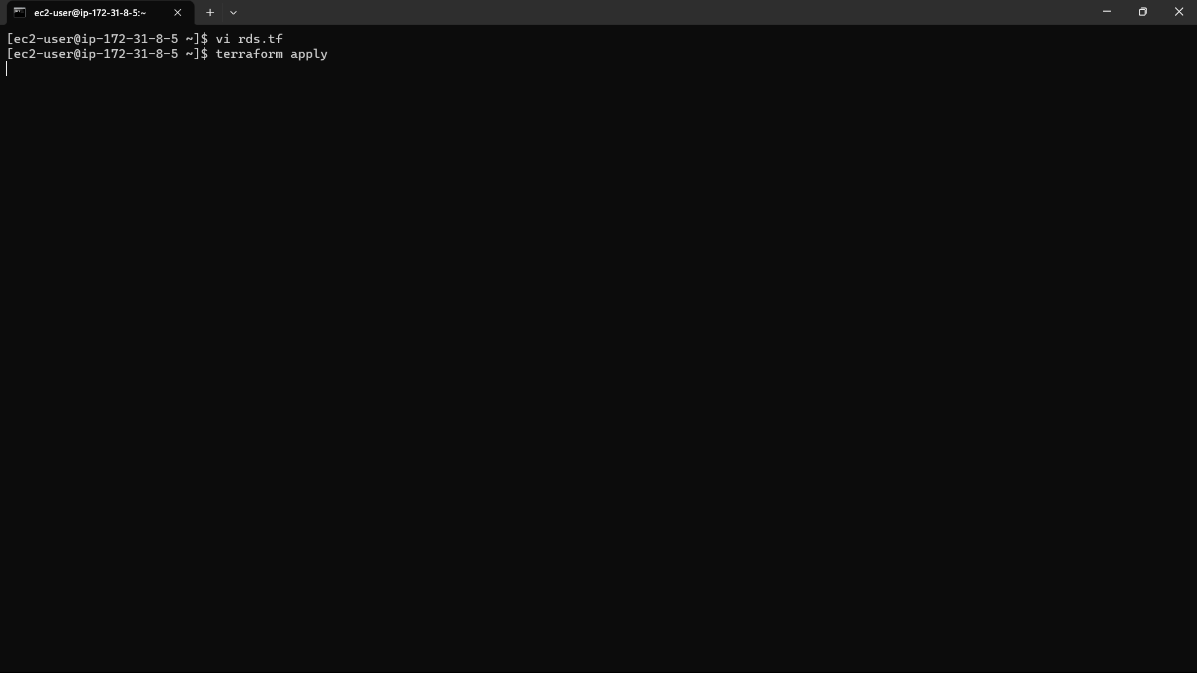

62)The infrastructure is created.

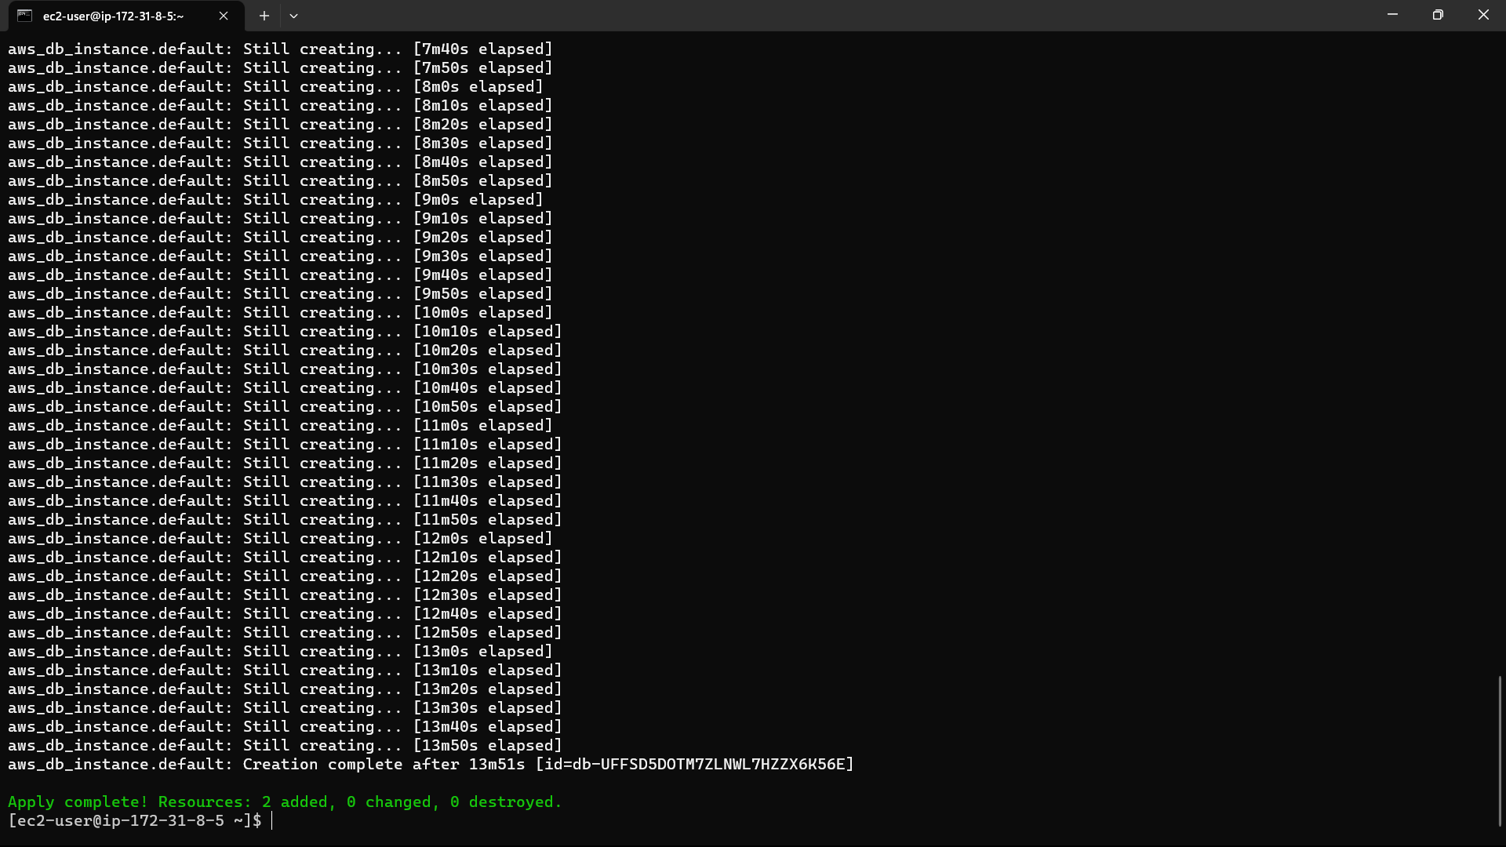

63)Check in AWS it is created or not.

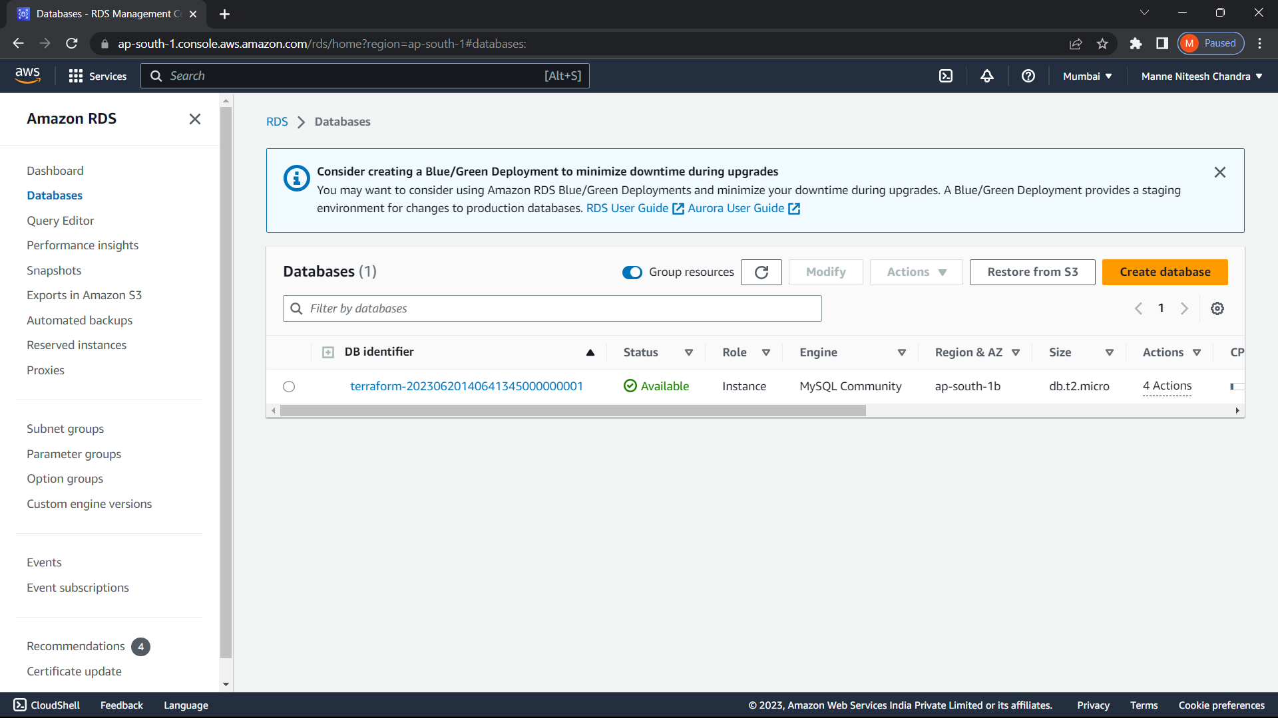

64)Type “EC2” in search bar and select the “EC2” option below.

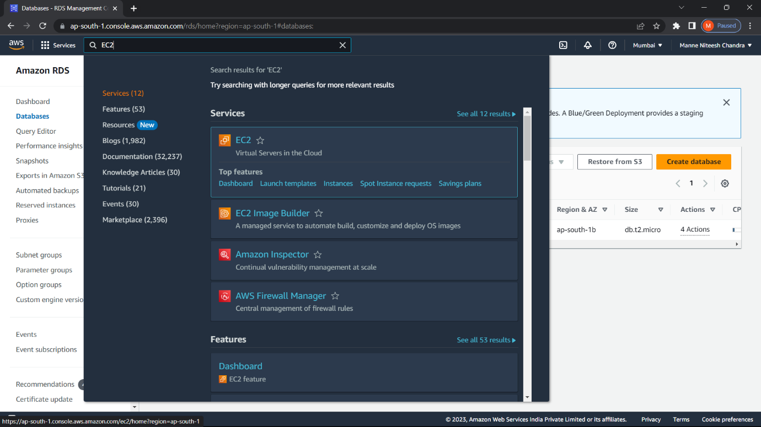

65)Click on “Instance(running)” option in “Resources”.

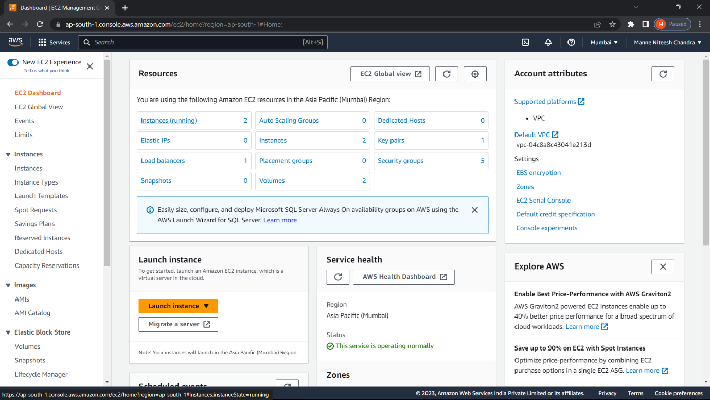

66)Select the instance i.e., created using terraform and copy its IPv4 address.

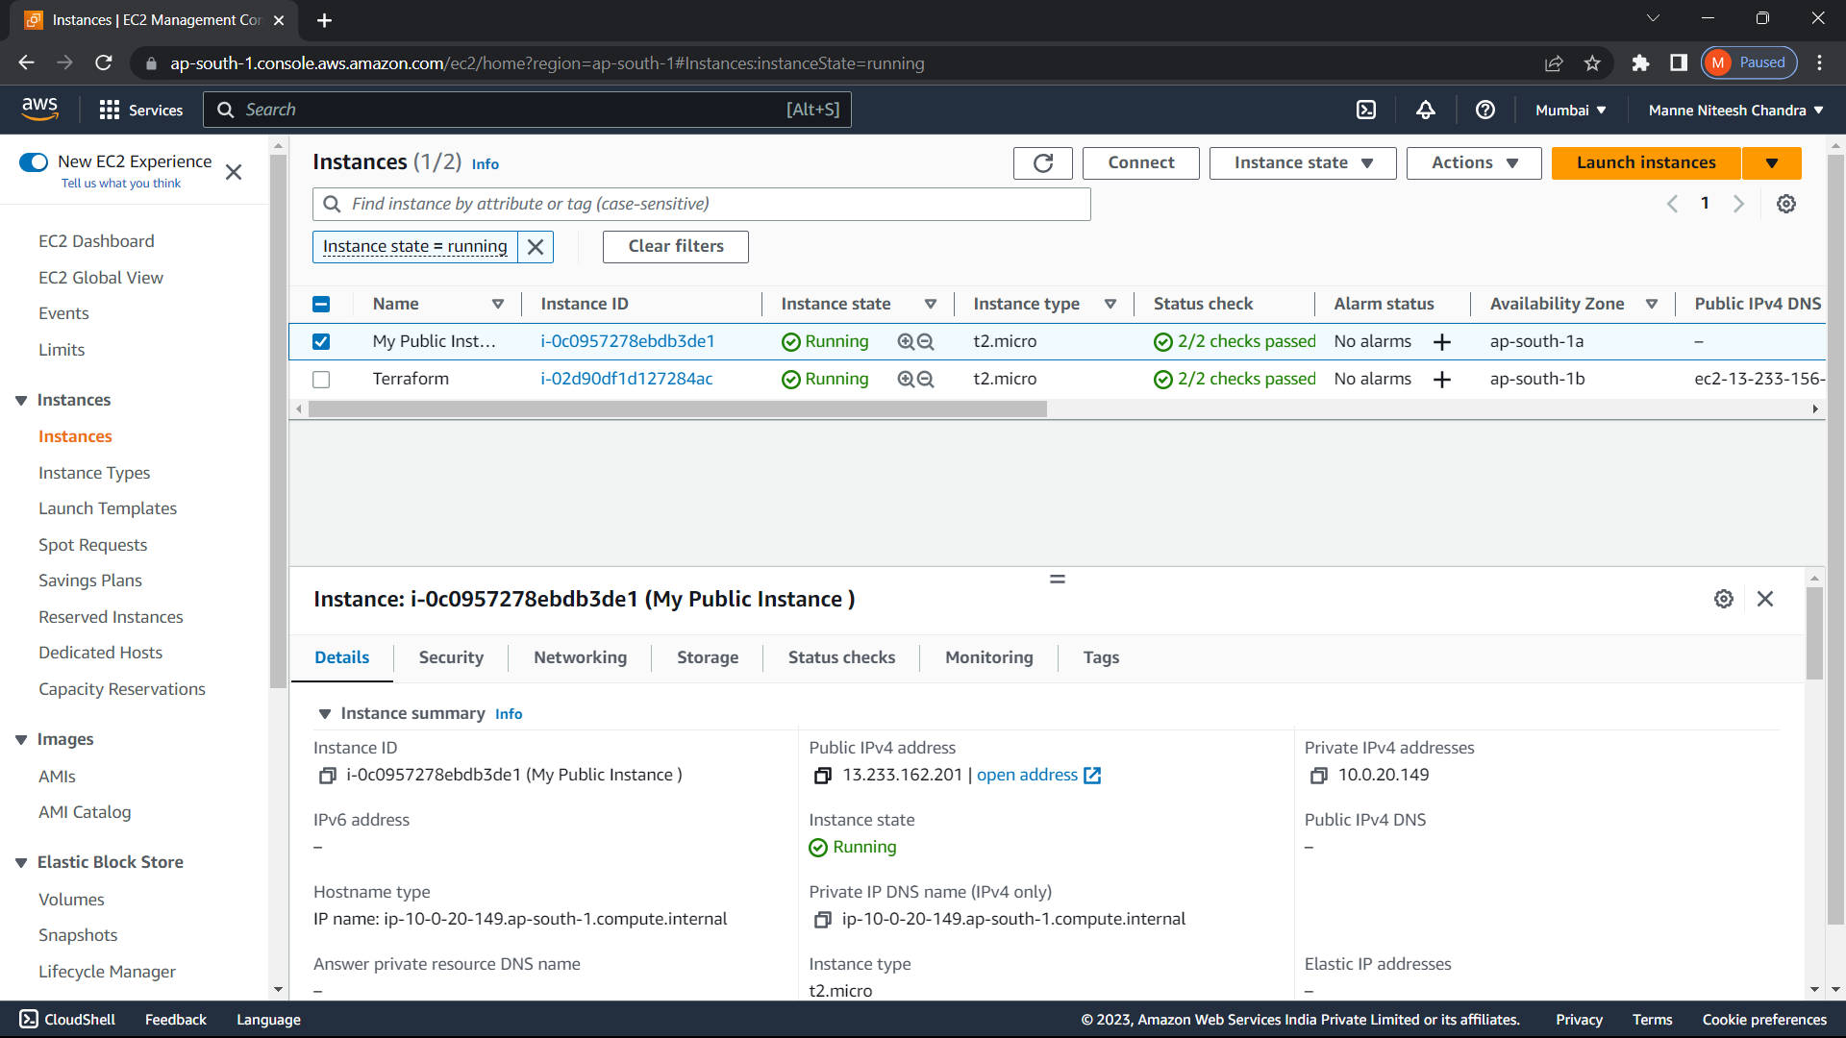

67)Paste the IP address in new tab, The webpage is opened.



68)Now type the command “terraform destroy” it will destroy total infrastructure you created.

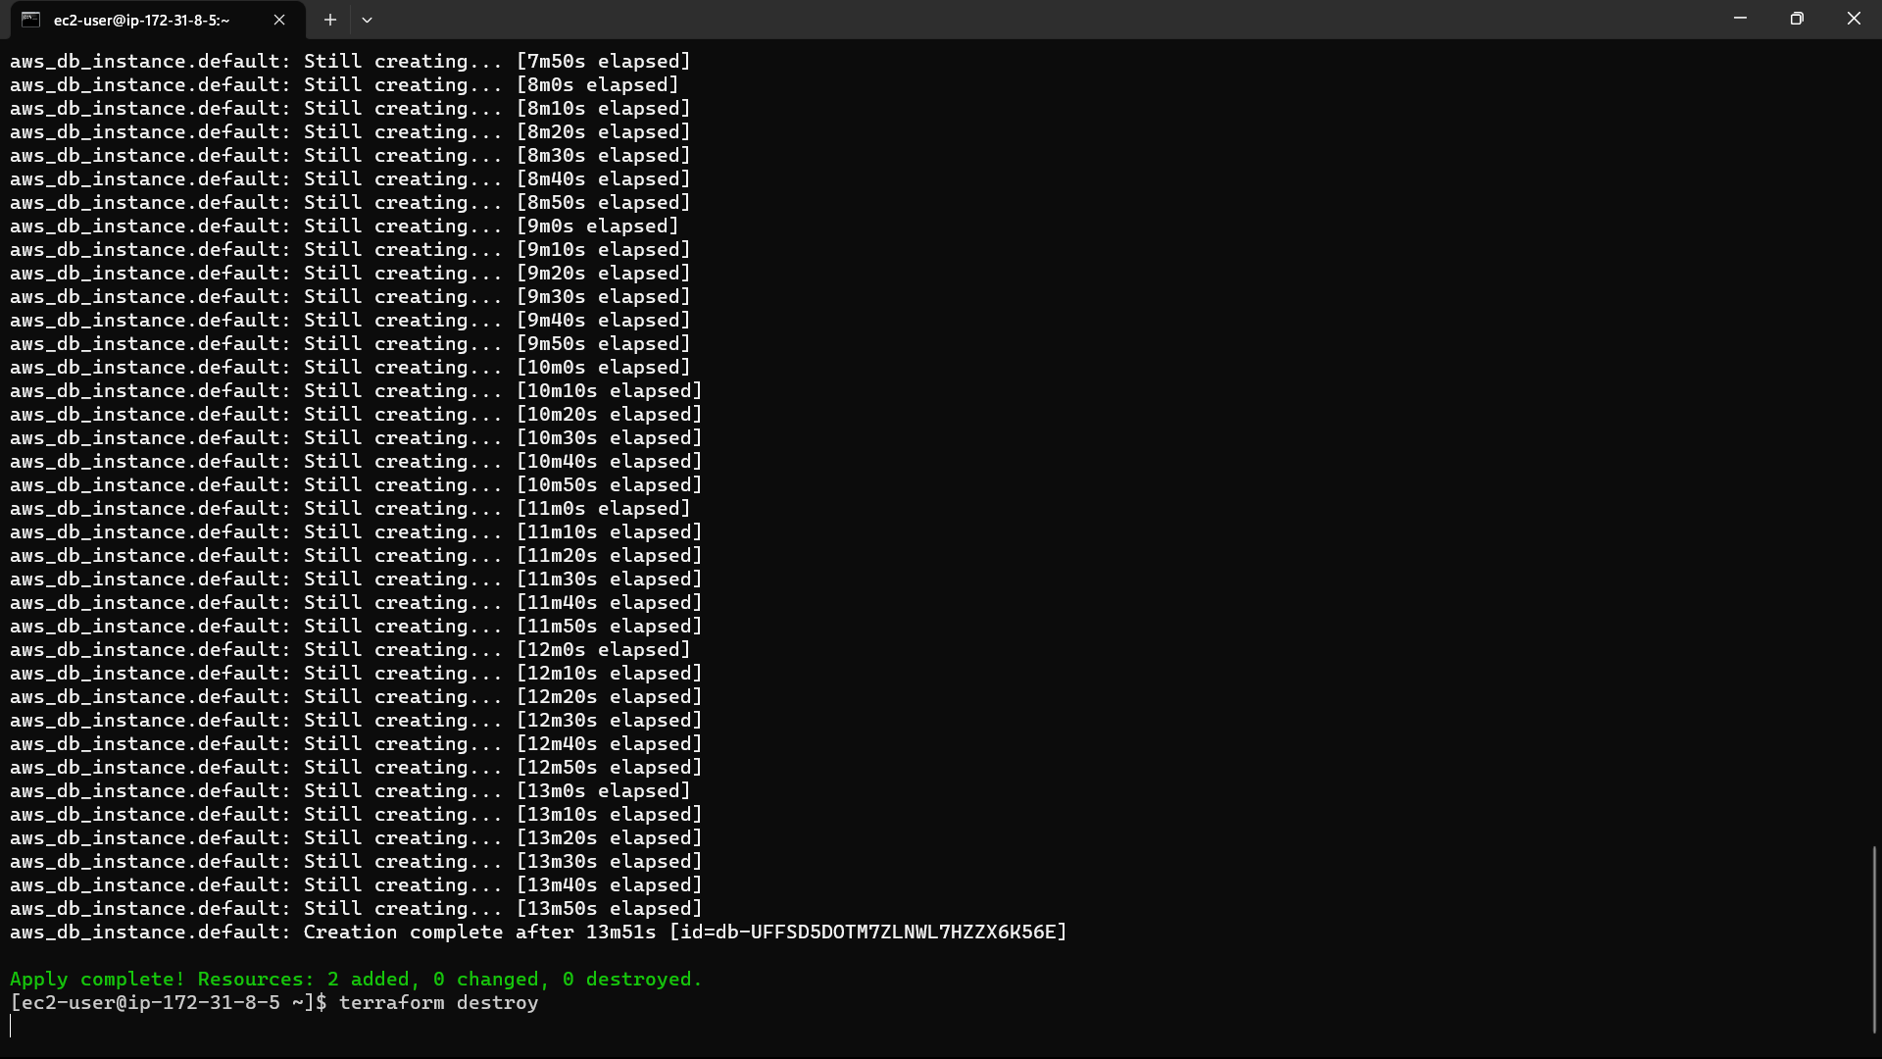

69)The infrastructure is destroyed.

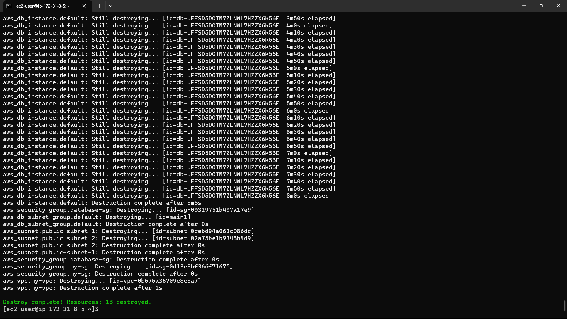

70)Check in AWS Console whether it is destroyed or not.

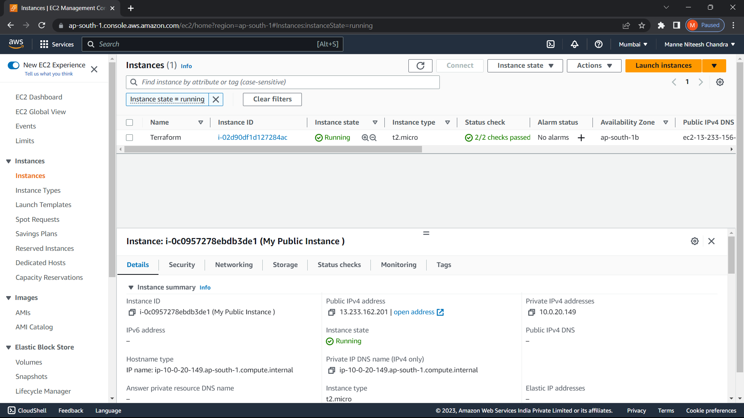

It is destroyed.

71)Login to you’re Github account and click on “new repository” in “+” at top right.

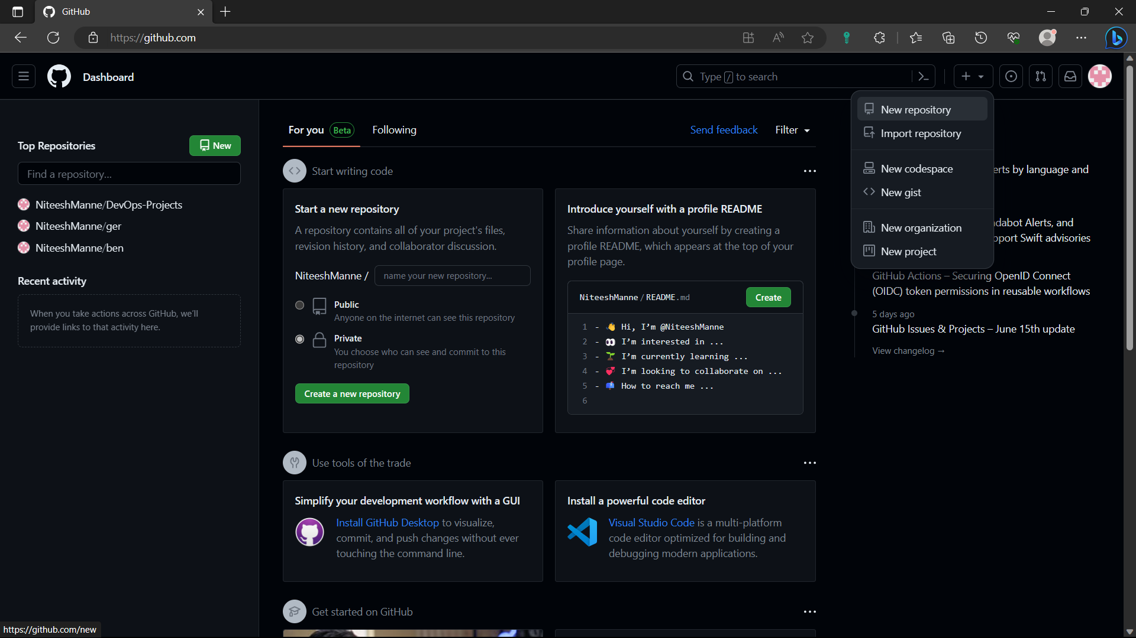

72)Give a name to the repository and change the repository to private and click on “create repository”.

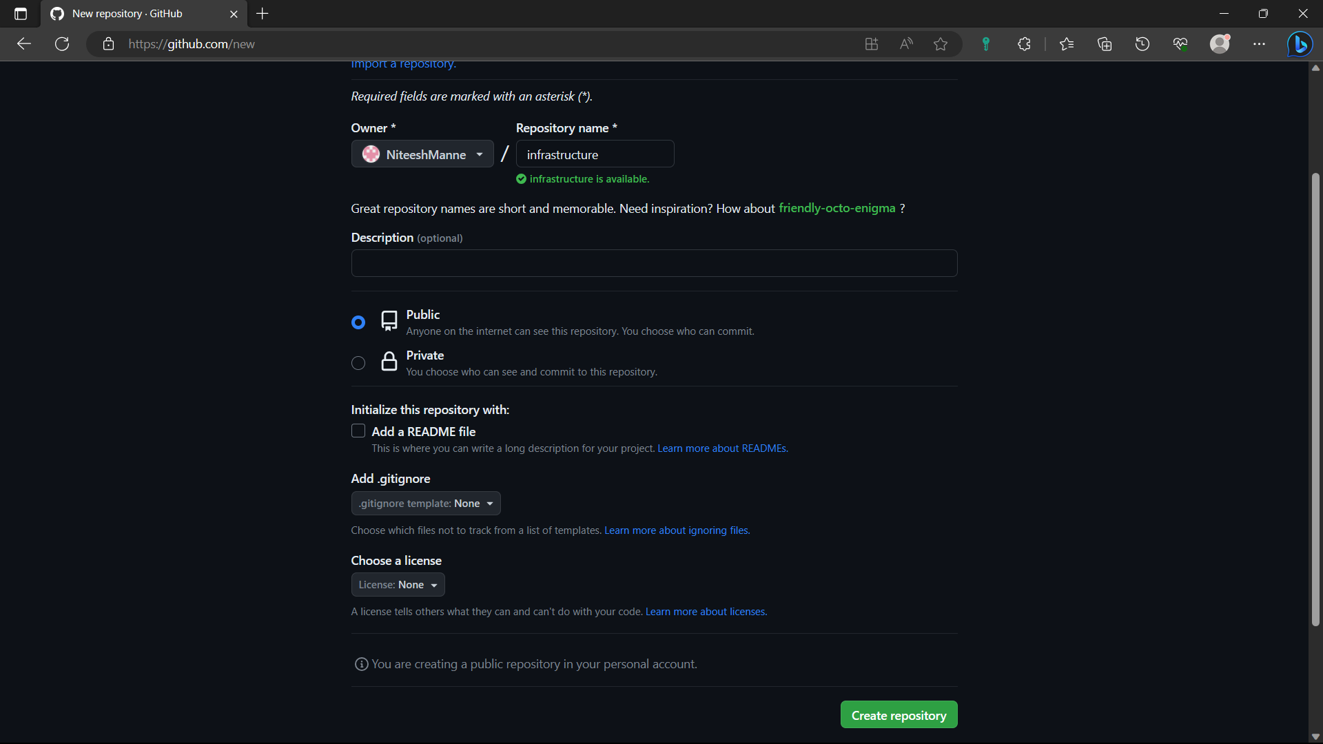

73)Install git in linux using “sudo yum install git -y” if it is already installed no need to use the command.

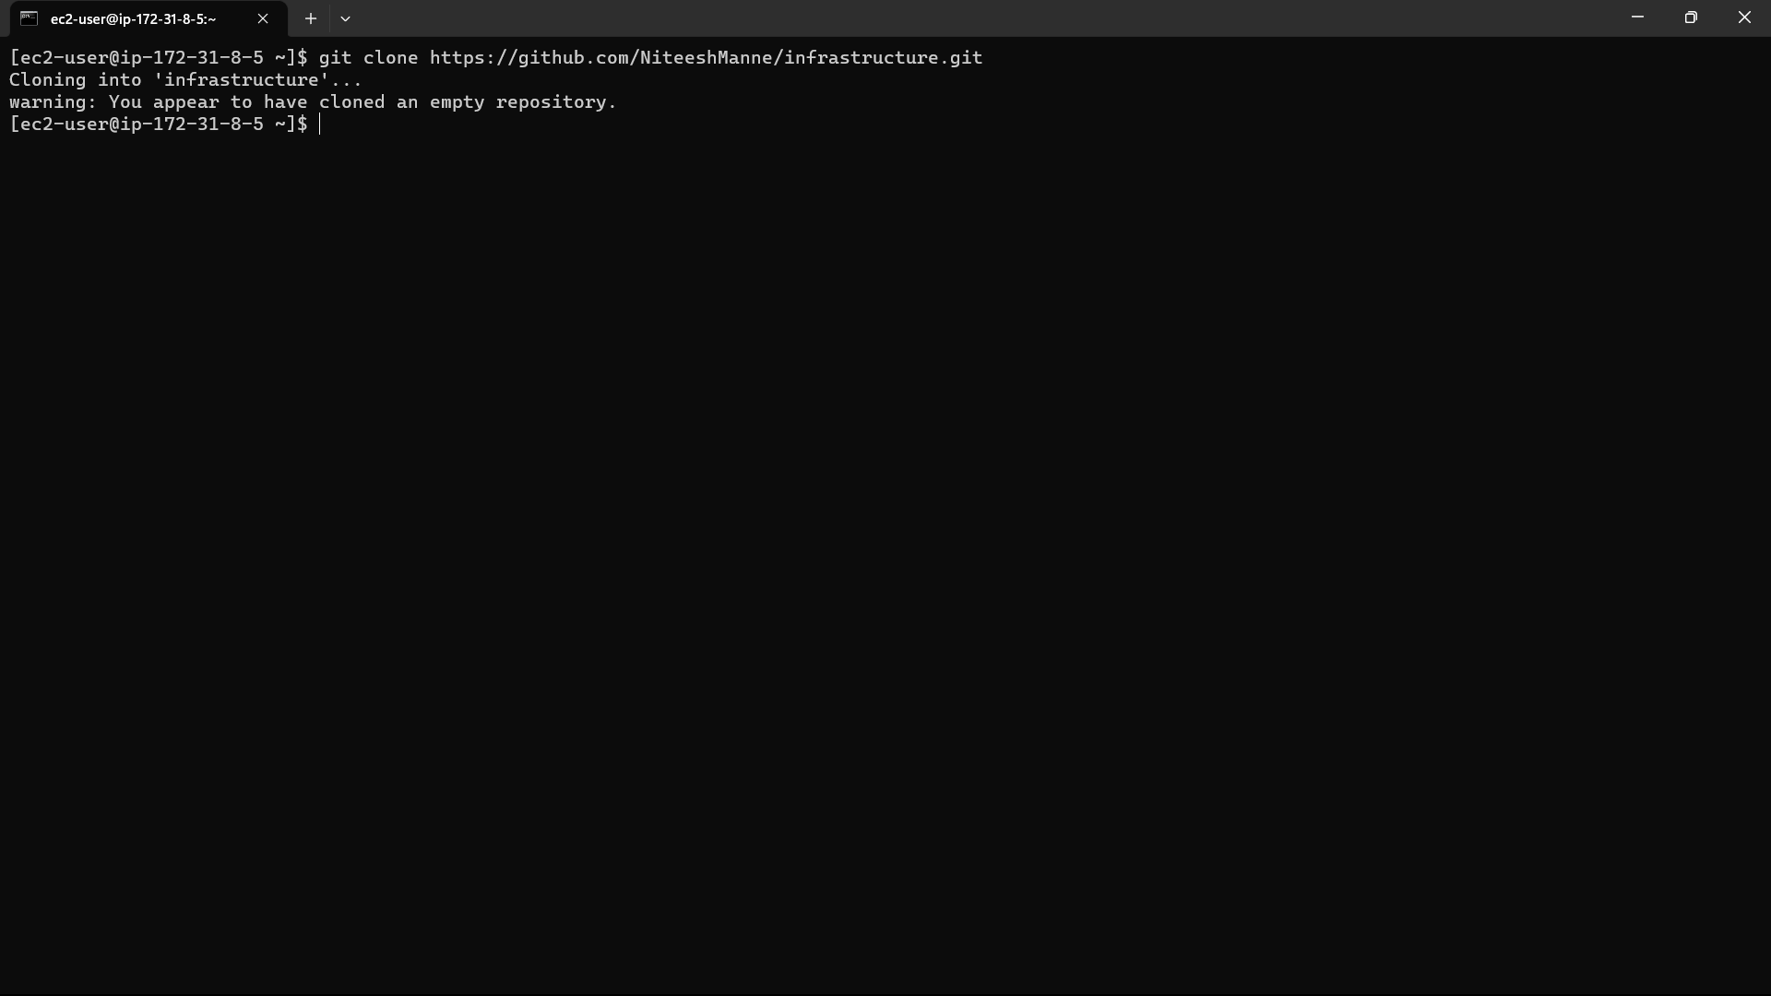

74) Then push the files to the github with the commands below

Git init: To initialize the repository

Git add filename: To move the files from local machine to staging area

Git commit -m “message” : To move the files from staging area to local repo

Git push -u origin main: To push the files from local repo to Github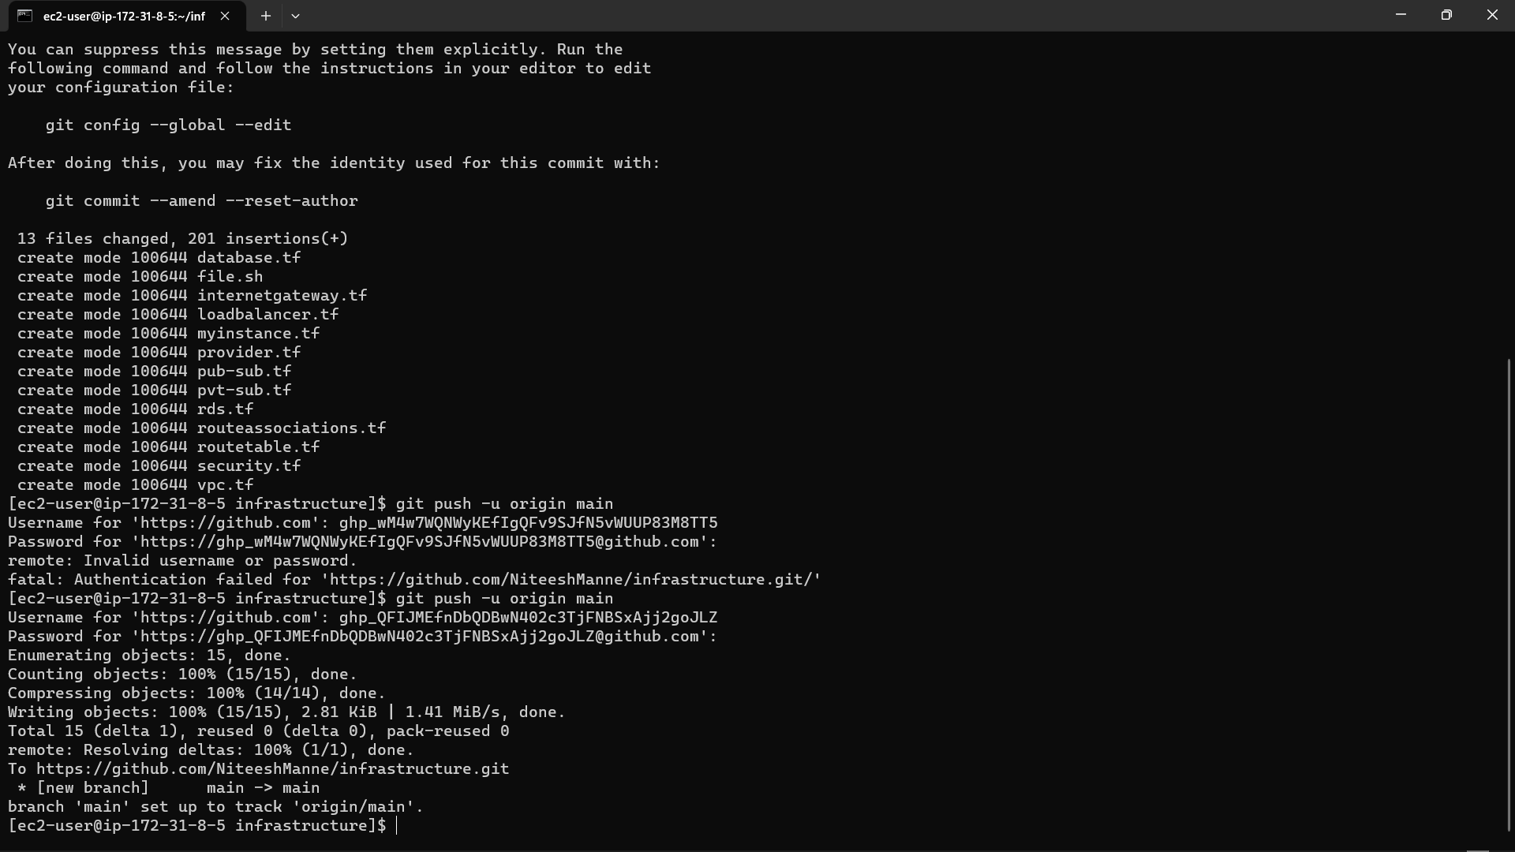

75)Now the files are pushed to Github, if the files are deleted in the instace they are stored in github as a backup.

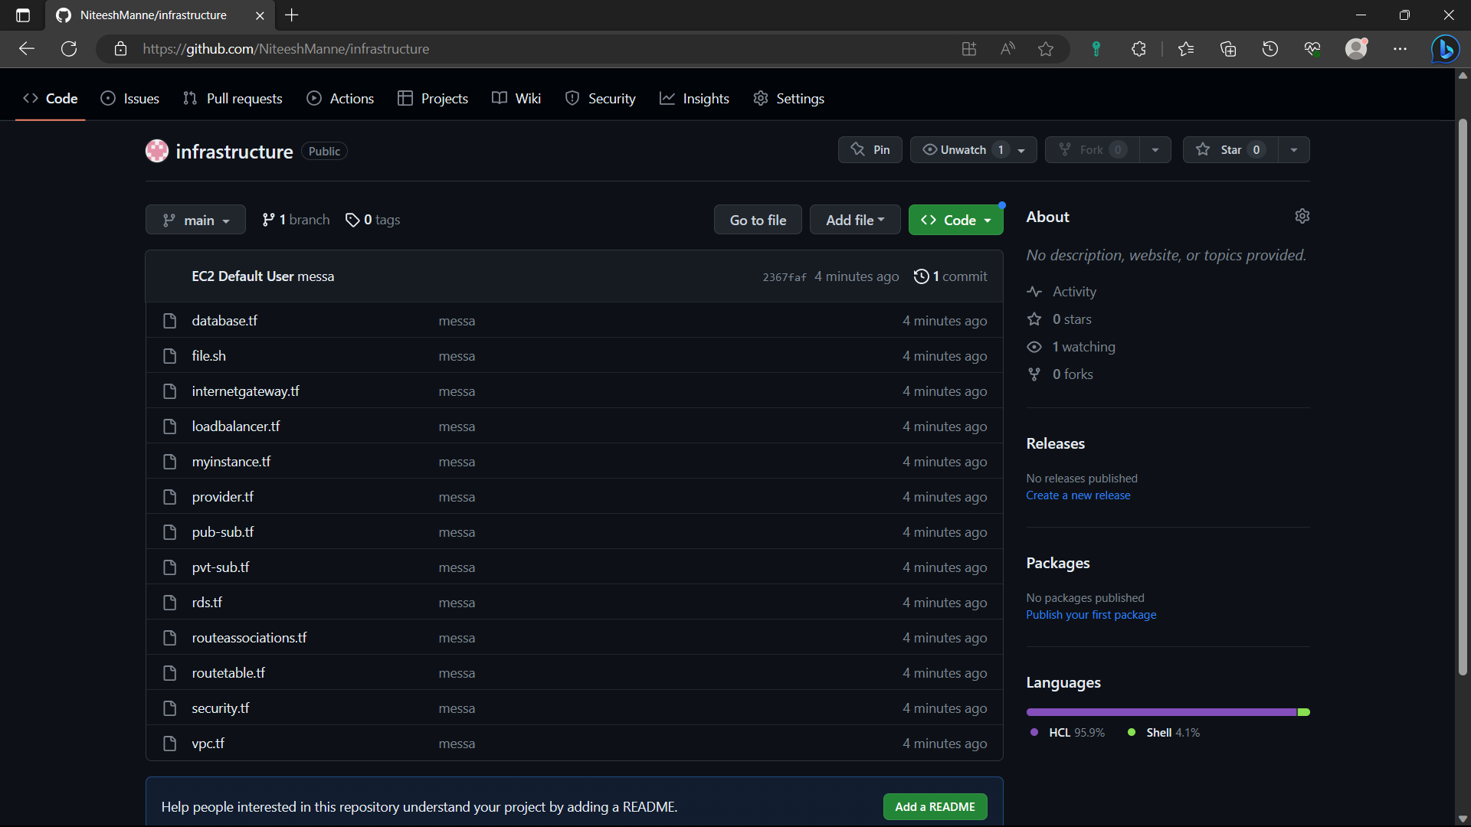

76)Create another instance in AWS by following the steps:(1-12).

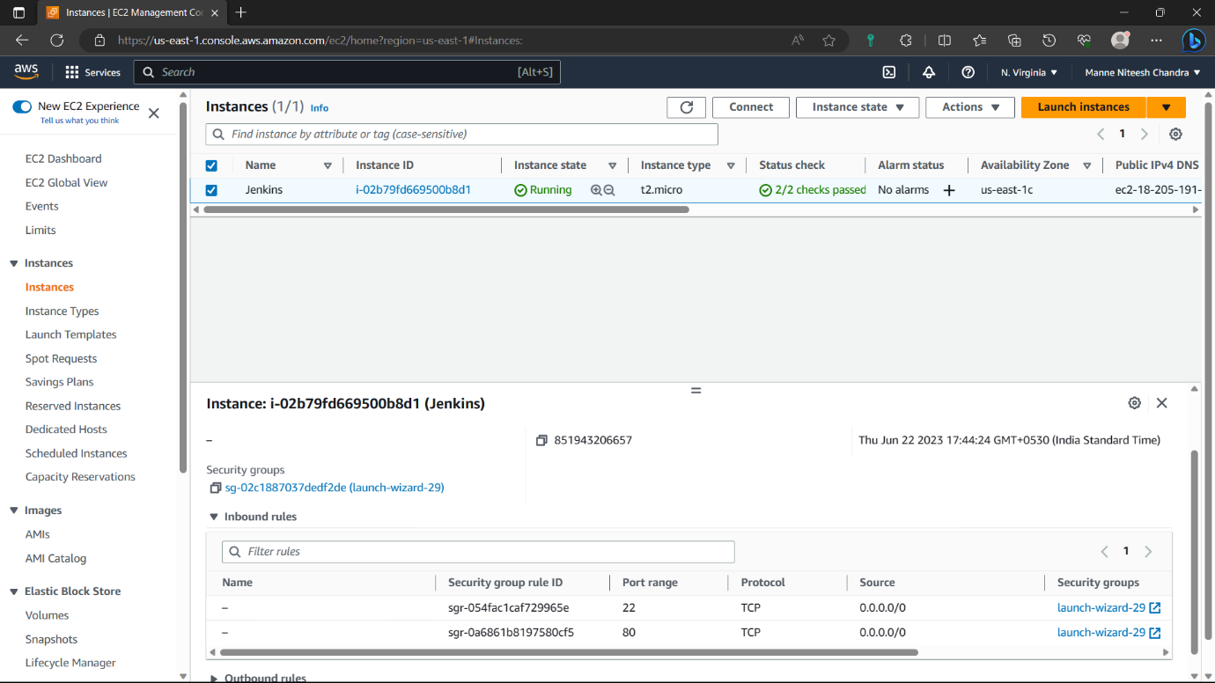

77)Access the instance in you’re local machine by following the steps : (13-18).

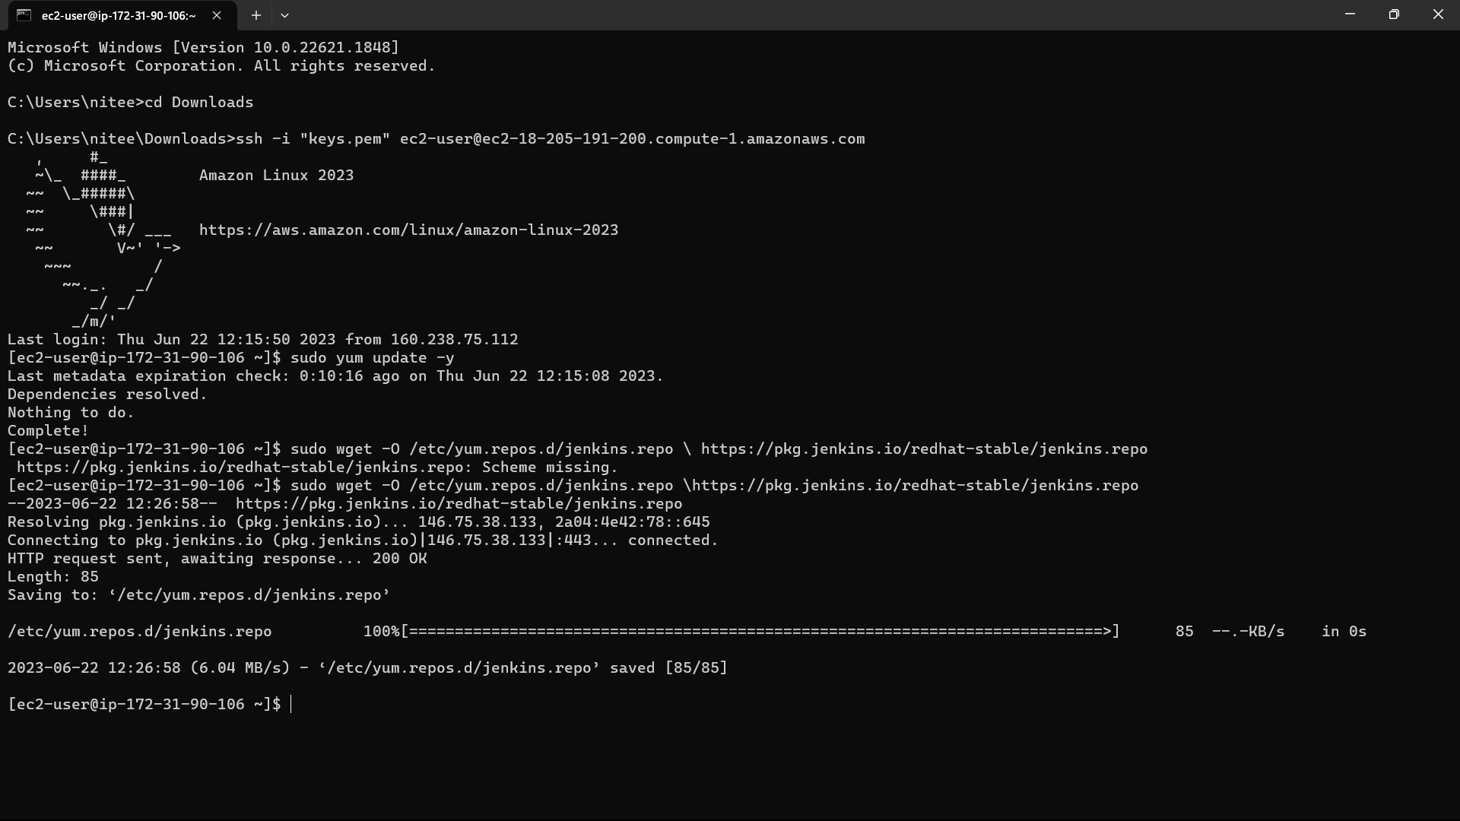

78) <https://www.jenkins.io/doc/tutorials/tutorial-for-installing-jenkins-on-AWS/>. Paste this link in the browse and copy the installation commands and paste in you’re instance.

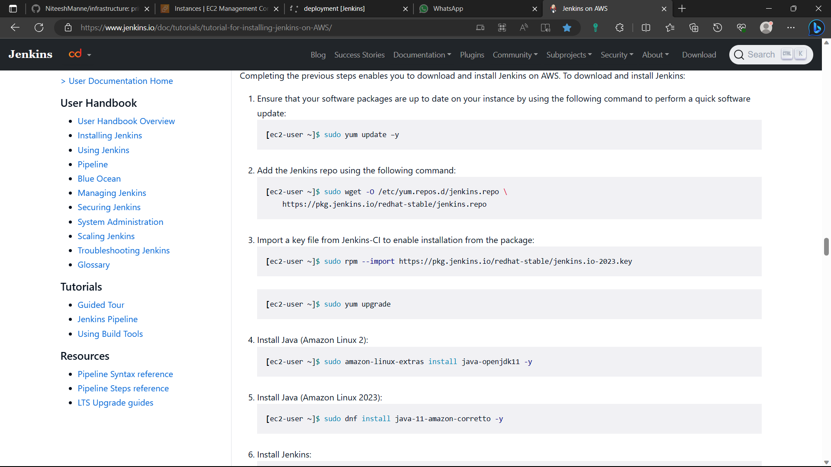

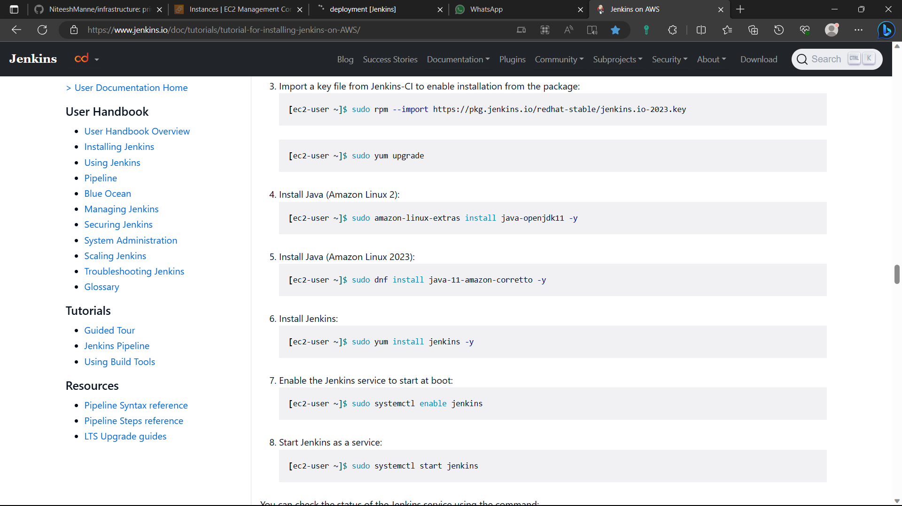

79)The Jenkins is installed in the instance.

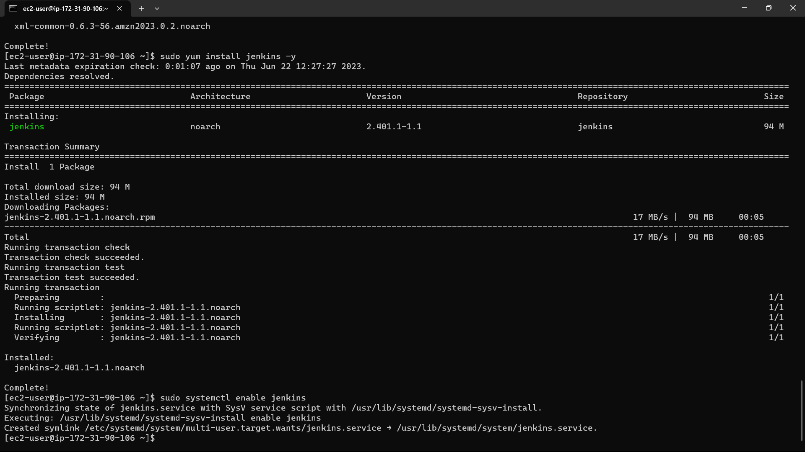

80)Now install git in the instance using the command “sudo yum install -y git”.

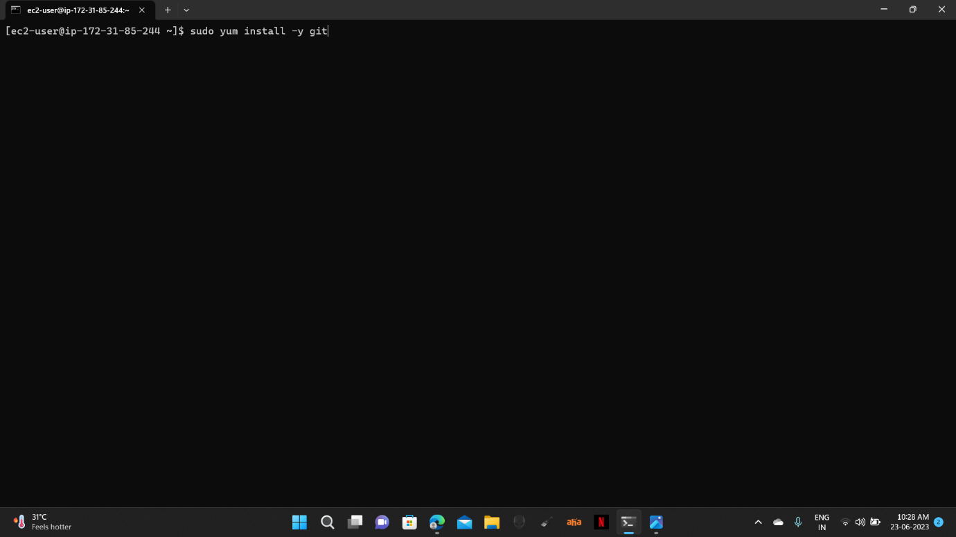

81)Now type the command “sudo visudo” for linux file.

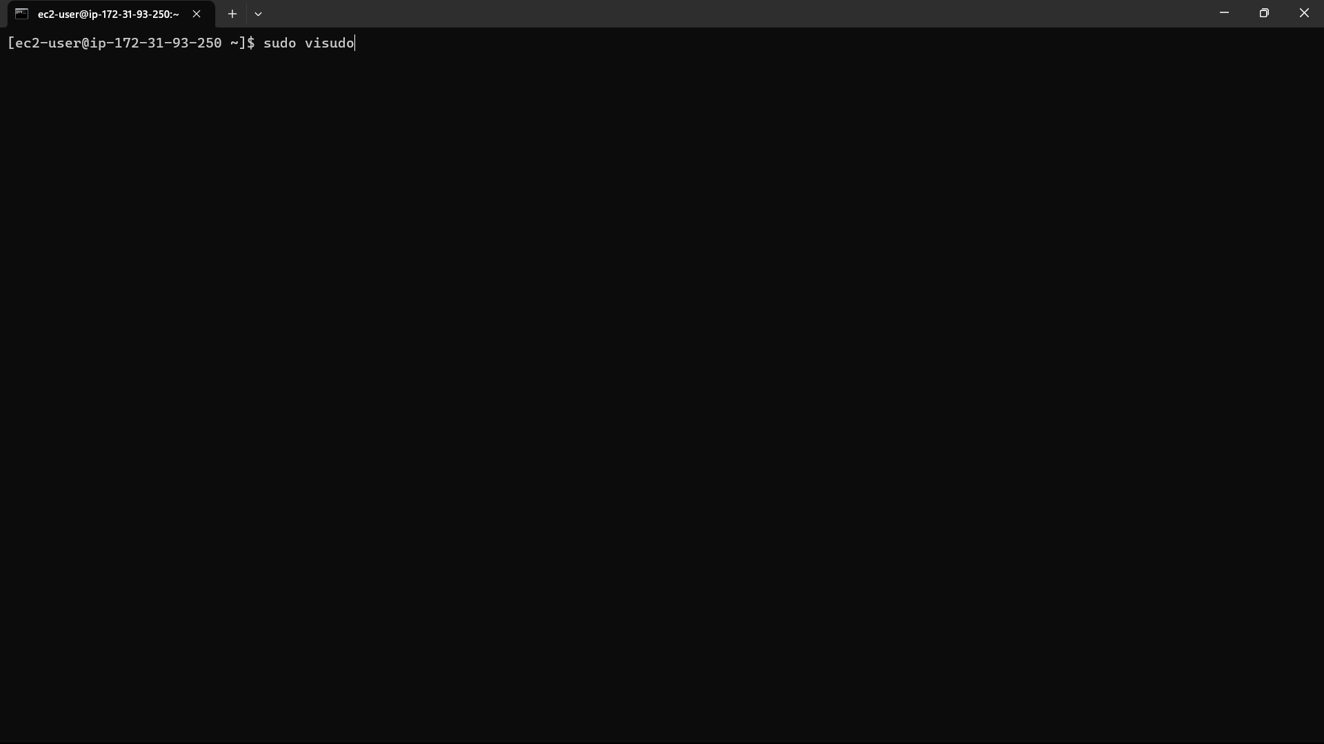

82)The file is opened. Go down and add an extra line below the root user i.e.,

“jenkins ALL=(ALL) NOPASSWD: ALL”. The ctrl+s, ctrl+x.

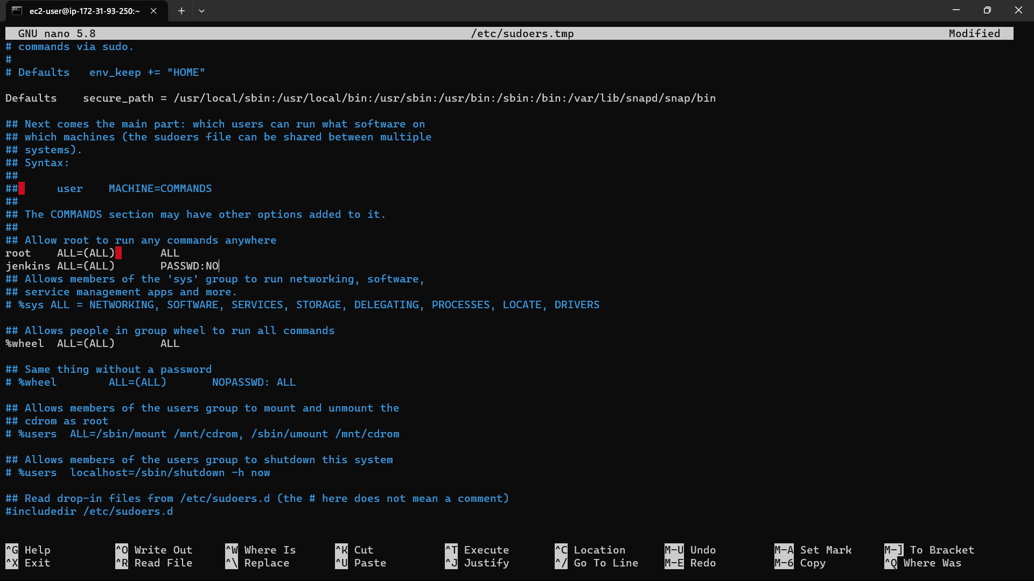

83)Go to the instances in console and select the instance you created.

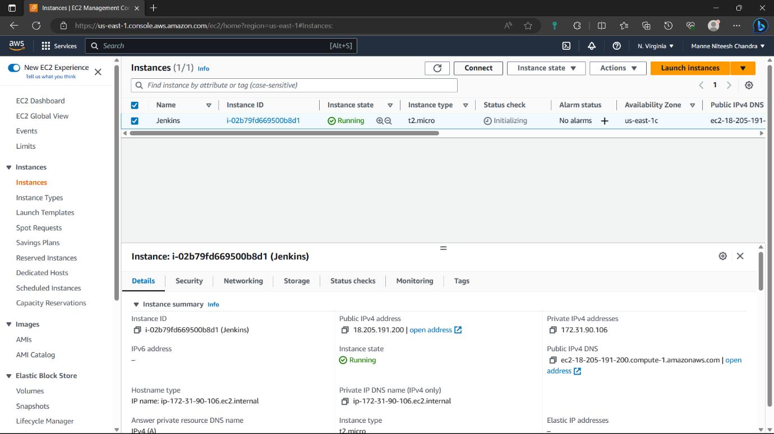

84)Navigate to security of the instance and click on the security group.



85)Click on “edit inbound rules” option.

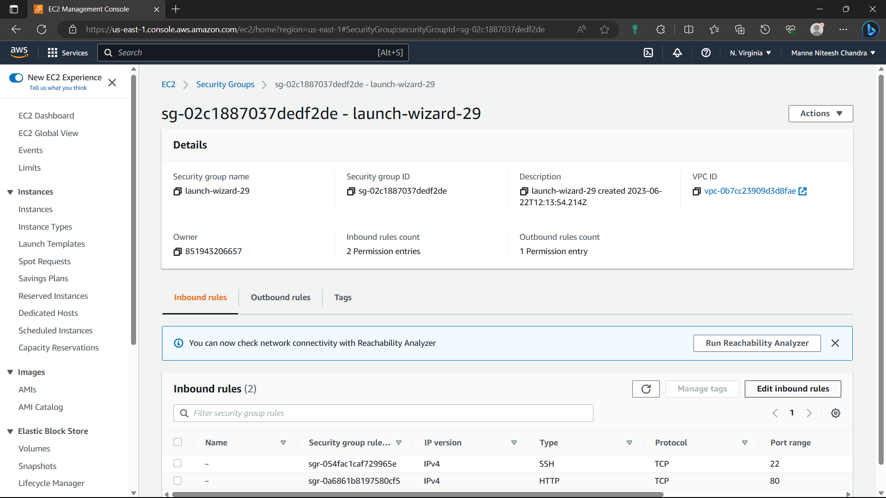

86)Click on “Add rule”.

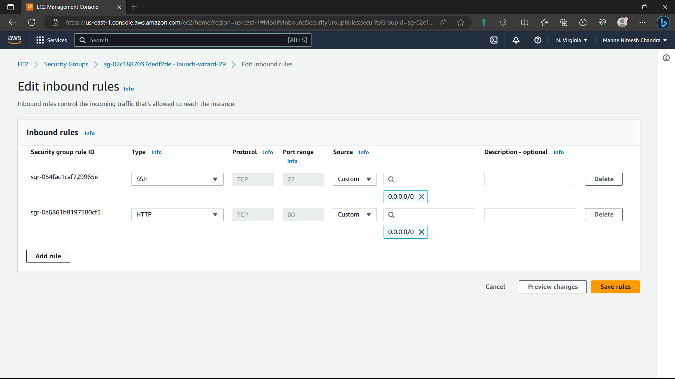

87)Type-Custom, port-8080, cidr-0.0.0.0/0 and click on “save rules” option.

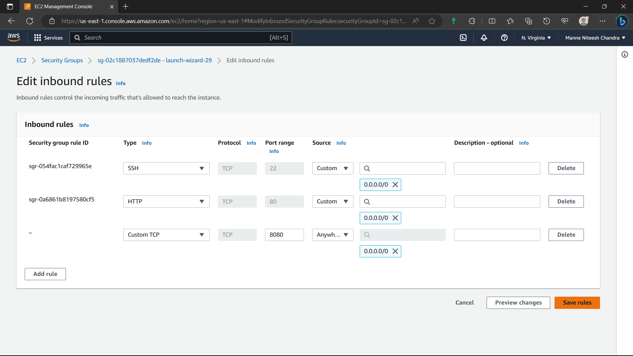

88)Now the rule is saved.

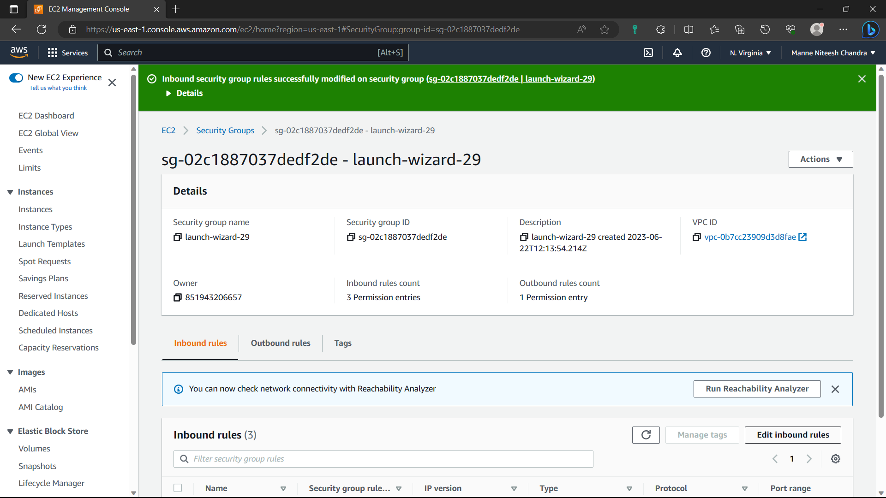

89)Go to “Instances” and select the instance you created and copy the ipv4address.

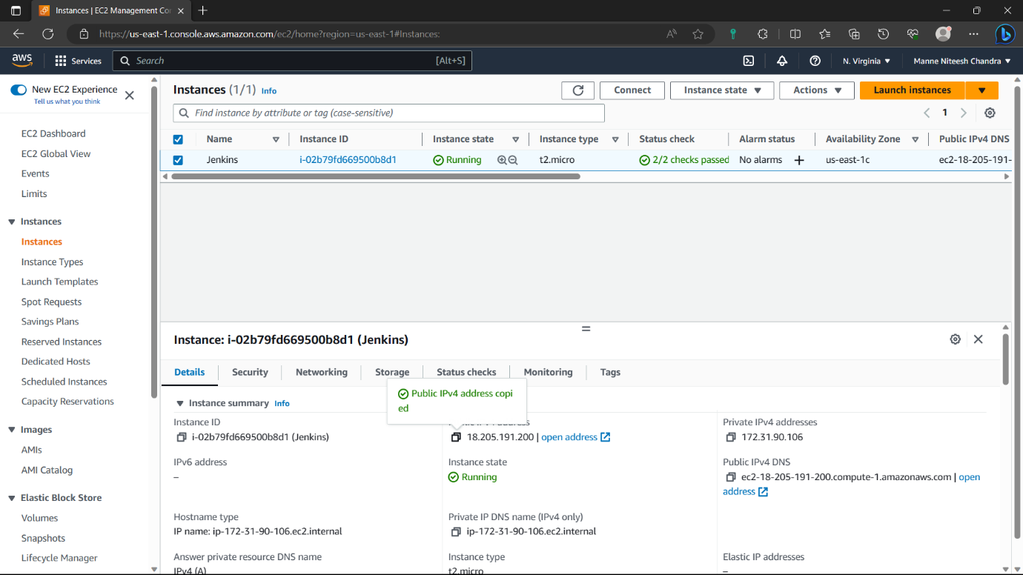

90)Before pasting it in browser add ”:8080” to the ipv4address to open Jenkins in the browser. Jenkins is opened in browser. Copy the pathi.e., in red colour.

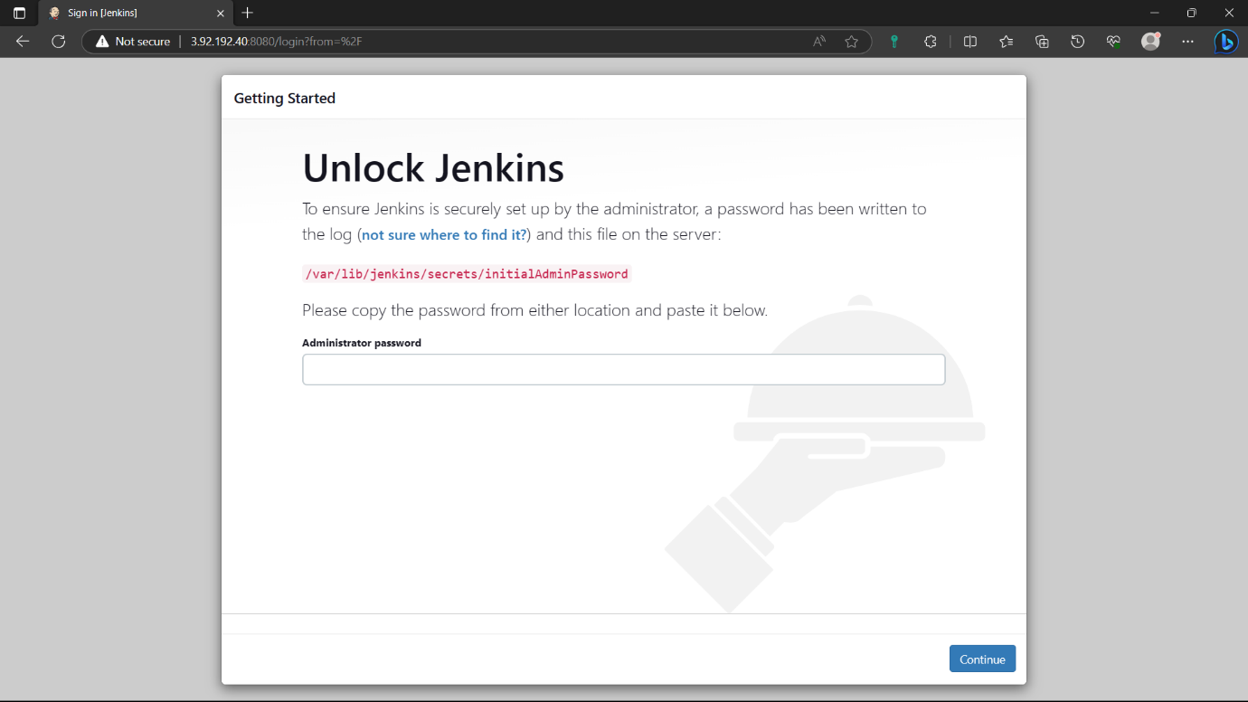

91)go to instance and type the command “sudo cat path”: for password to create Jenkins account.

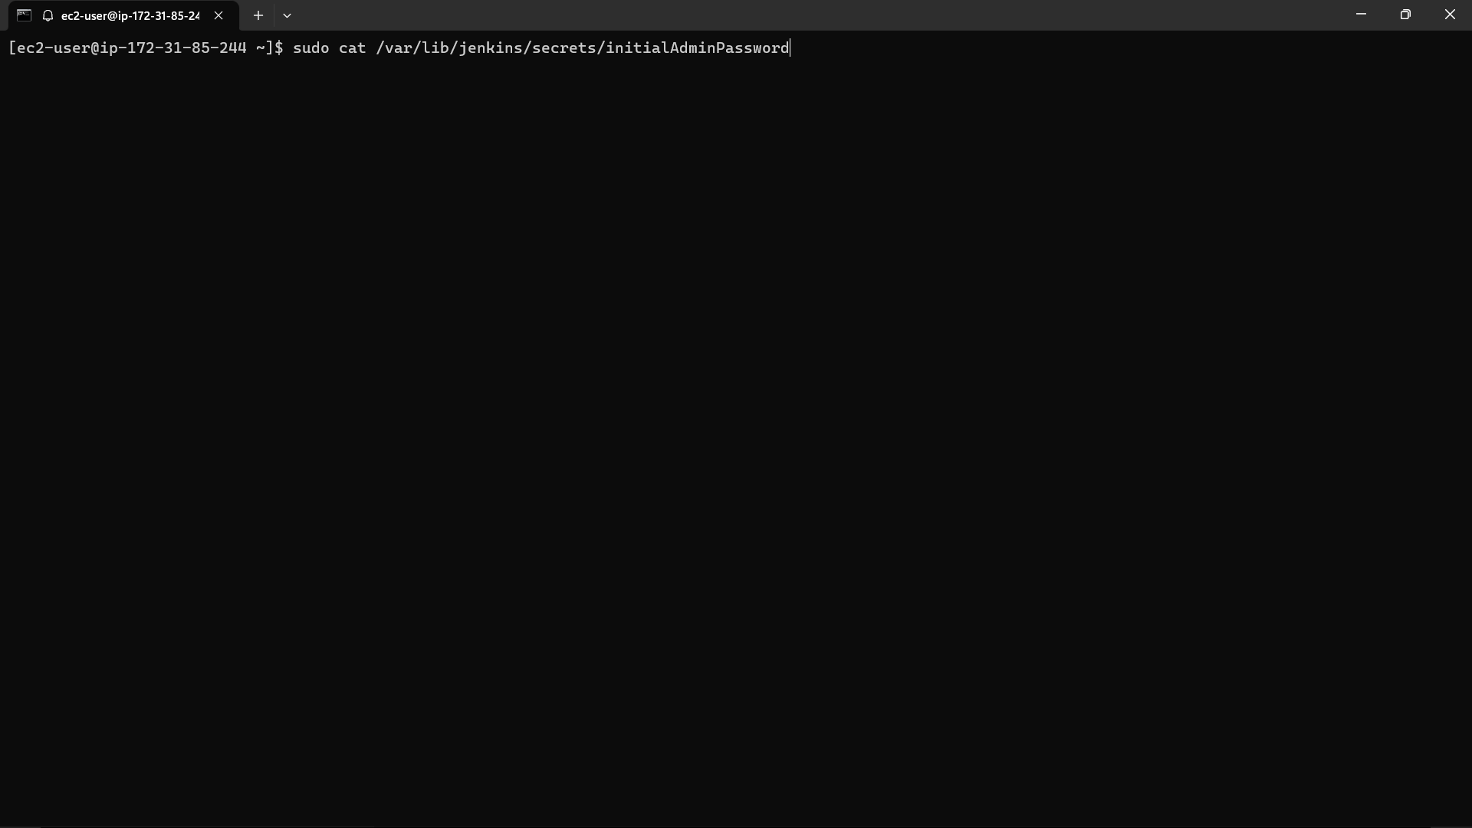

92)Copy the output and paste it in the Jenkins and click on continue.

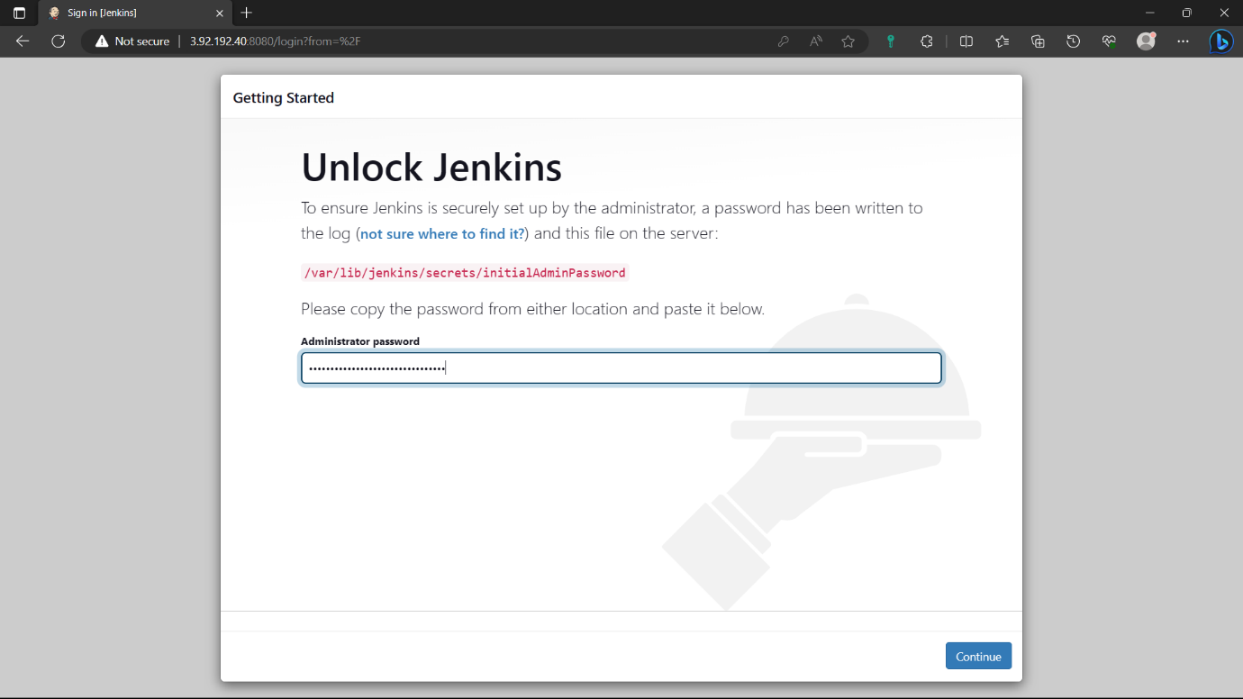

93)Select the “Install suggested plugins” option. And wait for some to install required plugins.

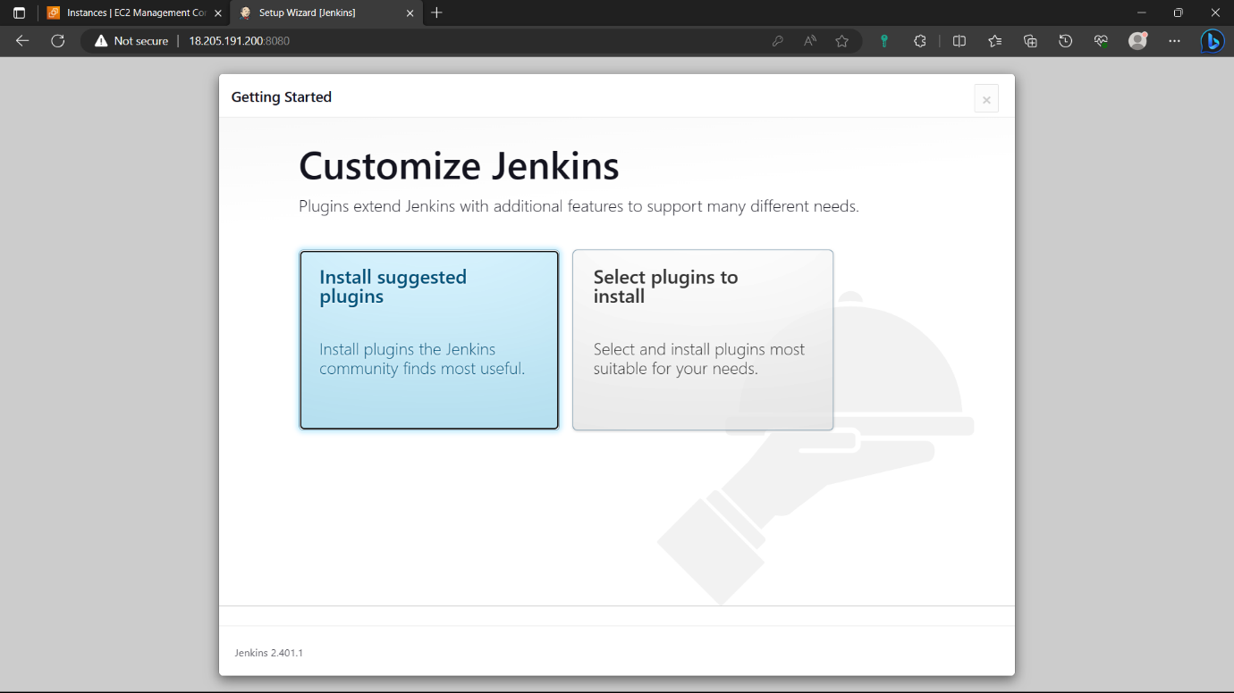

94)Give credentials to create an account click on “save and continue” and click on “continue” again.

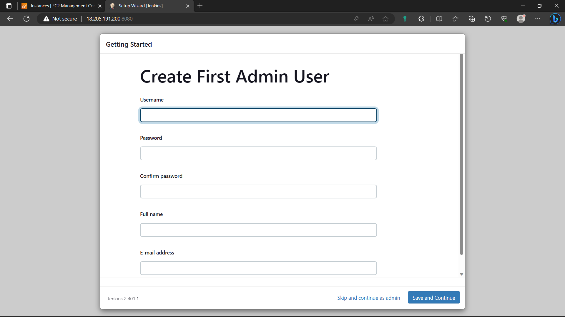

95)click on “start using Jenkins”.

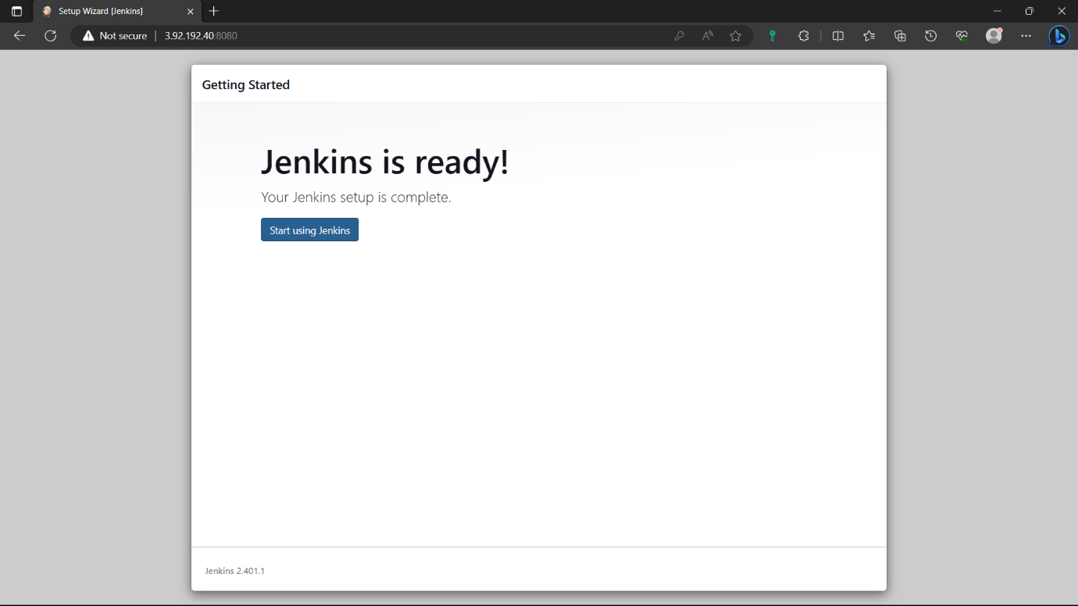

96)Jenkins is ready. Click on “create a job”.

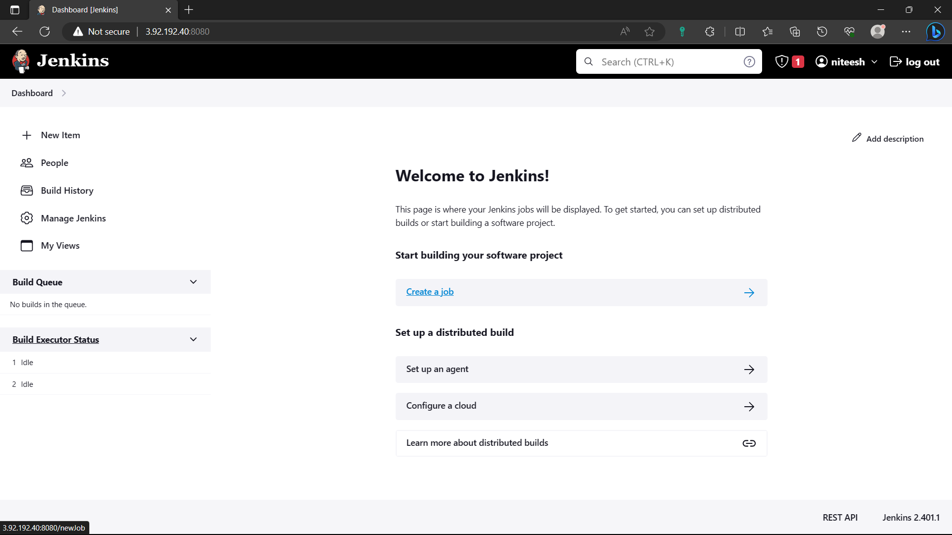

97)Give a name to the job, Select “Free style project”, click on “ok”.

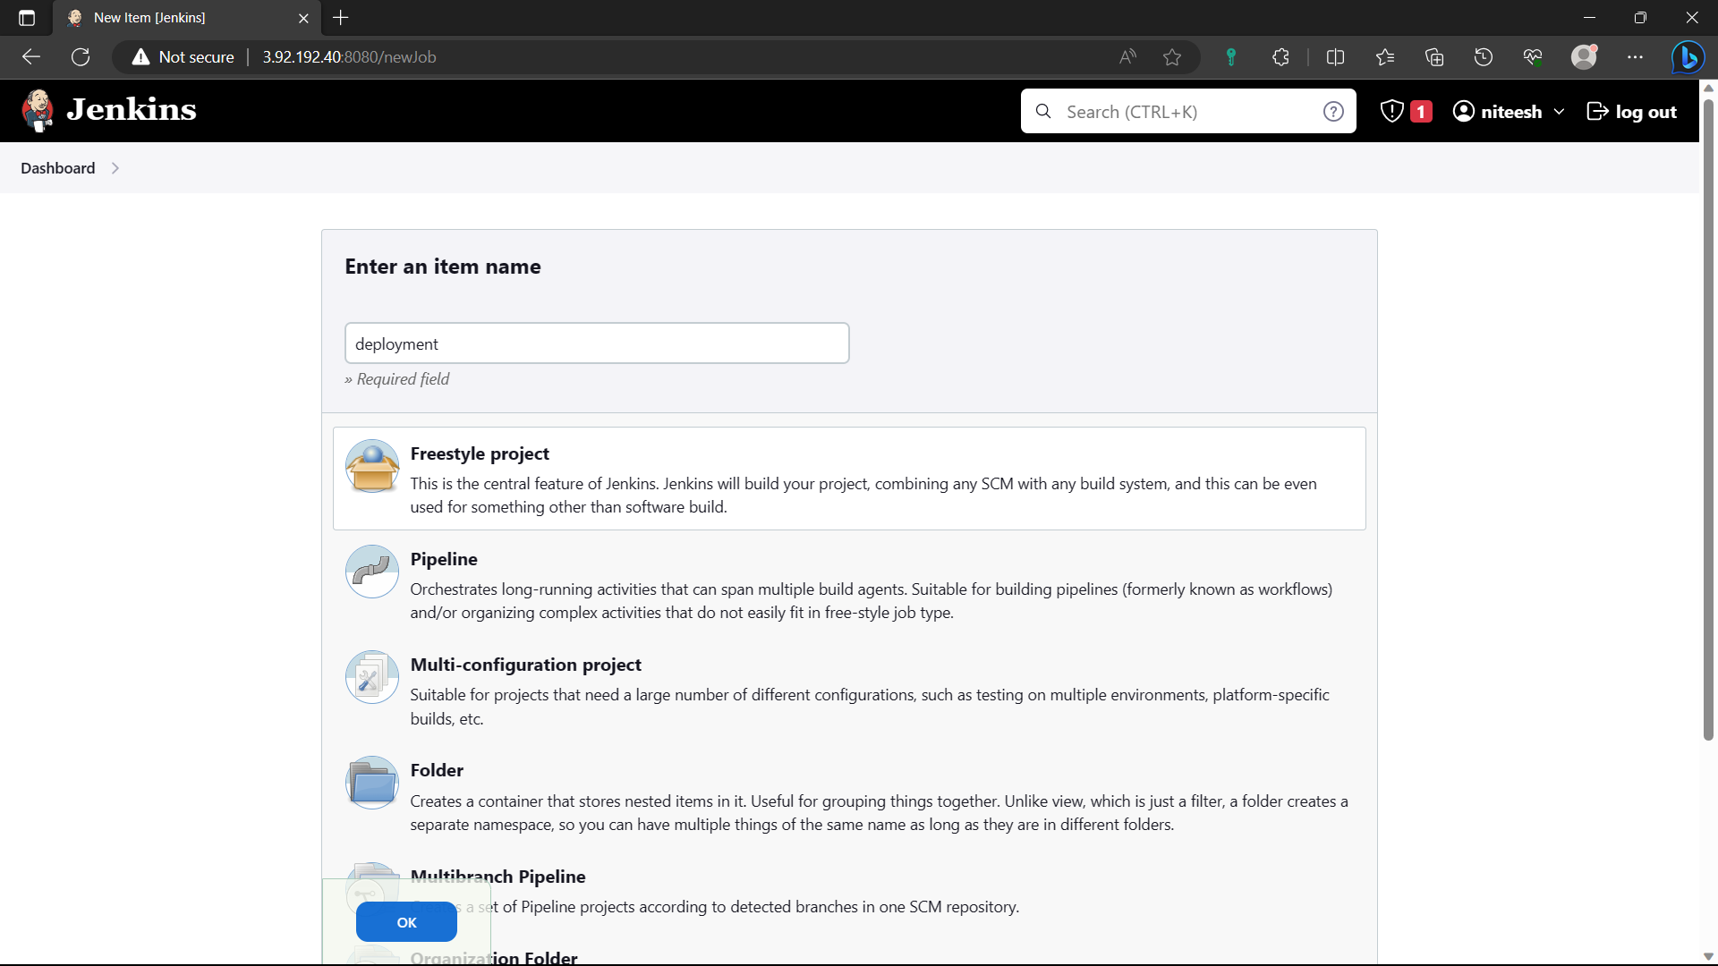

98)Go to “source code management” option select “git”.

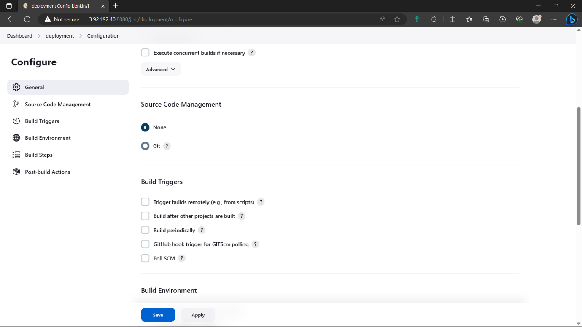

99)Open a new tab and login to you’re github account and select the private repository where you pushed all infrastructure files and copy the “HTTPS” link in “code” option.

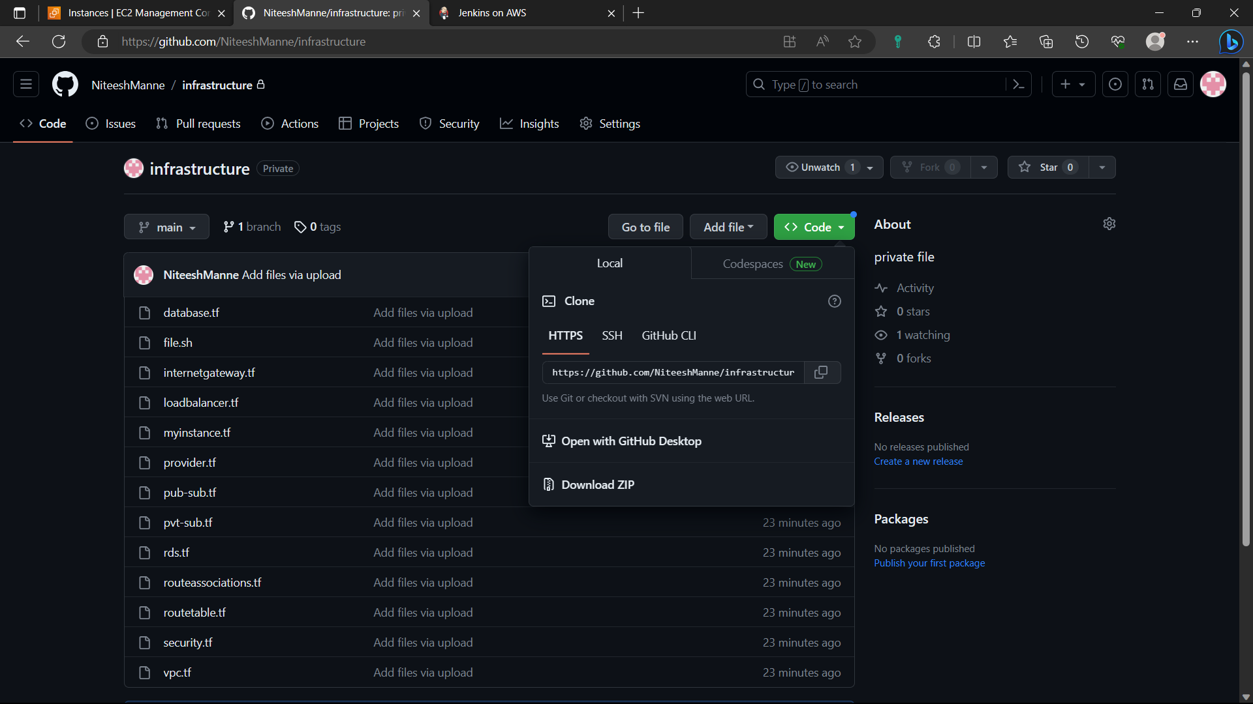

100)Paste it in the “Repository URL” and click on “Add”🡪”Jenkins”.

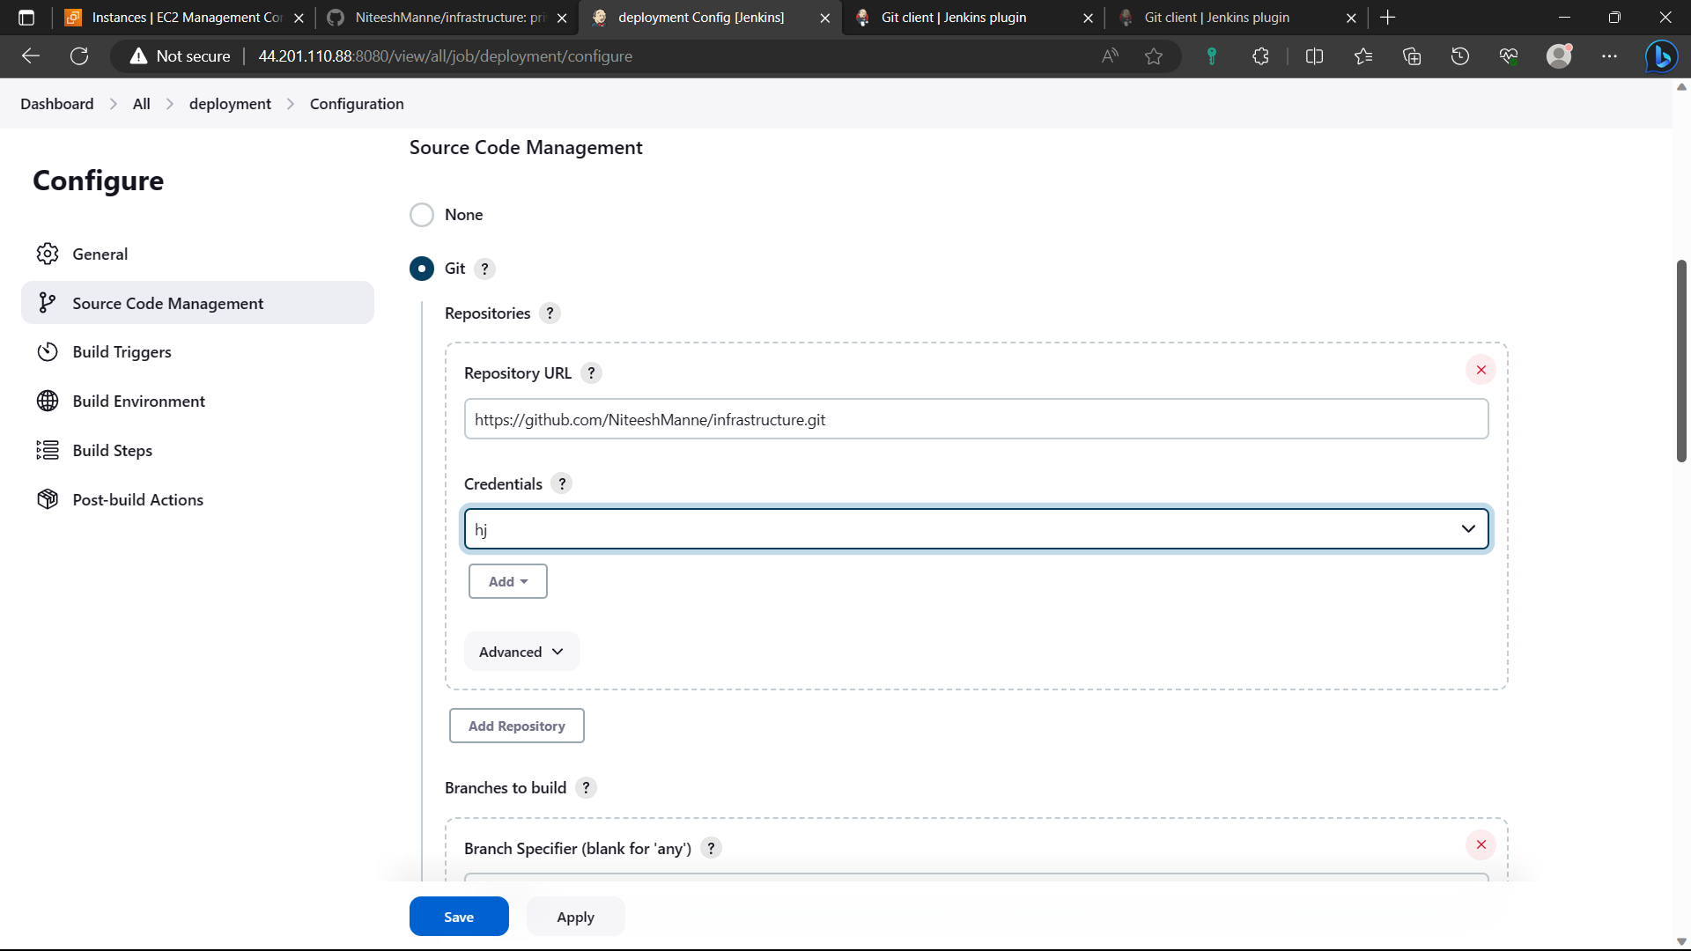

101)Give the github username and for password give personal token. And click on add. If you don’t have any follow the below step.

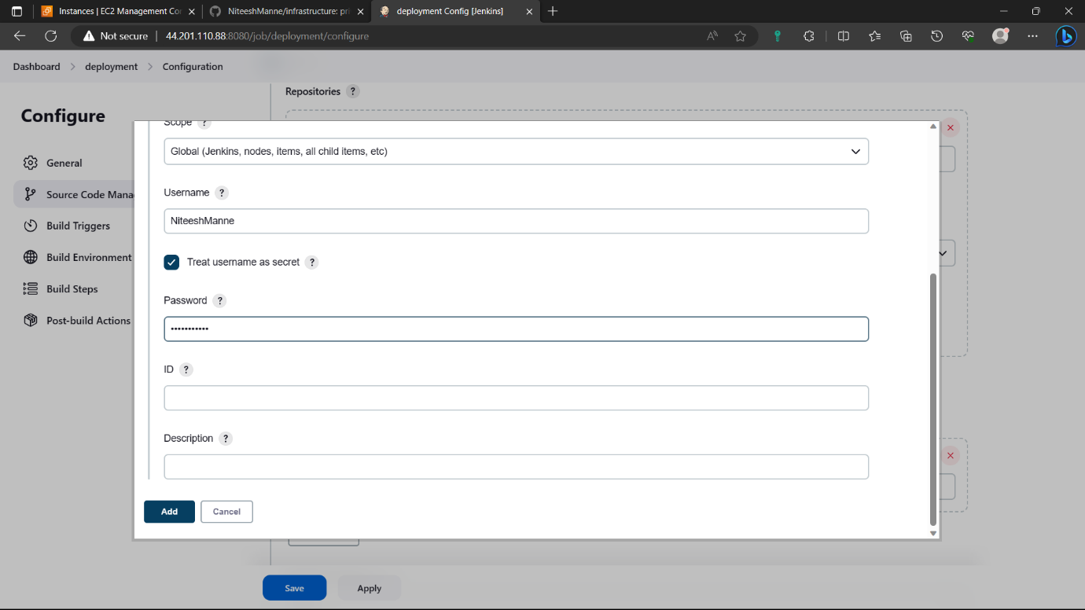

102)Click on profile🡪settings🡪developer settings🡪personal access token🡺create personal access token(classic)🡪give a name🡪enable repo🡪click on create🡪copy the token and paste it in secure file.

In credentials of Jenkins select your credentials.



103)Now go to ”Build steps” select “execute shell” and type the below commands.

sudo yum install -y yum-utils shadow-utils

sudo yum-config-manager --add-repo https://rpm.releases.hashicorp.com/AmazonLinux/hashicorp.repo

sudo yum -y install terraform

terraform init

terraform validate

terraform plan

terraform apply –auto-approve and click on save.

Click on “Build now” option you can see the commands are all executing below.

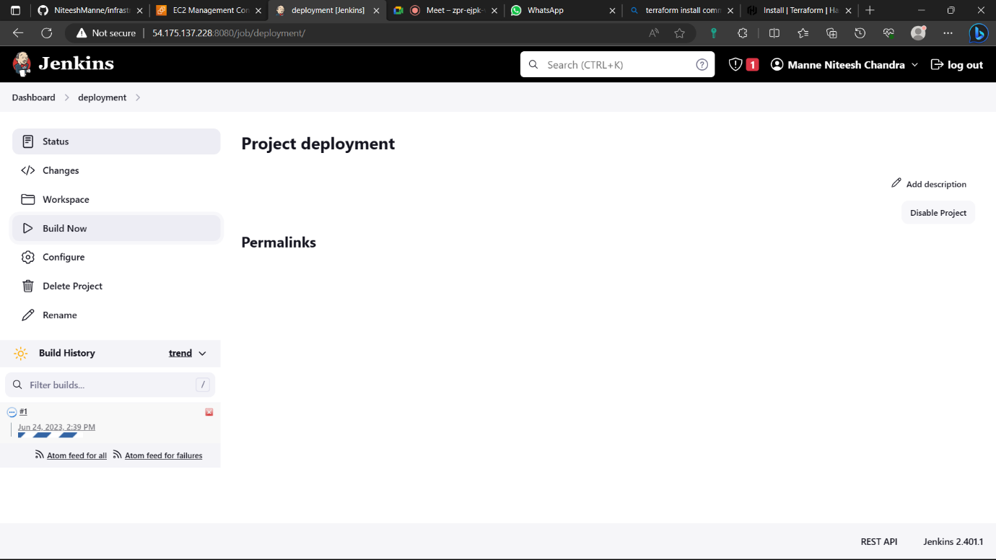

104)Select “#1” running and click on “console output” you can see the execution.

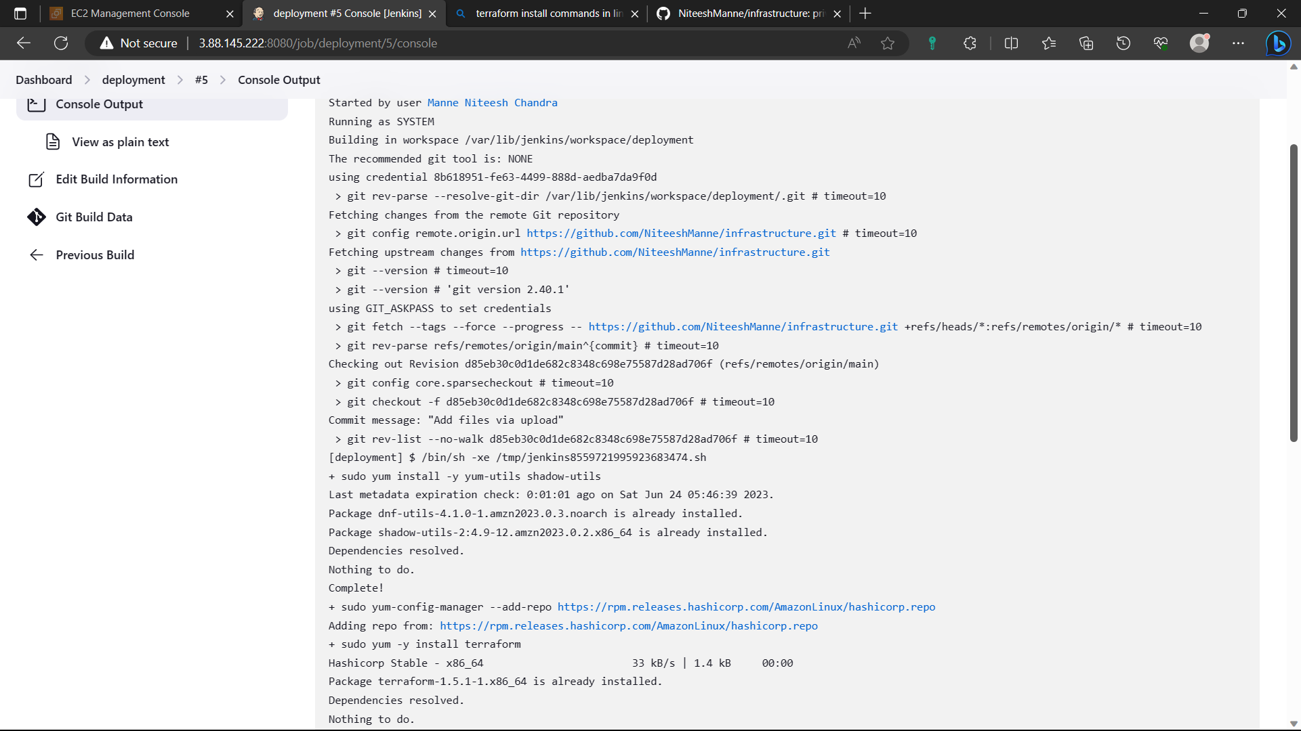

105)Now to the AWS console🡪search VPC🡪select VPC🡪”Your VPC’s” you can see that the VPC is created.

